I want to make a separate EQ maintenance app as a part of ENG portal..
purpose this app is to monitor EQ status, maintenance status and major structural parts and replacement status in 3D view.. management can easily view the status on the EQ fleet in 1 screen and users can update the major repair jobs. In admin mode, user can add EQ, repair jobs, Main Mechanism, sub Mechanism, main parts.. then user can update replacement jobs in Main Mechanism, sub Mechanism, main parts..
When user clicks on 3D view main Mechanism, system should zoom and load the 3D view of main Mechanism, and all the replacement done in that section in right side pannel..
if user selects sub Mechanism from main Mechanism, system should do the same..
system should have technical view with all the details and over view of EQ 3D view (user selectable)..
EQ team user can mark if the EQ is under maintenance or breakdown.. then main page should show it graphically..
App should have 3 rolls..
Admin
Management view
EQ team
1st page should show all the EQs as below..
EQ maintenance management
QC01
QC02

QC03

QC04

QC04

QC
RTG
ES
RT01
RT02

RT03

RT04

RT05

ES01
ES02

ES03

ES04

ES05

When user click on EQ button, it should load 2nd page as below
it should show the selected EQ in movable 3D view with main parts named.
ES05

ES04

ES03

ES02

ES01
ES

EQ maintenance management
QC01
Jobs
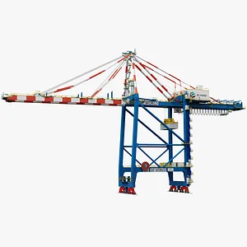

EQ team roll should have separate tab to add completed work, pending work and current work in each category and relevant EQ..
And EQ team user can update the relevant EQ status as Ready for OPS, Breakdown, Maintenance. If shod show in dashboard in separate colours..
refer below sites for 3D view look.. but cranes should be graphically identically to provided drawings and actual clours of CICT cranes (check provided photos and internet)
https://3dwarehouse.sketchup.com/model/u7940ce65-699d-42ab-8a10-047b5606dc2a/Super-Post-Panamax-Container-Quay-Crane
https://www.turbosquid.com/3d-models/harbor-crane-contains-3d-model-1562481?dd_referrer=https%3A%2F%2Fwww.google.com%2F

