# Lab3_Homework

library(tidyverse)

## -- Attaching packages ------------------------------------------------------- tidyverse 1.2.1 --

## v ggplot2 3.0.0 v purrr 0.2.5  
## v tibble 1.4.2 v dplyr 0.7.6  
## v tidyr 0.8.1 v stringr 1.3.1  
## v readr 1.1.1 v forcats 0.3.0

## -- Conflicts ---------------------------------------------------------- tidyverse_conflicts() --  
## x dplyr::filter() masks stats::filter()  
## x dplyr::lag() masks stats::lag()

library(ggplot2)  
library(gapminder)  
p2 = ggplot()  
p3 = ggplot()

# Creat dataset “data_2007” for year=2007:

data<-gapminder  
data_2007 <- data %>%  
 filter(year==2007)

# Creat dataset “data_euro” for european countries with GDP>40000

data_euro <- data_2007 %>%   
 filter(continent=="Europe") %>%   
 filter(gdpPercap > 40000)

# Creat dataset “data_top6GDP” for top 6 countries with highest GDP

data_top6GDP <- data_2007 %>%   
 arrange(desc(data_2007$gdpPercap))%>%  
 head(n = 6)

# Creat a plot for 2007: GDP Vs. Lifeexp, and annotate european countries with GDP>40000

p2 = p2+geom_point(data=data_2007,aes(x=gdpPercap,y=lifeExp)) +  
 geom_text(aes(x=data_euro$gdpPercap,y=data_euro$lifeExp,label=data_euro$country),  
 color="blue",hjust=0, vjust=0) +  
 theme_bw()  
p2

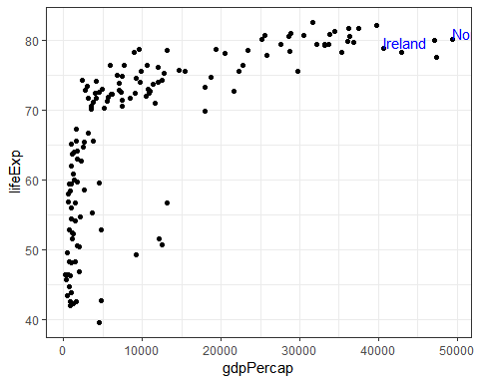 #Creat a plot which highlight the top 6 countries with highest GDP

xminimum=min(data_top6GDP$gdpPercap)-350  
xmaximum=max(data_top6GDP$gdpPercap)+350  
yminimum=min(data_top6GDP$lifeExp)-1  
ymaximum=max(data_top6GDP$lifeExp)+1  
  
p3 = p3+geom_point(data=data_2007,aes(x=gdpPercap,y=lifeExp), shape = 1) +  
geom_rect(data=data_top6GDP, mapping=aes(xmin=xminimum, xmax=xmaximum,   
 ymin=yminimum, ymax=ymaximum),   
 fill="pink",color="pink", alpha=0.1)  
p3=p3+geom_text() +  
 annotate("text", label = "Countries highest GDP", x = 45000, y = 74, size = 3,  
 colour = "black")+  
 theme_bw()  
p3

