Lab Homework 4

Huaian Yu

Due noon OCT 10, 2018

# Loading Library

library(tidyverse)

## -- Attaching packages ------------------------------------------------------- tidyverse 1.2.1 --

## v ggplot2 3.0.0 v purrr 0.2.5  
## v tibble 1.4.2 v dplyr 0.7.6  
## v tidyr 0.8.1 v stringr 1.3.1  
## v readr 1.1.1 v forcats 0.3.0

## -- Conflicts ---------------------------------------------------------- tidyverse_conflicts() --  
## x dplyr::filter() masks stats::filter()  
## x dplyr::lag() masks stats::lag()

library(ggplot2)  
library(dplyr)

# Recreate Plot:

#Creat dataset:  
x1<-seq(-3,3,by=0.001)  
y1<-dnorm(x1,mean=0,sd=1)  
x2<-seq(0.2,6.2,by=0.001)  
y2<-dnorm(x2,mean=3.2,sd=1)  
df_group1<-data.frame(x1,y1)  
df_group2<-data.frame(x2,y2)

#Plot density functions:  
p1 <- ggplot()+theme_bw() +  
 theme(panel.grid.major = element_blank(),panel.grid.minor = element_blank())+  
 scale_x_continuous(breaks=c(0,3.2),labels=c(expression(theta(0)), expression(theta(a))))+  
 xlab("") +ylab("")   
p1=p1+geom_line(mapping = aes(x=x1,y=y1),data=df_group1,colour="blue",size=1)+  
 geom_line(mapping = aes(x=x2,y=y2),data=df_group2,colour="red",size=1)+  
 geom_vline(xintercept=qnorm(0.95,0,1),size=1,linetype = 2)  
#Shadow the alpha and beta area:  
df_group1 %>%   
 filter(x1>=qnorm(0.95,0,1)) ->df_alpha  
df_group2 %>%   
 filter(x2<=qnorm(0.95,0,1)) ->df_beta  
p1 <- p1+geom_area(mapping=aes(x =df_alpha$x1 ,y=df_alpha$y1,fill="Type I error"),  
 data=df_alpha,colour="black",alpha=0.5,show.legend=TRUE)+  
 geom_area(mapping=aes(x =df_beta$x2 ,y=df_beta$y2,fill="Type II error"),  
 data=df_beta,colour="black",alpha=0.5,show.legend=TRUE)+  
 scale_fill_manual(values=c("blue", "red"))+  
 theme(  
 legend.title = element_blank(),  
 legend.text = element_text(size=15),  
 legend.position = c(0.01, .95),  
 legend.justification = c("left", "top"),  
 legend.box.just = "left"  
)  
p1=p1+geom_text() +  
 annotate("text", label = expression(beta), x = 1, y = 0.02, size = 5,colour = "black")+  
 annotate("text", label = expression(alpha), x = 2, y = 0.02, size = 5,colour = "white")  
p1

## Warning in is.na(x): is.na() applied to non-(list or vector) of type  
## 'expression'  
  
## Warning in is.na(x): is.na() applied to non-(list or vector) of type  
## 'expression'

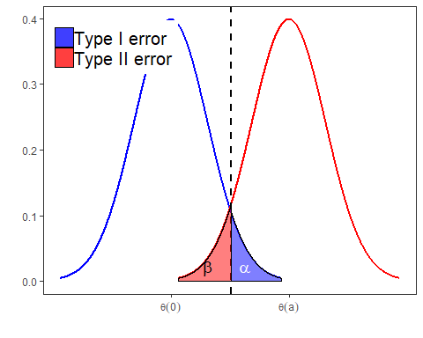

# Q4: Implement a function that will check if a given positive integer is a prime number.

is.prime <- function(num) {  
 if (num == 2) {  
 TRUE  
 } else if (any(num %% 2:(num-1) == 0)) {  
 FALSE  
 } else {   
 TRUE  
 }  
}

# TEST:

test1 <- is.prime(0)  
test2 <- is.prime(1)  
test3 <- is.prime(2)  
test4 <- is.prime(9)  
test4 <- is.prime(11)