Thrust Stand & Twin Rotor System

Matthias Kim & Han Yang

Abstract—This paper deals with the design and construction of a Twin Rotor System – the model was created using custom 3D printed material. The system consists of two rotors that resemble one arm of an X-shaped quadrotor drone. The non-stationary parts of the system can rotate around one perpendicular axis to produce an elevation output. This output is affected by the speed of the rotors. The system parameters were refined by identification based on real-time experiments.

Introduction
This document presents the results of an experiment that determined the outcome of Thrust vs RPM brushless motors. The system was improved based on measurements. The main goal of this project was to design a model for the Twin Rotor System Setup and to obtain angular data corresponding to the given input speeds. The reason for this project was to learn more about rotors by gaining hands-on experience.
The report is ordered as follows. Section 2 describes in detail the equipment used for the system setup. Section 3 divides the initial setup for the experiment, the procedural steps taken to obtain the results, a discussion of those results, and a short summary and conclusion into four subsections. Section 4 discusses some future possibilities and plans of the authors.

Description of Equipement

Component details
All major components used in this experiment are listed below. The main components consist of a Series 1580 Drone Test Stand from TYTO Robotics, two Emax RS2205S 2600KV brushless motors and two EMX-SC-1775 Bullet Series 35A electronic speed controllers (ESCs) from EMAX, one WT901C-TTL Tilt Angle Sensor (IMU tiltmeter) from Wit-Motion, one Signswise Incremental Optical Rotary Encoder, two Arduino Uno’s and a custom twin rotor stand.

Component descriptions
The Series 1580 Drone Test Stand is a Dynamometer for Drone Propulsion System (Fig. 1.). Depending on the motor and ESC choice, the Test Stand can measure up to 5 kgf of thrust and 2 Nm of torque as well as voltage, current, power, motor rotation speed, vibration, and efficiency. For our experiment, the Test Stand was used to obtain data correlation between thrust and revolutions per minute (RPM).
The remaining components, including the motor and ESC that were used with the 1580 Test Stand, are combined to create the Twin Rotor setup (Fig. 2). In this setup, the brushless motors rotate to create a thrust that pushes the arm to the desired angle. The ESCs control the speed of those motors. The IMU tiltmeter measures the rotational angle of the arm and its changes to the hundredths decimal point. The rotary encoder acts as an additional data source to again measure the angle on a separate scale which increases the overall accuracy. The two Arduinos were used to combine, control, and collect data from the system setup.
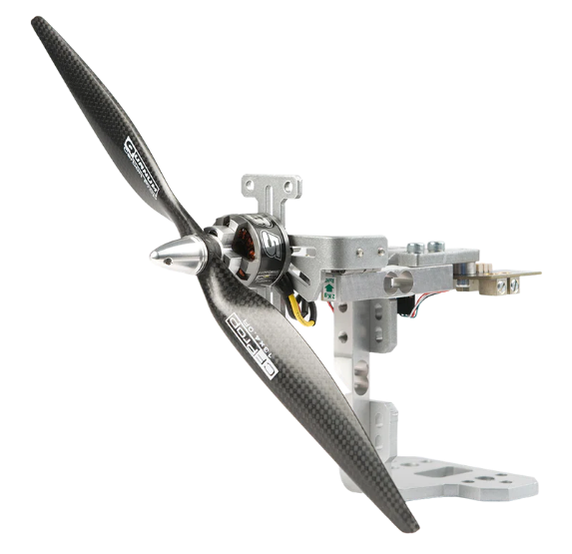
Fig. 1. Series 1580 Drone Test Stand
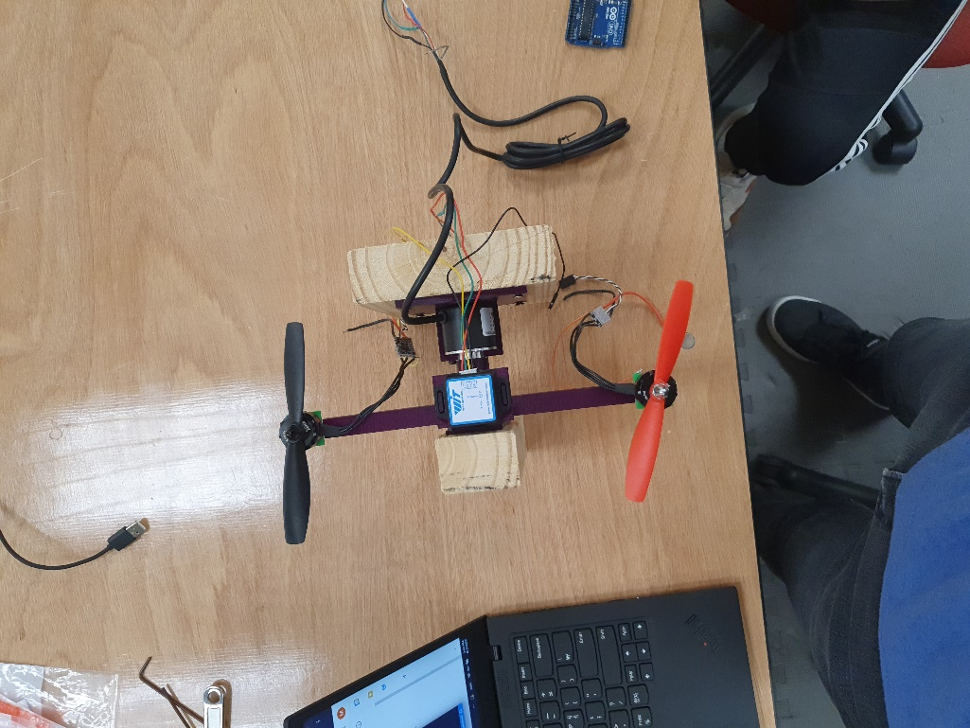
Fig. 2. Twin Rotor Test Setup

Procedure

Series 1580 Test Stand Setup
The initial process of the experiment was started by assembling the Series 1580 Test Stand. This was a simple process of screwing together the load cells, motor mounting plate, and a PCB. Once the mainframe was assembled, the load cells were calibrated using a 200gram weight. The stand was completed by soldering together an ESC to a motor and attaching it to the motor mount plate while connecting the other end of the ESC and an RPM probe to the PCB finished by connecting the PCB to an 11.1-volt LiPo battery.
After fully assembling the Test Stand, the ESC was manually calibrated by using a maximum to minimum software from RCBenchmark. More specifically, the process to calibrate was done by starting the system at max throttle, connecting it to the battery, then moving the throttle stick back down to the minimum. When done correctly, a pattern of beeps were emitted by the ESC. This calibration method allows the ESC to map the PWM signal to the actuating signal sent to the motor, which sets the PWM values of 1000 and 2000 to be the corresponding minimum and maximum.
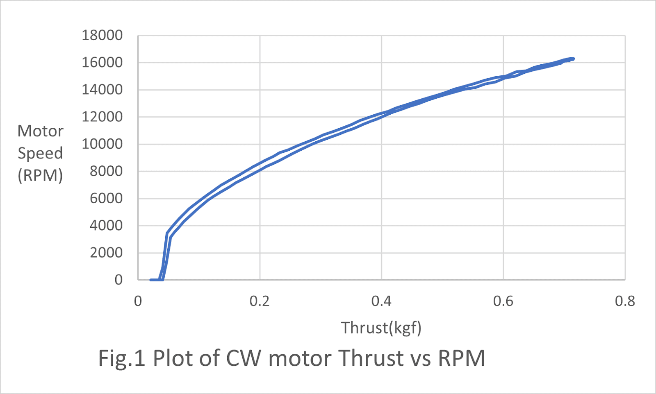
Once calibrated, the Test Stand becomes operational and is ready to collect data. The data acquisition process is controlled by the RCBenchmark software, which transmits the PWM signal to the ESC. Through the connection, an analog signal from the load cells and a pulse signal frequency from the ESC are collected and then used to output thrust and RPM. The user software was programmed to start with an initial PWM value of 1000 and then continuously increase until the target value is reached, where it then returns to its original value. This program ran for roughly 75 seconds where it increased and decreased for 35 seconds each while holding the peak speed for approximately 5 seconds. This program collected three sets of data from three different continuous PWM rates, ranging from input values of 1000 to 1600, 1000 to 1800, and 1000 to 2000. Each time the program was run, data was logged into CSV files from which thrust and RPM were extracted to create visual illustrations between the two using Excel Plots (Fig. 3 & 4). These steps were repeated for both clockwise (CW) and counterclockwise (CCW) motor rotations.
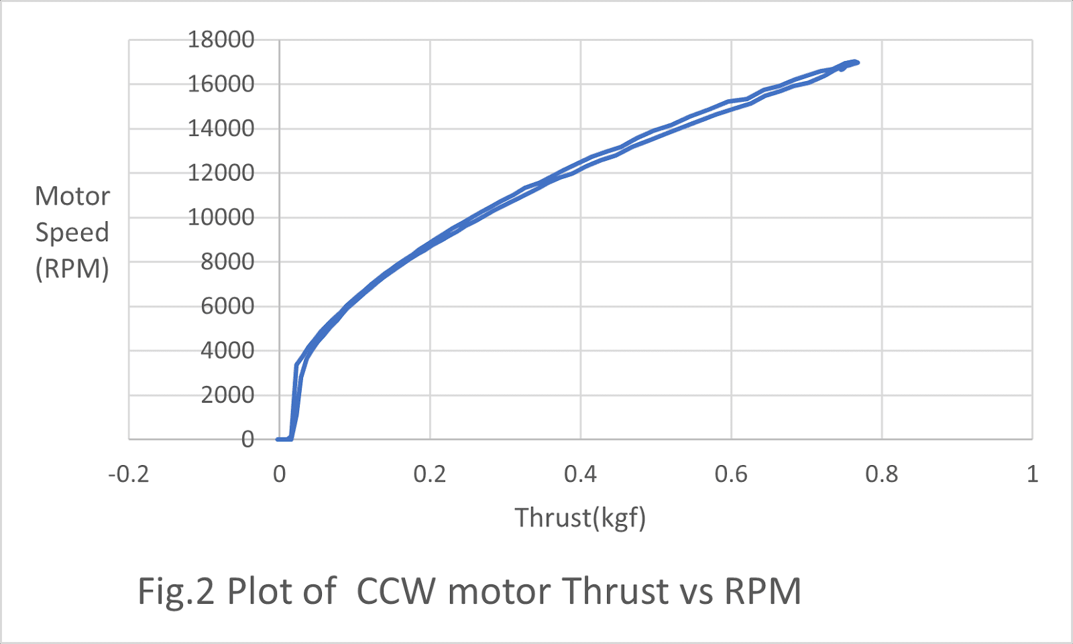
Fig. 3 Plot of CW motor Thrust vs RPM (range 1000-2000)
Fig. 4. Plot of CCW motor Thrust vs RPM (range1000-2000)

Twin Rotor System Setup
The second half of our experiment was designing and fabricating the Twin Rotor System Setup. The mainframe for this setup was a 3D-printed arm made of PLA which was held by two pieces of wood. The finished setup was created by attaching the remaining components to the mainframe (Fig. 2.). More specifically, the non-stationary arm is free to rotate about its centroid as a press-fitted bearing acts as a joint between the stand and the arm. The two motors are attached at opposite ends with 250mm between them. Above the centroid lies the press-fitted IMU tiltmeter along the vertical axis. The rotary encoder sits coaxial with the bearing. With everything centered and symmetrically placed, the 3D printed arm along with the rotary encoder create a flush fit each supported by a piece of wood. Each Arduino is connected to a breadboard that powers and controls the system’s electronic components. These are then mounted using easily removable adhesive mechanisms.
The system software is also separated into two subsections controlled by two different microcontrollers. The first one used the Arduino library, servo.h, for the simultaneous calibration of the two motors and to set them to maintain a variable speed between PWM values ranging from 1000 to 2000. The second microcontroller controlled the IMU tiltmeter and the rotary encoder. The software for the second controller used two Arduino libraries. One was a custom library that was designed to automatically output rotational angles from the IMU. The other used the library, wire.h, to create a more precise and accurate system using both an interrupt and debounce mechanism.
The experiment was tested with three sets of PWM values. The first trial was done with symmetrical PWM values of 1300 for both motors. The second trial was done using asymmetrical values of 1250 and 1350 were used. The third trial reversed the asymmetrical valued motors used in the second trial. All trials were recorded and stored into CSV files using Excel’s data streamer. The angular data obtained from both the IMU and the rotary encoder were stored in two channels. The first is the IMU’s angles in degrees and the second is the rotary encoder’s value (Fig. 5 & 6).
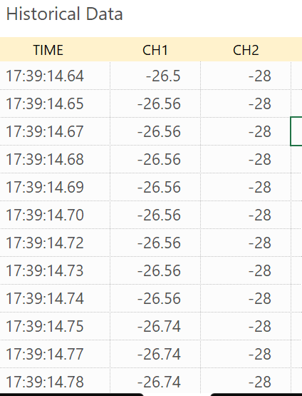
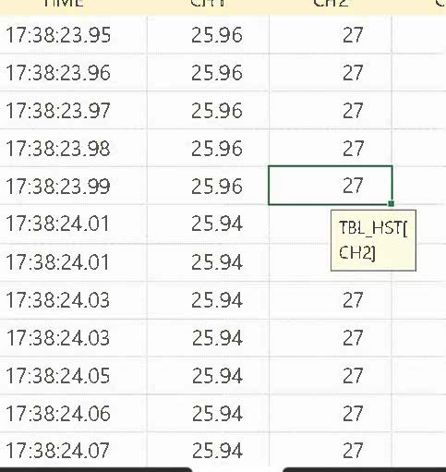

Fig. 5 (Left) CW rotation of the Twin Rotor System
Fig. 6 (Right) CCW rotation of the Twin Rotor System

Results and Discussion
The initial goal of the experiment was to analyze the thrust vs RPM data and use that to generate a sustainable model for the Twin Rotor System. By completing it, the Twin Rotor setup would be controllable by a thrust to produce the desired outcome. Throughout the experiment, both the Test Stand and Twin Rotor System were made functional. The desired data were collected as Excel CSV files. Despite the successful action of retrieving data, as the experiment was being conducted many challenges faced created inconsistencies or increased the error margins.
The first main issue faced was the damaged Test Stand. During a trial to record data on the motors, four four-ohm resisters were damaged causing the PCB to reject direct electrical currents. The workaround used to solve this was to directly connect the ESC to the LiPo battery instead of attaching it to the PCB. The only problem would be that any values related to the electrical power on the board turn void. Nevertheless, the solution would suffice as the thrust utilized the load cells and the RPM was collected by the pulse frequency sent from the ESC. Since the primary data values were extracted, it was then used for the graphical representations presented in Fig. 3 & 4. The data was then compared to the product datasheet to confirm similarities between performance and mechanical efficiency. The Thrust vs RPM data can now be used to later tune a controller and relate inputs, outputs, and actuating signals.
The second main issue appeared during the software combination process of the components for the Twin Rotor System. After having combined the software of the IMU tiltmeter, the rotary encoder, and the ESC calibration and control, the overlapping commands within the code created a loop that caused the system to malfunction. More specifically, to make a rotary encoder as accurate as possible, it required a brief interrupt within the loop code to act as a debounce mechanism. This short delay counteracted the motor’s continuous speed control making the actuation of the ESCs to halt momentarily causing stutters, errors, or inconsistencies in data. The solution used was to add a second microcontroller to divide the tasks. One controller was used for motor calibration and input speed control, while the other was used for data acquisition. The minor problem faced with this solution was that the feedback loop of the first microcontroller would act as an input followed by the second feedback loop. This enables the system to be slightly more prone to inconsistencies and larger error margins.
Although additional variations of the solutions could be implemented, both setups effectively collected their desired outputs and recorded them accurately.

Summary and Conclusion
This experiment presented the Thrust vs RPM of a brushless motor as well as how that can be used to control the twin-rotor setup to produce the desired angles. Using the data obtained from our software, graphs were plotted to create a visual representation of the results. The images in Fig. 5 & 6 demonstrate how the angular data is being received and in what form of collection. This data can be converted and sent back to a microcontroller where it can then be used as an error signal for a feedback controller.

Future plans

Matthias Kim
After having worked on this twin-rotor research project, my goal for the current project and future projects roughly remain the same. That being, I would like to learn more about the physical aspect of controls through innovation and experimentation. Although I have been learning more about the topic through rotors, it is clear that there is still much to learn. Therefore, when it comes to future plans, a couple of options I’ve thought about working on would be to either further stabilize the current Twin-Rotor setup or to move on and work with more dimensions. If I were to choose the first option, I would work on improving efficiency, accuracy, and consistency; later followed by a PID control system to work on stabilization from disturbances. If I were to choose the option of adding more dimensions, a similar concept to the initial twin-rotor setup would be used, but a spherical joint will act as its base. Both options result in achieving steps towards understanding free-flying position control and have enough overlapping content to not hinder my progress to this end goal.

Han Yang
I also foresee my next few milestones being completing the dual rotor setup and moving on to the 3 degrees of freedom setup. Eventually, I wish to learn how to control an actual flying drone that has 6 degrees of freedom. In the long run, I wish to continue the research in two directions. First being adding more variables to the system. Currently, we only have thrust and angles as our controlled output, and in the future, I wish to introduce variables such as propeller configuration and arm length to the system such that we can tune and control other variables such as reaction speed (the time it takes for the setup to move to a stable position). The other research direction involves navigation and machine learning. I wish to create a drone that can navigate through tunnels or seek something in a room, say, a light source, and have it complete the navigation task as fast as possible. To accomplish this, we would apply methods in machine learning and make the drone learn during each trial, thus, navigate more effectively each time.

