Using domain as an example, the following are some data visualizations:

1. Simple by domain and year_category

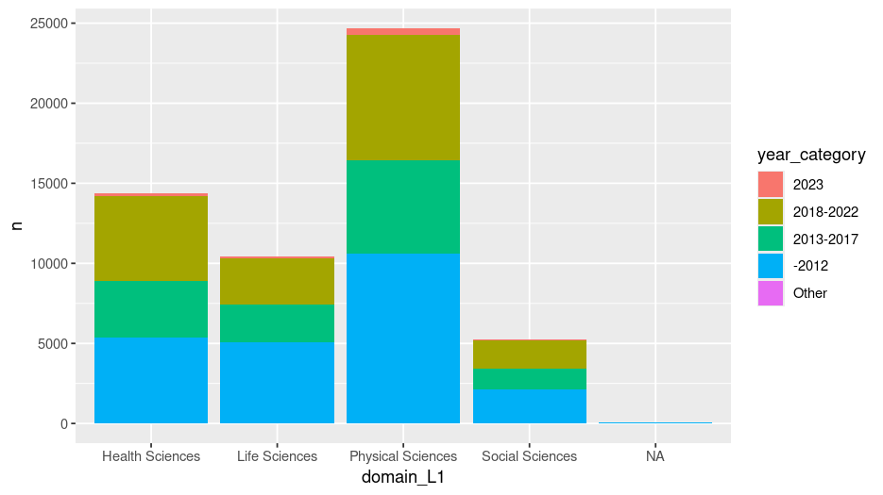
2. Citation Age Heatmap

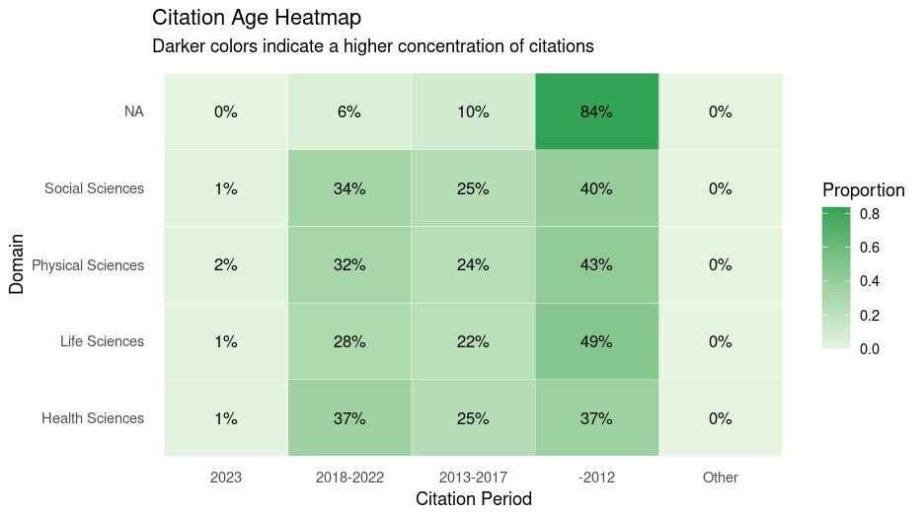
3. Citation Decay Rates by Domain ( the older the citation, the higher the rate of decay?)

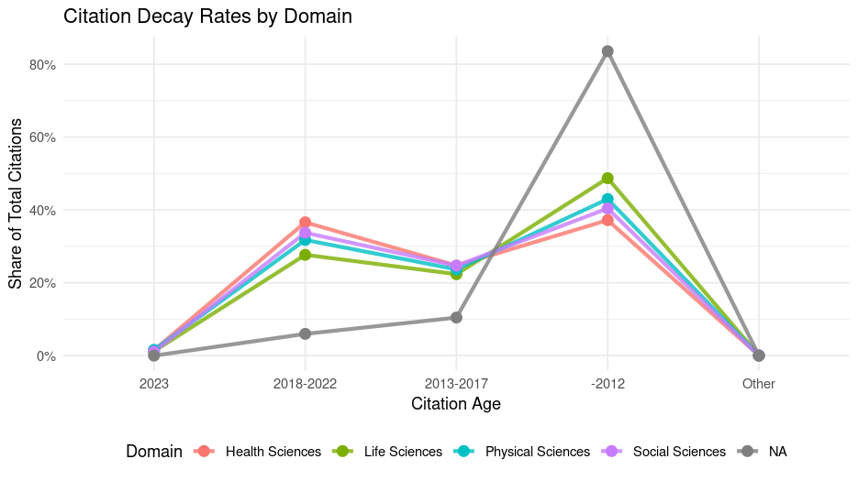
4. Citation Volume

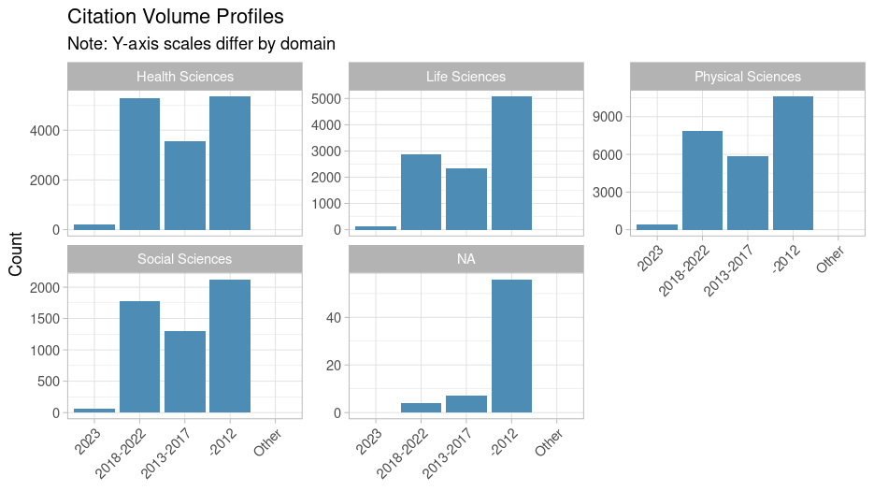
2. Using Field as an example, the following

2.1 Citation field and year_category

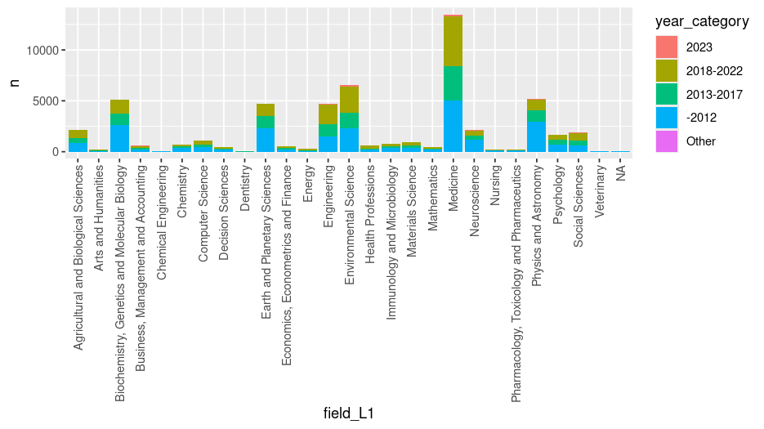
2.2 Heatmap

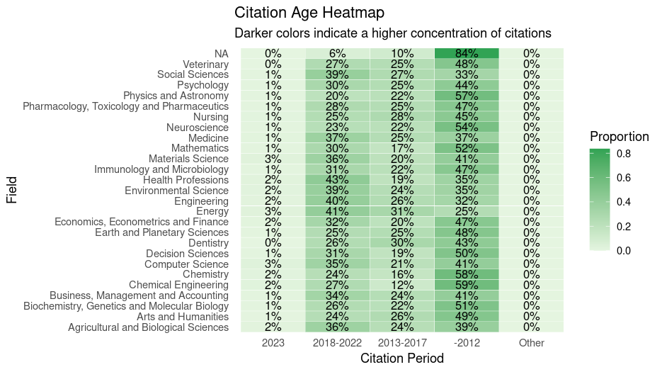
2.3 Citation Decay Rate by Field

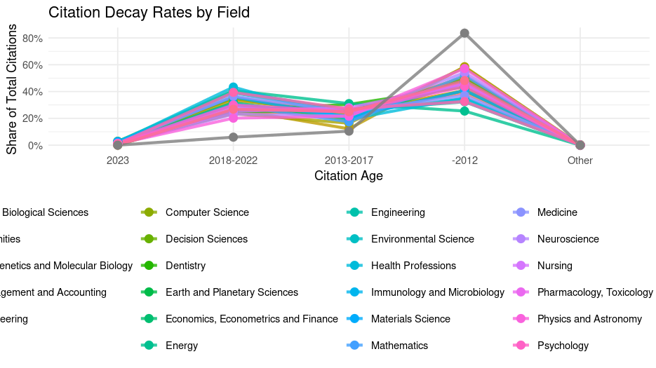
2.4 Citation Volume Profile by Field

