1. %d 与 %s的用法
2. %s, 表示格式化一个对象为字符

例子：

“Hello, %s” % “zhang3”

输出结果：”Hello, zhang3”

1. %d, 替换整数

例子：

“%d” % 33

输出结果：”33”

1. 综合应用：

“%s: %d” % (“ab”, 3)

输出结果：”ab: 3”

1. Range ()

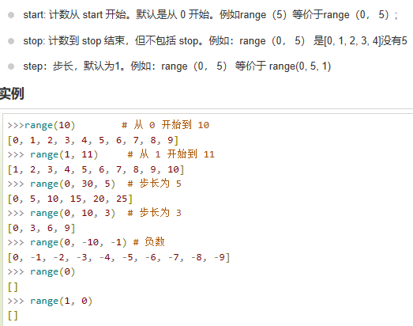

1. For

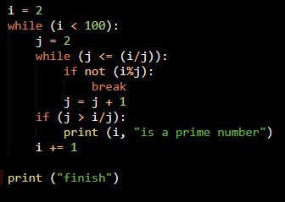

Logic:

i = 2, j = 2, j > (i / j = 1)

print (2 is a prime number)

i = 3, j = 2, j > (i / j = 1.5)

print (3 is a prime number)

i = 4, j = 2, j <= (i / j = 2), i % j = 0 (“0” means false), not (i % j) = 1 = true, break

i = 5, j = 2, j <= (i / j =2.5), i % j = 1 (“1” means true), not (i % j) = 0 = false, j = j + 1 = 3

j = 3, j > (i / j = 2.5)

print (5 is a prime number)

.

.

.

1. 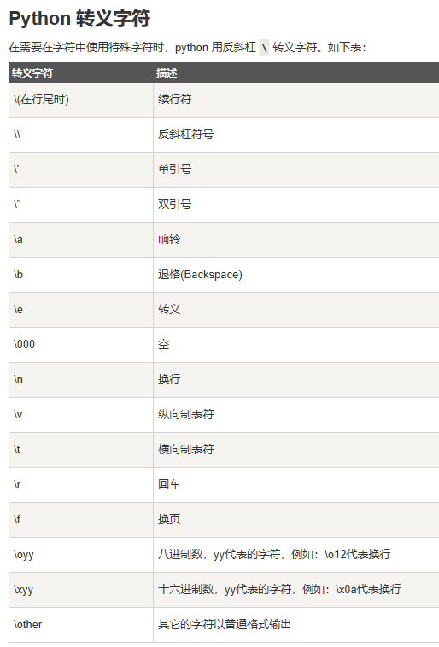
2. 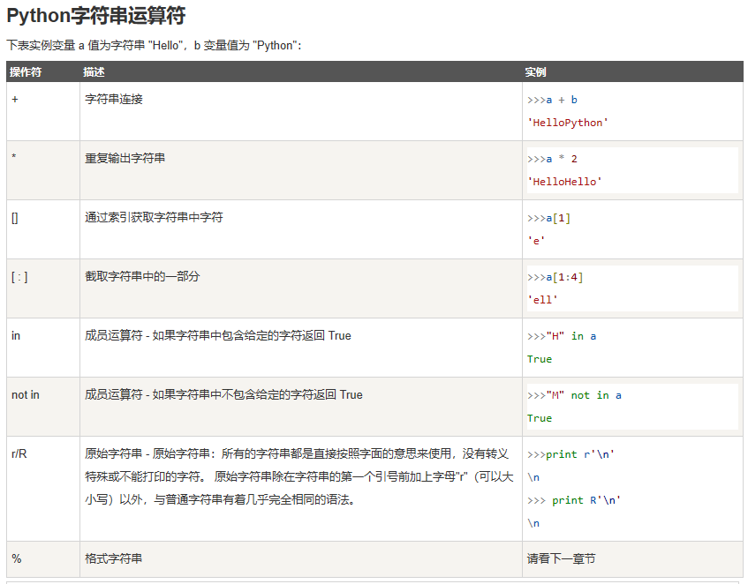
3. 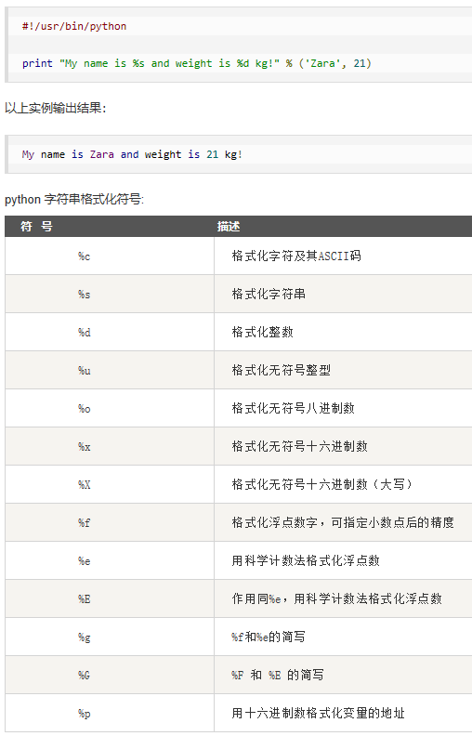
4. 