# Unit 1 Derivatives

## Lecture 1 What is a derivative?

1. The derivative is the limit of the secant line approaching the tangent line:

* Geometric interpretation:

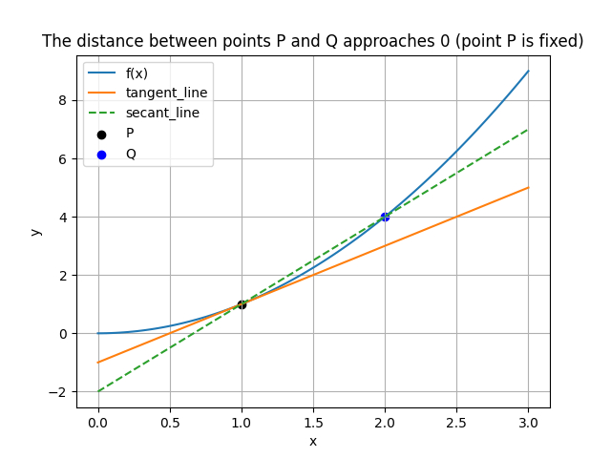

* Algebraic Explanation:

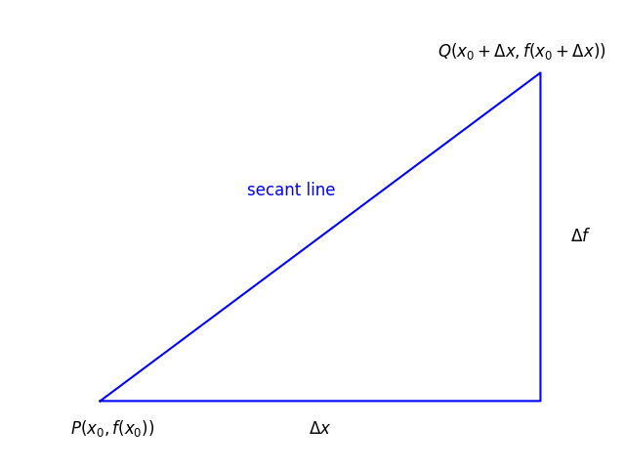

$$\lim_{Δx→0} \frac{Δf}{Δx}=\lim_{Δx→0} \frac{f\left(x_{0}+Δx\right)-f\left(x_{0}\right)}{Δx}=f^{'}\left(x_{0}\right)$$

1. Example:

$\begin{aligned}f(x)=\frac{1}{x} \\ \\ proof:\frac{Δf}{Δx}&=\frac{\frac{1}{(x+Δx)}-\frac{1}{x}}{Δx} \\ &=\frac{-Δx}{Δx⋅x⋅(x+Δx)} \\ &=\frac{-1}{x⋅(x+Δx)} \\ f^{'}(x)&=\lim_{Δx→0} \frac{Δt}{Δx} \\ &=\lim_{Δx→0} \frac{-1}{x⋅(x+Δx)} \\ &=-\frac{1}{x^{2}}\end{aligned}$ $\begin{aligned}f(x)=x^{\begin{aligned}n \\ \end{aligned}} \\ \\ proof:\frac{Δf}{Δx}&=\frac{(x+Δx)^{n}-x^{n}}{Δx} \\ &=\frac{x^{n}+n⋅Δx⋅x^{n-1}+o\left[(Δx)^{2}\right]-x^{n}}{Δx} \\ &=n⋅x^{n-1}+o(Δx) \\ f^{'}(x)&=\lim_{Δx→0} \frac{Δf}{Δx} \\ &=\lim_{Δx→0} \left[\begin{aligned}n⋅x^{n-1}+o(Δx)\end{aligned}\right] \\ &=n⋅x^{n-1}\end{aligned}$

1. Note:

Tangent Line Equation:

$$y-y_{0}=f^{'}\left(x_{0}\right)\left(x-x_{0}\right)$$

## Lecture 2 Limits and Continuity

1. Limits:
$$\lim_{x→x_{0}} \frac{Δf}{Δx}=\lim_{x→x_{0}} \frac{f\left(x_{0}+Δx\right)-f\left(x_{0}\right)}{Δx}$$

2. Continuity:

$$\lim_{x→x_{0}} f(x)=f\left(x_{0}\right)$$

* Removable discontinuities of the first type:

$\lim_{x→x_{0}^{+}} f(x)=\lim_{x→x_{0}^{-}} f(x)≠f(x_{0})$ or $f(x_{0})$ is not defined.

* Jump discontinuities of the first type:
$$\lim_{x→x_{0}^{+}} f\left(x\right)=a≠b=\lim_{x→x_{0}^{-}} f\left(x\right)$$

* Infinite discontinuities of the second type:
$$\lim_{x→x_{0}^{+}} f(x)/\lim_{x→x_{0}^{-}} f(x)→∞$$

* Other discontinuities of the second type.

1. Two trigonometric limits:
$$\lim_{θ→0} \frac{\sin{θ}}{θ}=1$$

$$\begin{aligned}\lim_{θ→0} \frac{1-cos⁡θ}{θ}=0\end{aligned}$$

2. Theorem:

A differentiable function must be continuous:

$$\begin{aligned}proof&:\lim_{x→x_{0}} (f(x)-f(x_{0})) \\ &=\lim_{x→x_{0}} \frac{f(x)-f(x_{0})}{x-x_{0}}⋅(x-x_{0}) \\ &=f(x_{0})⋅0=0\end{aligned}$$

## Lecture 3 Derivative formula

1. General formula:

$\left(u+φ\right)'=u'+φ'$

Proof: $\left(u+φ\right)'\left(δ\right)=\lim_{Δx→0}\frac{\left(u+φ\right)\left(δ+Δx\right)-\left(u+φ\right)\left(δ\right)}{Δx}$

$$=\lim_{Δx→0}\frac{u\left(δ+Δx\right)+φ\left(δ+Δx\right)-u\left(δ\right)-φ\left(δ\right)}{Δx}$$

$$=\lim_{Δx→0}\left(\frac{u\left(δ+Δx\right)-u\left(δ\right)}{Δx}+\frac{φ\left(δ+Δx\right)-φ\left(δ\right)}{Δx}\right)$$

$$=(u)'\left(δ\right) + \left(φ\right)'\left(δ\right)$$

${\left(Cu\right)}^{'}{\left(C⋅u\right)}^{'}=C⋅u^{'}$

$$\begin{matrix}{\left(C⋅u\right)}^{'}\left(x\right) \\ =\lim_{Δx→0}\frac{C⋅u\left(x+Δx\right)-C⋅u\left(x\right)}{Δx} \\ =C⋅\lim_{Δx→0}\frac{u\left(x+Δx\right)-u\left(x\right)}{Δx} \\ =C⋅u^{'}\left(x\right)\end{matrix}$$

$\left(u⋅v\right)'=u'⋅v+u⋅v'$

Proof: $\left(u⋅v\right)'=\lim_{Δx→0}\frac{\left(u⋅v\right)\left(x+Δx\right)-\left(u⋅v\right)\left(x\right)}{Δx}$

$$=\lim_{Δx→0}\frac{\left(u⋅v\right)\left(x+Δx\right)+u\left(x+Δx\right)⋅v\left(x\right)-u\left(x+Δx\right)⋅v\left(x\right)-\left(u⋅v\right)\left(x\right)}{Δx}$$

$$=\lim_{Δx→0}\left(u\left(x+Δx\right)⋅\frac{v\left(x+Δx\right)-v\left(x\right)}{Δx}+v\left(x\right)⋅\frac{u\left(x+Δx\right)-u\left(x\right)}{Δx}\right)$$

$$=u\left(x\right)⋅v'\left(x\right)+v\left(x\right)⋅u'\left(x\right)$$

Geometric interpretation:

$$ΔS=Δv⋅u+Δu⋅v$$

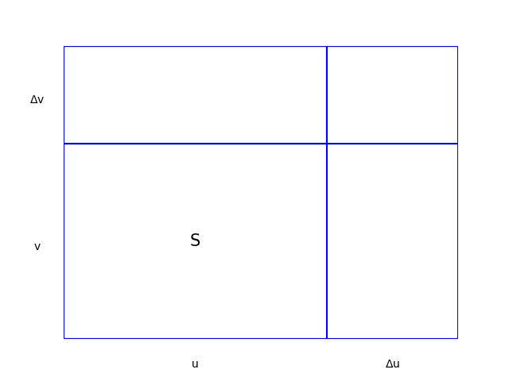

$(\frac{u}{v})^{'}=\frac{u^{'}v-uv^{'}}{v^{'}}$

$$\begin{aligned}Proof: \frac{u\left(x+Δx\right)}{v\left(x+Δx\right)}-\frac{u\left(x\right)}{v\left(x\right)} \\ =\frac{\left(u+Δu\right)⋅v-\left(v+Δv\right)⋅u}{\left(v+Δv\right)⋅v} \\ =\frac{\left(Δu\right)⋅v-\left(Δv\right)⋅u}{\left(v+Δv\right)⋅v} \\ &\frac{1}{Δx}\left(\frac{u\left(x+Δx\right)}{v\left(x+Δx\right)}-\frac{u\left(x\right)}{v\left(x\right)}\right) \\ =\frac{\frac{Δu}{Δx}⋅v-\frac{Δv}{Δx}⋅u}{\left(v+Δθ\right)⋅v} \\ \underset{→}{\lim_{Δx→0} }\frac{\frac{du}{dx}⋅v-\frac{dv}{dx}⋅u}{v^{2}} \\ =\frac{u^{'}v-v^{'}u}{v^{2}}\end{aligned}$$

* Note:

$$\left(u+v\right)\left(x\right)=u\left(x\right)+v\left(x\right)、uv\left(x\right)=u\left(x\right)·v(x)$$

1. Special formula：

$\frac{d}{dx}x^{n}=n⋅x^{n-1}$

$\frac{d}{dx}sinx=cosx$

Proof: $\frac{d}{dx}sinx=\lim_{Δx→0}\frac{sin\left(x+Δx\right)-sin\left(x\right)}{Δx}$

$$=\lim_{Δx→0}\frac{sinxcosΔx+sinΔxcosx-sinx}{Δx}$$

$$=\lim_{Δx→0}\left(sinx⋅\frac{cosΔx-1}{Δx}+cosx⋅\frac{sinΔx}{Δx}\right)$$

$$=cosx$$

$\frac{d}{dx}cos⁡x\&=-sin⁡x$

$$\begin{aligned}Proof: \frac{d}{dx}\cos{x}=\lim_{Δx→0} \frac{\cos\left(x+ax\right)-\cos\left(x\right)}{Δx} \\ =\lim_{Δx→0} \frac{\cos{\operatorname{xcos}{x}}-\sin{\operatorname{xsin}{x}}-\cos{x}}{Δx} \\ =\lim_{Δx→0} \left(\cos{x}⋅\frac{\cos{x}-1}{Δx}-\sin{x}⋅\frac{\sin{x}}{Δx}\right) \\ =-\sin{x}\end{aligned}$$

## Lecture 4 Chain Rule and Higher-Order Derivatives

1. Chain Rule:
$$\frac{Δy}{Δt}=\frac{Δy}{Δx}⋅\frac{Δx}{Δt}$$

$$\frac{d}{dt}f\left(g\left(t\right)\right)=f^{'}\left(g\left(t\right)\right)⋅g^{'}\left(t\right)$$

$$(fog)(x)=f(g(x))、(gof)(x)=g(f(x))$$

2. Higher-Order Derivatives：

$$f^{(n)}(x)=D^{n}f=\frac{d^{n}f}{dx^{n}}$$

## Lecture 5 Implicit functions and Inverse

1. Implicit function calculation method：

Derivatives ($\frac{dy}{dx}$) are taken for all terms and finally separated.

1. Inverse:

$$x=g\left(y\right)=f^{-1}(y)$$

$${\left(f^{-1}\left(y\right)\right)}^{'}⋅y^{'}=1$$

$$\begin{aligned}&Proof: ∵f^{-1}\left(y\right)=x \\ &∴\frac{d}{dx}f\left(y\right)=\frac{d}{dx}⋅x=1 \\ &⇒\frac{d}{dy}⋅\frac{dy}{dx}f\left(y\right)=1 \\ &⇒\frac{d}{dy}f\left(y\right)⋅\frac{dy}{dx}=1 \\ &⇒{\left(f^{-1}\left(y\right)\right)}^{'}⋅y^{'}=1\end{aligned}$$

* Among them, the nested expressions of trigonometric functions and inverse trigonometric functions can be expressed through geometric substitution：

$$\begin{matrix}y=arctanx \\ ⇒tany=x \\ ⇒{\left(tany\right)}^{'}⋅y^{'}=1 \\ ⇒\frac{1}{\cos^{2}y}⋅y^{'}=1 \\ ⇒y^{'}=\cos^{2}y \\ ⇒y^{'}=\cos^{2}\left(arctanx\right)=\frac{1}{1+x^{2}}\end{matrix}$$

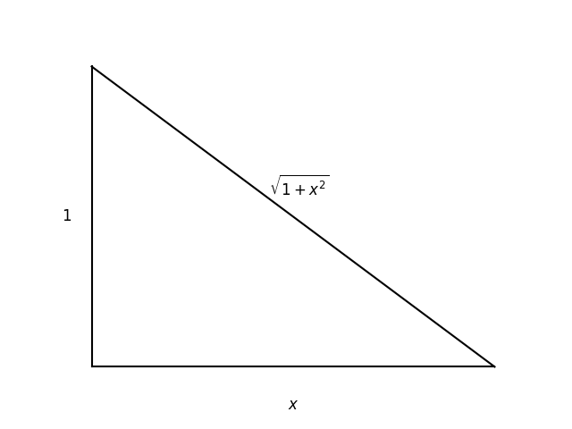

$$⇒\cos^{2}⁡y=\frac{1}{1+x^{2}}$$

* Geometric relationship:

Symmetrical with the original function about line $y=x$.

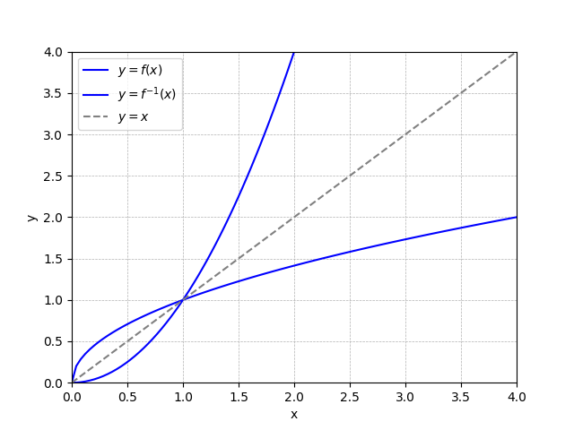

* Notes:

$$f^{-1}(f(x))=f(f^{-1}(x))=f^{-1}of(x)=fof^{-1}(x)=x$$

## Lecture 6 Exp and Log function derivatives

1. Exp function: $y=a^{x}$

$$∵\frac{d}{dx}a^{x}=\lim_{Δx→0}\frac{a^{x+Δx}-a^{x}}{Δx}$$

$$=\lim_{Δx→0}a^{x}⋅\frac{a^{Δx}-1}{Δx}$$

$$=a^{x}\lim_{Δx→0}\frac{a^{Δx}-1}{Δx}$$

$$∴assuming M\left(x\right)≡\lim_{Δx→0}{\frac{a^{Δx}-1}{Δx}}$$

$$⇒\frac{d}{dx}a^{x}=M\left(x\right)⋅a^{x}$$

After analysis, $M\left(a\right)=\frac{d}{dx}a^{x}|_{x=0}.$

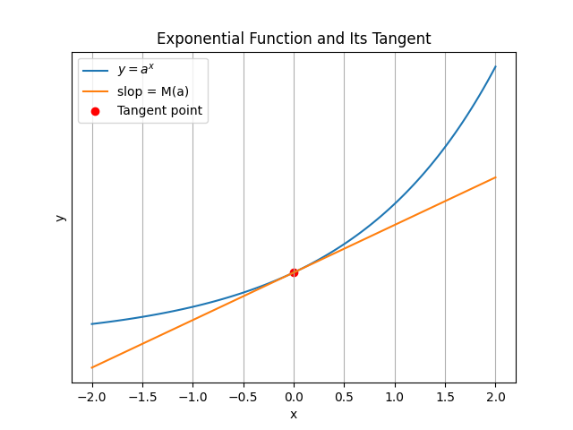

Consider a slope equal to 1

According to the geometric form of the derivative:

$$\begin{matrix} & M\left(2\right)<1,M\left(3\right)>1 \\ & hence,M\left(e\right)≡1,2<e<3 \\ & ⇒\lim_{λ→0}\frac{e^{λ}-1}{λ}=1⇒\frac{d}{dx}e^{x}=e^{x}.\end{matrix}$$

1. Log function: $y=lnx$ (Inverse $y=e^{x}$)

* Basic theory: $ln(x_{1}x_{2})=lnx_{1}+lnx_{2}$

$$\begin{matrix} & ∵y=lnx⇒e^{y}=x \\ & ⇒{\left(e^{y}\right)}^{'}⋅y^{'}=1 \\ & ⇒y^{'}=\frac{1}{e^{y}}=\frac{1}{x}\end{matrix}$$

Then, for the exponential function $y=a^{x}$, we have:

$$y={\left(e^{lna}\right)}^{x}=e^{xlna}$$

According to the chain rule:

$$\begin{matrix}y^{'} & =\frac{d}{dx}e^{xlna}=\left(lna\right)⋅e^{xlna} \\ & =\left(lna\right)⋅a^{x} \\ ⇒\frac{d}{dx}a^{x} & =\left(lna\right)⋅a^{x}\end{matrix}$$

1. Derivative Applications:

$\begin{matrix} & y=x^{x} \\ & ∵y=e^{xlnx}⇒lny=xlnx \\ & ∴y^{'}/y=lnx+1 \\ & ⇒y^{'}=y\left(lnx+1\right) \\ & ⇒y^{'}=x^{x}⋅\left(lnx+1\right)\end{matrix}$ $\begin{matrix} & \lim_{k→∞}{\left(1+\frac{1}{k}\right)}^{k} \\ & ∵\lim_{k→∞}{\left(1+\frac{1}{k}\right)}^{k}=\lim_{k→∞}e^{k·ln\left(1+\frac{1}{k}\right)} \\ & \text{Consider the exponential equation,} \\ & y=\frac{1}{x}ln\left(1+x\right),x=\frac{1}{k} \\ & ⇒\lim_{x→0}y=\lim_{x→0}\frac{ln\left(1+x\right)-ln\left(1\right)}{x} \\ & =\frac{d}{dx}ln\left(x\right)|_{x=1}=1 \\ & ⇒\lim_{k→∞}kln\left(1+\frac{1}{k}\right)=1 \\ & ⇒\lim_{k→∞}{\left(1+\frac{1}{k}\right)}^{k}=e\end{matrix}$

## Lecture 7 Hyperbolic function

1. Manifestation：
$$sinh⁡(x)=\frac{e^{x}-e^{-x}}{2},cosh⁡(x)=\frac{e^{x}+e^{-x}}{2}$$

2. Derivative：
$$\frac{d}{dx}\sinh\left(x\right)=\frac{d}{dx}\left(\frac{e^{x}-e^{-x}}{2}\right)=\frac{e^{x}-\left(-e^{-x}\right)}{2}=\cosh\left(x\right)$$

$$\frac{d}{dx}cosh⁡(x)=\frac{d}{dx}(\frac{e^{x}+e^{-x}}{2})=\frac{e^{x}-e^{-x}}{2}=sinh⁡(x)$$

3. Theorem:

$$\cosh^{2}⁡(x)-\sinh^{2}⁡(x)=1$$

Trigonometric functions (circular functions): $\sin^{2}⁡x+\cos^{2}⁡x=1$

$$\begin{aligned}Proof: &∵\cosh^{2}⁡(x)-\sinh^{2}⁡(x) \\ &=(\frac{e^{x}+e^{-x}}{2})^{2}-(\frac{e^{x}-e^{-x}}{2})^{2} \\ &=\frac{e^{2x}+2+e^{-2x}-e^{2x}+2-e^{-2x}}{4} \\ &=1\end{aligned}$$

# Unit 2 Applications of Derivatives

## Lecture 8 Linear and Quadratic approximations

1. Linear approximations: