# Unit 1 Derivatives

## Lecture 1 What is a derivative?

1. The derivative is the limit of the secant line approaching the tangent line:

* Geometric interpretation:

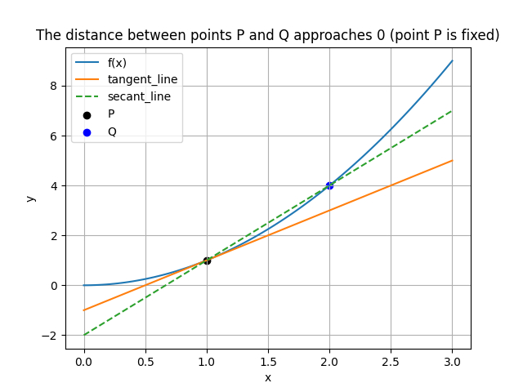

* Algebraic Explanation:

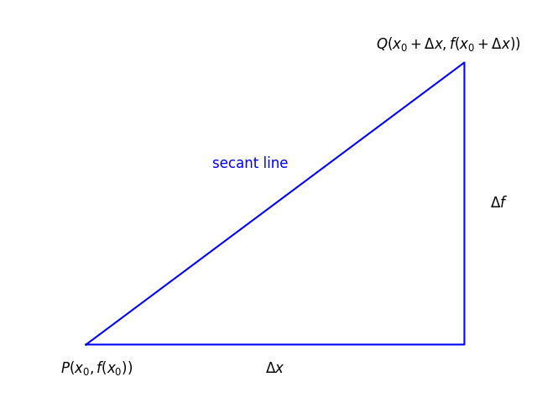

1. Example:

1. Note:

Tangent Line Equation:

## Lecture 2 Limits and Continuity

1. Limits:
2. Continuity:

* Removable discontinuities of the first type:

or is not defined.

* Jump discontinuities of the first type:
* Infinite discontinuities of the second type:
* Other discontinuities of the second type.

1. Two trigonometric limits:
2. Theorem:

A differentiable function must be continuous:

## Lecture 3 Derivative formula

1. General formula:

Proof:

Proof:

Geometric interpretation:

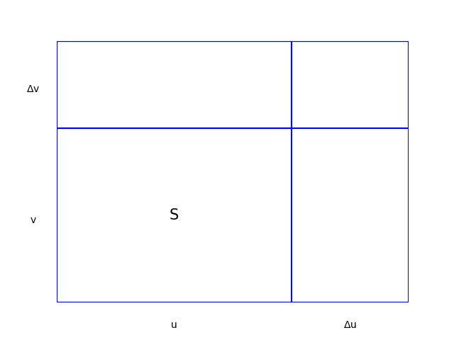

* Note:

1. Special formula：

Proof:

## Lecture 4 Chain Rule and Higher-Order Derivatives

1. Chain Rule:
2. Higher-Order Derivatives：

## Lecture 5 Implicit functions and Inverse