|  |  |  |
| --- | --- | --- |
| Assignment 2 Report |  |  |

**Date:** 22-May-2016

**Document Author:** Achana Weerathunga (100030272), Yan Hao (100026051)

Table of Contents

1. System Components 3

1.1 Book Inventory Service (BookInventorySOAP) 4

1.2 Student Service (StudentSOAP) 5

1.3 Book Information SOAP (Proxy service deployed on ESB) 5

1.4 Booking Ordering Process 6

1.5 Database 8

1. System Components

Component View –Following diagram depicts the high level component landscape of the BPEL process and downstream services.

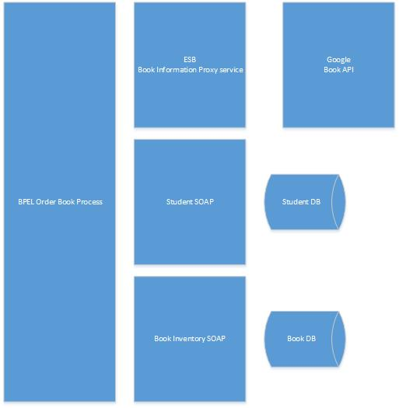

Figure – Component View

* 1. Book Inventory Service (BookInventorySOAP)

Book Inventory Service is a SOAP web service that exchanges SOAP messages in (XML form. This service functionality is depending on Book Database.

|  |  |
| --- | --- |
| End Point | validateBookOrder |
| Url | http://localhost:9763/services/BookInventoryServiceSOAP. BookInventoryServiceSOAPHttpSoap12Endpoint/validateBookOrder |
| Request Parameters | String isbn |
| Description | 1. Check is isbn number already there in the Book database (check in both isbn10, isbn13)    1. If not found return response, Positive    2. If found return response, Negative |

|  |  |
| --- | --- |
| End Point | addBook |
| Url | http://localhost:9763/services/BookInventoryServiceSOAP. BookInventoryServiceSOAPHttpSoap12Endpoint/addBook |
| Request Body | String bookTitle  String authorList  String isbn10  String isbn13  String publisherName  String publishDate  String bookStatus |
| Description | This is to add a new Book record in Book database and return the added book in the response   1. If book inserted in to book database successfully, return response, Positive 2. If found return response, Error with error description |

* 1. Student Service (StudentSOAP)

Student Service is a SOAP service that exchanges SOAP messages in (XML form). It is depending on Student Database and performing database operations.

|  |  |
| --- | --- |
| End Point (Operation) | Authenticate |
| Url | http://localhost:9763/services/StuentServiceSOPAStudentServiceSOAPHttpSoap12Endpoint/authenticate |
| Request Body | Integer studentId, Integer pin |
| Description | This is to authenticate student by student pin by retrieving student record from student Database  1 If the pin is match with studentId, then return response “Authentication Successful”  2 Else, return message Authentication failed. |

* 1. Book Information SOAP (Proxy service deployed on ESB)

This is a proxy service to call Google Book API that is deployed on ESB (WSO2 ESB server). This service fetches JSON from Google Book API and process and return XML response to the consumer.

|  |  |
| --- | --- |
| End Point | retrieveBookDetails |
| Url | http://localhost:9763/services/GooglrBookServiceREST. GoogleBookServiceRESTHttpEndpoint/ retrieveBookDetails |
| HTTP Method | GET |
| Request Parameters | String isbn |
| Description | 1. This is invoking Google Book API by passing apikey and isbn. 2. Process the Google Book API response return following information: 3. String isbnValidity 4. String bookTitle 5. String authorList 6. String isbn10 7. String isbn13 8. String publisher 9. String publishDate 10. String averageRating 11. String australianAvailablility     1. If the input isbn is invalid, the isbnValidity will return 0 and other information returned will be empty;     2. If the input isbn is valid, information of the matched book will be returned. |

* 1. Booking Ordering Process (BPEL)

Book Ordering is a BPEL process that invokes StudentSOAP, BookInventorySOAP and BookInformation proxy service to fulfil student Order Book scenario.

* Order Book
* Input:
  + studentId: int
  + pin: int
  + isbn: String
* Output:
  + status: String
  + title: String
  + author: String
  + publisher: String
  + reason: String (this field will be empty if the process succeeds)

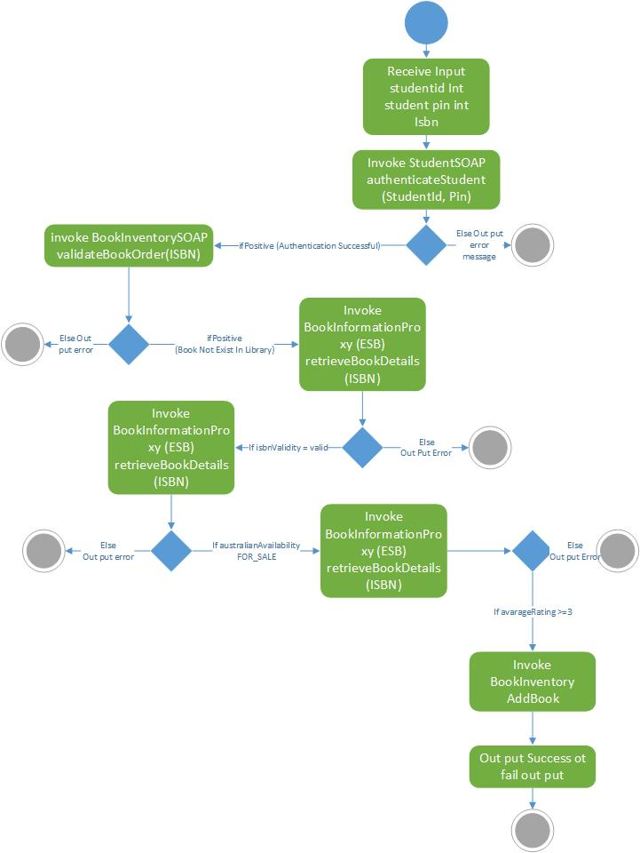

* 1. Database

The MySQL Database stores UniLab application data:

* Book Database
  + Book Table
* Student database
  + Student Table

