1) Explain SDLC at a high level

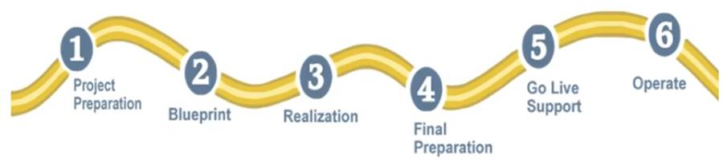

**Project Preparation**->project kick off presentation/meeting, high-level project plan to get things started

During this phase the team goes through initial **planning and preparation for project**.

Ex: If IBM is implementing SAP for BMW, then IBM is going to discuss about the business process with BMW (**Discuss and understand the business flow first**).

Just have a overview of **how many people are going to work on this particular system, scope of the project** (15 to 30 days)

Usually starts after you have the statement of work with your customer and you meet your customer to understand what is the project objective

**Business Blueprint**->Business blue print document where you have the process defined ,Function specification

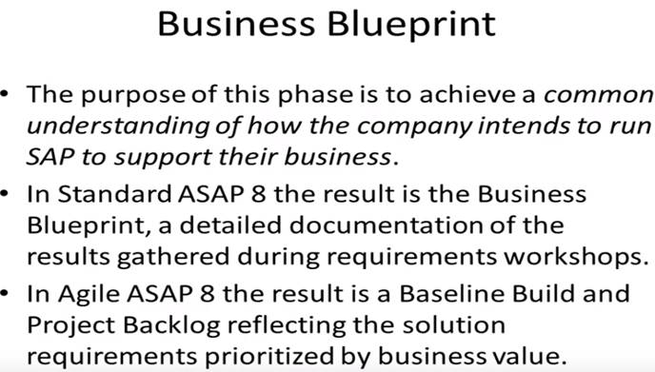

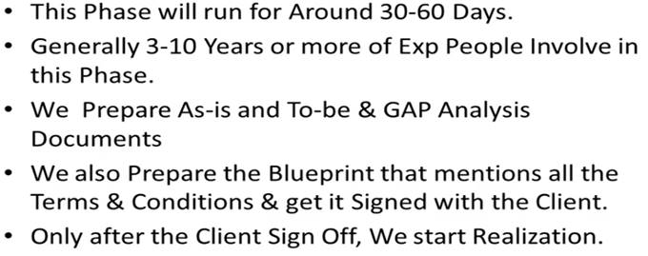

Understand what is as-is process and what's gonna be the to be state

**Realization**: Build, Unit Testing (Individual pieces testing), Integration testing (End to End),UAT

**Final Preparation**: Cutover process (Q->Training (Train the trainers))

**Go Live** (Technical go-live, Functional Go live (When users start using it))

**Post-Production Support**: Transition from project over the operations of this system ,this is when the users use the system and they may require some support from IT team

Waterfall vs Agile Methodology:

o    Waterfall is a linear plan. Everything is mapped out ahead of time and customers interact only at the beginning and at the end of the project.

This methodology is effective when customer knows scope of the project in advance, or when contract terms limit changes. Both customer and implementation team agree on what will be delivered early in the development lifecycle.

o   Agile is an iterative process, where new priorities and requirements are injected into the project after sprints and customer feedback sessions.

This methodology works when scope is not known in advance.

Machine generated alternative text:
ALIGNING PROJECT TRAITS with 
DEVELOPMENT METHODOLOGIES 
PROJECT 
TRAIT/FACTOR 
CUSTOMER 
AVAILABILITY 
SCOPE/ 
FEATURES 
FEATURE 
PRIORITIZATION 
TEAM 
FUNDING 
SUMMARY 
AGILE 
Prefers Customer available 
throughout project. 
Welcomes changes, but 
changes come at the 
expensive of Cost, Schedule, 
or other Features. Works 
well when scope is not 
known in advance. 
Prioritization by value 
ensures the most valuable 
features are implemented 
first, thus reducing risk of 
having an unusable product 
once funding runs out. 
Funding efficiency is 
maximized. Decreases risk 
of complete failure by 
allowing "partial" success. 
Prefers smaller, dedicated 
teams with a high degree 
of coordination and 
synchronization. 
Works extremely well with 
Time & Materials or other 
non-fixed funding, may 
increase stress in 
fixed-price scenarios. 
Agile is better, where it 
is feasible. 
PLAN • DRIVEN 
(WATERFALL) 
Requires customer involvement 
only at milestones. 
Works well when scope is known 
in advance, or when contract 
terms limit changes. 
"Do everything we agreed on" 
approach ensures the customer 
gets everything they asked for; 
"all or nothing" approach 
increases risk of failure. 
Team coordionation/ 
synchronization is limited 
to handoff points 
Reduces risk in Firm Fixed 
Price contracts by getting 
agreement up-front. 
Plan-Driven may reduce risk in 
the face of certain constraints 
in a contract between a vendor 
and external customer such as 
the government. 
COMMENTS 
Customer involvement 
reduces risk in either model. 
Change is a reality so we 
should prefer adaptability 
where possible. Contract 
terms sometimes restrict it. 
Contract terms may not 
permit partial success and 
may require "do everything". 
Teams that work together 
work better, but when con- 
tracts are issued to different 
vendors for different aspects 
of the project, high degrees of 
synchronization may not work. 
Fixed price is tough when 
scope is not known in 
advance, but many 
government contracts 
require it. 
Through educating our 
customers about the 
Strengths and weaknesses 
of each model, we hope to 
steer them towards a more 
Agile approach. This may 
require changes to how our 
customers, particualarly 
the government, approach 
software development 
projects. 

2) What is waterfall and why it is still relevant

**Waterfall methodology is a linear project management approach, where customer requirements are gathered at the beginning of the project, and then a sequential project plan is created to accommodate those requirements.**

**The Phases of the Waterfall Model**

o   It has different phases that follow in strict linear order, where a phase can’t begin until the previous phase has been completed.

**Requirements Gathering**:

o    customer requirements are gathered at the beginning of the project, allowing every other phase to be planned without further customer involvement until the product is complete.

o    It is assumed that all requirements can be gathered at this phase.

**Design:**

o    The design phase is best broken up into logical design and physical design subphases. The logical design subphase is when possible solutions are brainstormed and theorized. The physical design subphase is when those theoretical ideas and schemas are made into concrete specifications.

**Implementation:**

o   The implementation phase is when programmers assimilate the requirements and specifications from the previous phases and produce actual code.

**Verification:**

o   This phase is when the customer reviews the product to make sure that it meets the requirements laid out at the beginning of the project. This is done by releasing a completed product to the customer.

**Maintenance:**

o    The customer is regularly using the product during the maintenance phase, discovering bugs, inadequate features and other errors that occurred during production. The production team applies these fixes as necessary until the customer is satisfied

Each phase has to be completed before the next phase can begin, and phases are never repeated, unless there is a massive failure that comes to light in the verification or maintenance phase.

3) Explain Agile Model with a use case and the role of SCRUM in that

o   Agile differs greatly in these two areas, linear action and customer involvement.

o    Agile is a nimble (able to move quickly and easily ), iterative process where the product is delivered in stages to the customer for feedback and review.

o   Instead of having everything planned out by milestones, such as in waterfall, agile operates in “sprints” where prioritized tasks are completed in a short window, like 2-weeks.

o   These prioritized tasks are fluid  (not settled or stable; likely or able to change) and appear based on the success of previous sprints and customer feedback, rather than having all tasks prioritized at the onset in the requirements phase, like in waterfall.

4) Who is product owner & Scrum Master

Product Owner

o   A Product Owner works with the customer and implementation team to set direction.

o    He manages and make visible the product backlog,

o   Requirements are organized &  prioritized in the product backlog for future product development.

The Scrum Master

o   works with the Product Owner and the development team to ensure the team members can move forward with development with no   impediments, and that the Scrum practices are carried out.

o     Responsible for improving interactions between the [Scrum team](https://www.visual-paradigm.com/scrum/what-is-scrum-team/) and the organization in order to maximize the productivity of the Scrum team.

o     Arranges and facilitates (makes easier) the team’s meetings – [daily Scrum](https://www.visual-paradigm.com/scrum/daily-scrum-meeting-quick-guide/), planning sessions, [sprint retrospective](https://www.visual-paradigm.com/scrum/what-is-sprint-retrospective-meeting/), and etc.

5) Differentiate between Product/Sprint Backlog

**Features** are written from the perspective of end user therefore features are known as **User story**.

The **collections of all these user stories** is called **product backlog**.

product backlog is like wish list ,have all the features to make this product great

Once we have a wish list /product backlog we need to start planning which specific user story is going to putting into a particular release of our product

6) What is Epic & Story & Task

**Epic**: A customer described software feature, that is itemized in the product backlog is known as epic. Epics are sub-divided into stories

**User Stories**: From the client perspective user stories are prepared which defines project or business functions, and it is delivered in a particular sprint as expected.

**Task**: Further down user stories are broken down into different task

7) What is called Velocity in SCRUM

Velocity is a metric that is calculated by addition of all efforts estimates related with user stories completed in an iteration. It figures out how much work Agile can complete in a sprint and how much time will it need to finish a project.

8) Explain the SCRUM ceremonies

Scrum requires self-organizing teams that can quickly solve problems in unpredictable environments. In order to provide transparency and regular communication in the midst of such environments, scrum ceremonies are held. Scrum ceremonies are meetings that are unique to scrum teams.

Scrum ceremonies ensure that everyone (the scrum master, product owner and development team) is in-sync. These ceremonies are held at key instances in a sprint, which we’ll outline below.

**The Four Scrum Ceremonies**

Scrum is executed in what are called sprints, or short iterations of work lasting usually no more than two weeks. A sprint use four different scrum ceremonies to ensure proper execution

o   **Sprint Planning**: This is where the team meets and decides what they need to complete in the coming sprint

o  **Daily Scrum**: This is a standup meeting, or a very short – 15-minute mini-meeting – for the team to make sure they’re all on the same page.

o   **Sprint Review**: This is another type of meeting, but one in which the team demos what they shipped in the sprint.

o  **Sprint Retrospective**: This is when the team reviews their work, identifying what they did well and what didn’t go as planned, so they can make the next sprint better.

[From <https://www.projectmanager.com/blog/guide-to-scrum-ceremonies>](https://www.guru99.com/images/2/agile_testing_interview_questions.png)

9) What is grooming (Preplanning)

o  **Grooming** (or refinement) is a meeting of the Scrum team in which the product backlog items are discussed, and the next sprint planning is prepared.

o   the grooming involves splitting big items into smaller ones, rewriting backlog items to be more expressive, deleting obsolete or no more need items, and so on.

o   Product grooming is critical in product management because it means keeping the backlog up to date and getting backlog items ready for upcoming sprints.

10) How Jira board is effective in SCRUM

WHAT IS A BOARD?

o   The Jira Scrum Board is the tool that unites teams around a single goal and promotes iterative, incremental delivery.

o   A board displays issues from one or more projects in columns that represent the team's process.

o   They provide the team with a shared view of all work that hasn't started, work that is in progress, and work that is completed.

WHICH BOARD TYPE SHOULD I CHOOSE?

The three board types are:

|  |  |
| --- | --- |
| **Scrum boards** | Manage stories, tasks, and, and bugs in sprints  Suits teams that deliver work on a regular schedule |
| **Kanban boards** | Manage stories, tasks, and bugs in a continuous flow  Suits teams who control work volume from a backlog |
| **Agility boards** | Manage tasks with a flexible, simple board  Suits teams that are new to agile, or teams that don't want to spend much time configuring things |

11) Differentiate between SCRUM & Waterfall

o   **Scrum**: In the scrum, a sprint is a basic unit of development. Each sprint is followed by a planning meeting, where the tasks for the sprint are identified and estimated. During each sprint, the team creates finished portion of a product

o   **Agile**: In Agile, each iteration involves a team working through a full software development cycle, including planning, design, coding, requirement analysis, unit testing, and acceptance testing when a product is demonstrated to stakeholders

In simple words, Agile is the practice and scrum is the process to following this practice.

12) Explain the responsibilities of Product Owner

A Product Owner works with the customer and team to set direction.

Product Owner role is to represent the customer to the development team.

A key activity is to manage and make visible the product backlog, or the prioritized list of requirements for future product development.

A Scrum Product Owner is responsible for maximizing the value of the product resulting from the work of the Development Team.

The Product Owner is the sole person responsible for managing the Product Backlog. Product Backlog management includes:

o   Clearly expressing Product Backlog items.

o   Ordering the items in the Product Backlog to best achieve goals and missions.

o   Optimizing the value of the work the Development Team performs.

o   Ensuring that the Product Backlog is visible, transparent, and clear to all, and shows what the Scrum Team will work on next.

o   Ensuring the Development Team understands items in the Product Backlog to the level needed.

The Product Owner may do the above work or have the Development Team do it. However, the Product Owner remains accountable.