Flex box

Open the exercise folder and look at the html and css files in your editor.

Now open the index.html in your browser. Your first job is to use flex box to get the three rows (tools, main and about) to work as a three column layout.

1. Set the div surrounding the three rows (container) to display: flex;  
   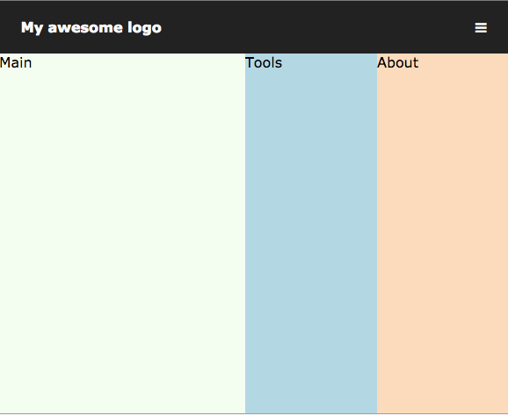

2) Give the tools and about divs a fixed width of 150px and then using css flex box get the main div to then fill the remainder of the space. (hint flex-grow)

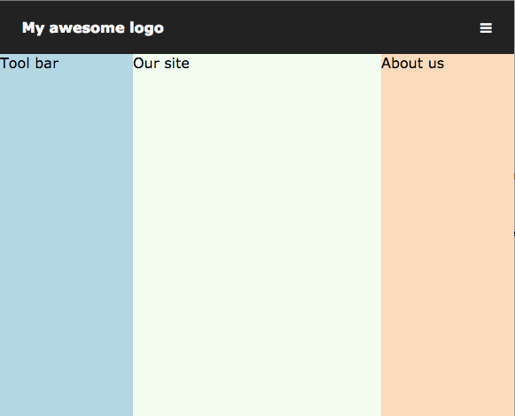

3) Can you change the order of the columns using css so they appear tools - main -about?

The layout should dynamically resize main to fit the available space but for smaller screen sizes we want to have the toolbar at the top and the about at the bottom.

By adding a couple of css rules to our mediaqueries.css can you get the layout to look like this on smaller screen sizes?