Contributor: Haoda Yu (Idea and code), ChatGPT (Part of code)
In this report, question 2,6,8 has used Haoda Yu’s N number as random seed (11375906).

- H₀: Explicitly rated songs are not popular than songs that are not explicit.
H₁: Explicitly rated songs are popular than songs that are not explicit.
For question 2 we first divide data into two sets “Explicit Rated (E)” and “Non-Explicitly Rated (non-E)”, E group has 5597 songs and non-E has 46403 songs. Next, we do the following steps 1000 times (use Haoda Yu’s N number as seed), do down sampling non-E songs number to equal the E songs number, then do a U test to these two sets of data. After this we calculate the mean value of U statistic and p-value.
We choose this procedure because two sets of data have significant difference on variance and are both not normal distribution, so U test is the best choice here also down sampling can compensate for the imbalance in data volume and doing it 1000 times then take the mean value can give us a more robust result.
Finally, we have average U statistic = 16806045.6165, Average p-value = 8.45*10⁻⁹. With the extremely low p-values from Mann-Whitney U test, we may confidently reject the H₀ and accept the H₁. This leads us to conclude that explicitly rated songs are popular than songs that are not explicit.

For question 6 we first import those 10 columns data and standardize them (StandardScaler) then we apply PCA to them with 95% confidence interval. Next, we calculate the total number of principal components and each components explained variance ratio. We got 8 principal components, in these components there are only 3 can be consider as meaningful principal components with cumulative variance ratio of 57.36% (Table 1). We have also drawn a cumulative variance graph (Graph 1), we can find at least two elbows (approx. at [2,0.6] and [6,0.9]) from the graph by eyeball it. Then we use iterations try to find the best silhouette scores and number of clusters by try it from 2 to 20 (use Haoda Yu’s N number as K means seed), finally we have best number of clusters at 2 and score of 0.4066. With these principal components, we finally find 2 clusters. This is far less than the genre (52) we have.
So, the result is that from 10 features we can extract 3 principal components, they have total 57.36% proportion, and with these principal components we can divide them into 2 clusters. But it is unable to genre labels in column 20.
Tabel 1
Principal Component | Explained Variance Ratio | Cumulative Variance Ratio
1 | 0.2734 | 0.2734
2 | 0.1617 | 0.4351
3 | 0.1385 | 0.5736
4 | 0.0980 | 0.6715
5 | 0.0875 | 0.7591
6 | 0.0815 | 0.8405
7 | 0.0678 | 0.9084
8 | 0.0472 | 0.9555
Graph 1
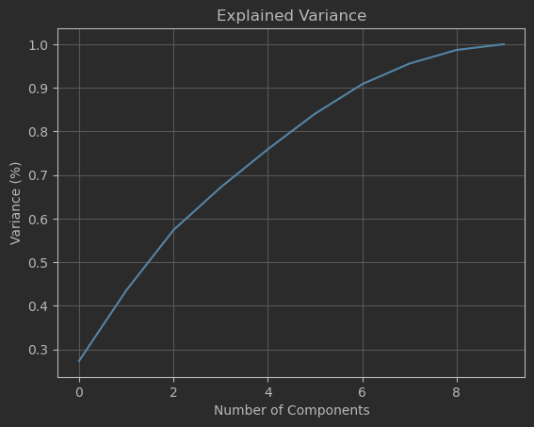

Considering we have only 2 clusters from question 6 result, this would be a big challenge to predict genre and may lead to a result with bias. So, we decided to use 10 features mentioned in question 4 to predict the genre. Here we choose to use a classification model called random forest to do the prediction work.
In this step we first import the data and standardize them (StandardScaler) and use test number = 0.3, which means 70% of data would be random (Haoda Yu’s N number is random seed) selected and used to training model and 30% left will be used to test model’s performance. Next, we create a random forest classifier (Use Haoda Yu’s N number as random seed) to classified data with estimator of 100 (we have tried 10,100,1000, from 10 to 100 there is like 5% of accuracy benefit but increase it to higher number would not have much prediction accuracy increase, so the best accuracy/time is 100).
After doing this, we have a model of 35.78% accuracy, this is too low and not accurate enough do any genre classification work. The performance of this model is not very well, our expected accuracy should be higher than 50%.

