- H₀: High-popularity movies rated not higher than low-popularity movies.
H₁: High-popularity movies rated higher than low-popularity movies.
D:
Based on the median number of ratings (197.5), divide movies into two data sets: high-popularity and low-popularity. We have 200 movies in each data sets.
Use Kolmogorov-Smirnov (K-S) test to do the normality check for ratings in both data sets.
Use Welch’s t-test to compare the ratings of two data sets, because both two data sets are normal distributed, but the sample variances are different.
Use Mann-Whitney U test for robust and compare the result to Welch’s t-test.
Y:
Use the median number of ratings to divide movies into two data set, make sure the comparison between high-popularity movies and low-popularity movies has no bias.
Use K-S test to determine an appropriate statistical test to use when comparing the ratings, because some tests depend on the distribution of the data. (Reason for not using Shapiro-wilk test: large sample size)
Chose Welch’s t-test instead of t-test because two data sets are both normal distributed, but the sample variances are different.
Use Mann-Whitney U test to verify the results from Welch’s t-test, adding robustness to the result.
F:
High-popularity movies: K-S test p-value = 0.238, sample variance = 0.085
Low-popularity movies: K-S test p-value = 0.571, sample variance = 0.053
These results indicate that both data sets are normally distributed but have different sample variances.
Welch's T-test: p-value = 9.537 * 10⁻⁵², T-test statistic = 17.756
Mann-Whitney U test: p-value = 1.697 * 10⁻⁴⁰, U value = 35404
The Welch’s t-test and Mann-Whitney U test results both strongly reject the H₀ and accept H₁.
A:
With the extremely low p-values from both Welch's t-test and the Mann-Whitney U test, we may confidently reject the H₀ and accept the H₁. This leads us to conclude that high-popularity movies rated higher than low-popularity movies.
- H₀: New movies not rated differently than old movies.
H₁: New movies rated differently than old movies.
D:
Based on the median years of movie published (1999), divide movies into two data sets: new movies and old movies. We have 174 new movies and 226 old movies.
Use histogram and Q-Q plot check the average rating distribution of new movies and old movies. (Figure 1)
Use Kolmogorov-Smirnov (K-S) test to do the normality check for distribution in both data sets.
Randomly pick 174 samples from old movies (Down sampling).
Conduct a t-test and Mann-Whitney U with new movies to compare whether there are differences in ratings.
Do the down sampling 100000 times and compute the mean of 100000 result.
Y:
Use the median year of movie published to divide movies into two data set, make sure the comparison between high-popularity movies and low-popularity movies has no bias.
Use histogram and Q-Q plot to check the distribution can give people an intuition feeling about the data distribution. (Figure 1)
Use K-S test to determine an appropriate statistical test to use when comparing the ratings, because some tests depend on the distribution of the data. (Reason for not using Shapiro-wilk test: large sample size)
Use down sampling is because the sample size is not equal 174≠226.
Use t-test because these two datasets are both normal distributed.
Use Mann-Whitney U test to verify the results from t-test, adding robustness to the result.
F:
New movies: K-S test p-value = 0.347, skewness: 0.134, sample variance: 0.127
Old movies: K-S test p-value = 0.124, skewness: 0.287, sample variance: 0.121
Histogram and Q-Q plot shows these two sets of data appears to have same distribution. (Figure 1)
These results indicate that both data sets appear to have same distribution and has a quasi-normal distribution.
After 100000 times down sampling:
T-test average: p-value = 0.317
Mann-Whitney U average: p-value = 0.316
The t-test and Mann-Whitney U test results both reject the H₁ and accept H₀.
A:
With the very close p-values from both t-test and the Mann-Whitney U test, we may confidently reject the H₁ and accept the H₀. This leads us to conclude that new movies not rated differently than old movies.
- H₀: Male and female viewers do not rate Shrek (2001) differently.
H₁: Male and female viewers do rate Shrek (2001) differently.
D:
Divide sample into two groups: male and female. We have 743 females and 241 males.
Use histogram and Q-Q plot check the rating distribution. (Figure 2)
Use Kolmogorov-Smirnov (K-S) test to do the normality check for distribution in both data sets.
Randomly pick 241 samples from female ratings. (Down sampling)
Conduct a Mann-Whitney U test.
Do the down sampling and Mann-Whitney U test 100000 times and compute the mean of 100000 result.
Y:
Use gender to dived viewer’s ratings is the most appropriate control group.
Use histogram and Q-Q plot to check the distribution can give people an intuition feeling about the data distribution. (Figure 2)
Use K-S test to determine an appropriate statistical test to use when comparing the ratings, because some tests depend on the distribution of the data. (Reason for not using Shapiro-wilk test: large sample size)
Use down sampling is because the sample size is not equal 241≠743.
Use Mann-Whitney U test because both male and female dataset are not normally distributed. Take the mean value of 100000 times result make result more robust.
F:
Female ratings: K-S test p-value = 4.065*10⁻⁸, statistic:0.180
Male ratings: K-S test p-value =2.461*10⁻⁰⁷, statistic:0.190
Histogram and Q-Q plot shows these two sets of data does not have normal distribution. (Figure 2)
These results indicate that both data sets do not have normal distribution.
After 100000 times down sampling:
Mann-Whitney U average: p-value = 0.172
The t-test and Mann-Whitney U test results both reject the H₁ and accept H₀.
A:
With p-values > 0.005, we may reject the H₁ and accept the H₀. This leads us to conclude that male and female viewers do not rate Shrek (2001) differently.
- H0: Male and female viewers do not rate movies differently.
H1: Male and female viewers do rate movies differently.
D:
Divide sample into two groups: male ratings and female ratings.
For each movie:
Use Kolmogorov-Smirnov (K-S) test to do the normality check for distribution in both data sets.
Compare male and female sample sizes and down sampling.
If both datasets are normal distributed: Conduct a Welch’s t-test.
Else: Conduct a Mann-Whitney U test.
Compute the mean of 1000 result.
Y:
Use gender to dived viewer’s ratings is the most appropriate control group.
Use K-S test to determine an appropriate statistical test to use when comparing the ratings, because some tests depend on the distribution of the data. (Reason for not using Shapiro-wilk test: large sample size)
Use down sampling is because sometimes the sample size is not equal.
Use Mann-Whitney U test for not normally distributed data. Take the mean value of 10000(It takes about 25 mins. Insufficient computing power, otherwise, we would compute 100000 times) times result make result more robust.
Use Welch’s t-test for normally distributed data. Take the mean value of 10000 times result make result more robust.
F:
After 10000 times down sampling:
33 of movies was rated different by male and females.
367 of movies was rated no different by male and females.
This would reject the H₀ and accept H₁.
A:
With those samples which has p-values > 0.005, we may reject the H₁ and accept the H₀. This leads us to conclude that Male and female viewers do rate movies differently. There are only 9% (33/367) of movies are rated different by male and female viewers.
Appendix
Figure 1
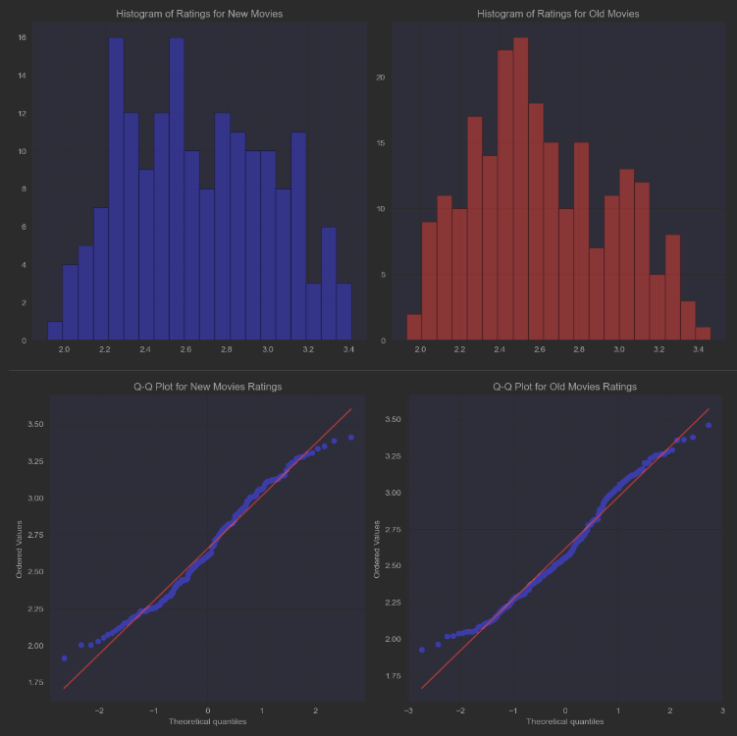
Figure 2
