- D:
Based on the data we have, first check completely empty rows, remove completely empty rows.
Compute arithmetic mean of row and columns and fill it into empty cells for all movie ratings.
Create a regression model for each movie based on other 399 movies’ rating.
Save COD result to a .csv file.
Compute average COD of those 400 simple linear regression models.
Draw histogram for COD values.
Find how many movies regression models has COD values lower than 0.5 and 0.6.
Y:
Remove completely empty rows: because we cannot blend completely empty rows by compute arithmetic mean.
Compute arithmetic mean to fill empty cell is the only method we could choose.
Based on other 399 movie can find best fit regression model.
Save COD result to a .csv file so we may use it later.
Drawing a histogram of COD values can give us an intuitive and easy-to-understand result.
Find how many movies regression models has COD values lower than 0.5 and 0.6 can gave us a better understanding of COD value distribution.
F:
Row 896 is the only completely empty row.
The best fit regression model for 400 movies has been found.
The average COD of the 400 simple linear regression models = 0.424.
Number of COD values below 0.5: 265
Number of COD values below 0.6: 339
Number of COD values below 0.7: 391
According to Figure 1, the histogram shows most of movie has less than 0.5 COD value.
According to Figure 2, the table shows 10 most predictable movies and 10 least predictable movies.
The first 8 movies in top 10 most predictable movies are highly related to each other (They become a group in 2, in other words they can predict each other.), but top 10 less predictable movies have not relations to each other.
A:
According to all these information and findings, we may conclude that most of movies seems like have no relations to each other (339/400 have COD values lower than 0.6, 9/400 has COD value higher than 0.7). But the reason due to this result might be the dataset is not good enough (Too much null value exists so we must use arithmetic mean to fill the empty.), or we need a better model to do the prediction.

D:
Add row 475, 476, 477 as additional predictor.
Remove any empty cell row in column 475-477.
Use 399+3 columns of movie rating data build regression model, just like we did in previous part.
Save result and compare with previous part.
Create scatter plot.
Y:
The data in 475-477 columns can not be blend-and-fill into empty cells, because these values are not ratings, they have special meaning.
Adding 3 more columns and do regression again to analyze if there are any connections between those values.
F:
The R² value of regression model has changed very slightly. See Figure 3.
The scatter plot shows the relationship between COD and R²
A:
Adding more predictors to the regression model to build a multiple regression model does not make the result change very much (Actually we could even ignore those value changes, because they are too small.). And if we draw a fit line on Figure 4(The scatter plot), the line will be cross through the plot from bottom left to the top right (slope is close to 1 which means result not changes with more predictors.), this could explain that even we add more predictors to the regression model the result would not changes too much.
Appendix
Figure 1
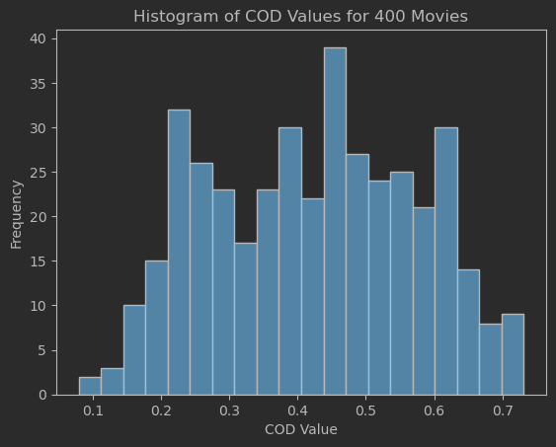
Figure 2
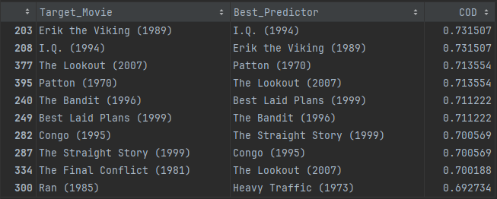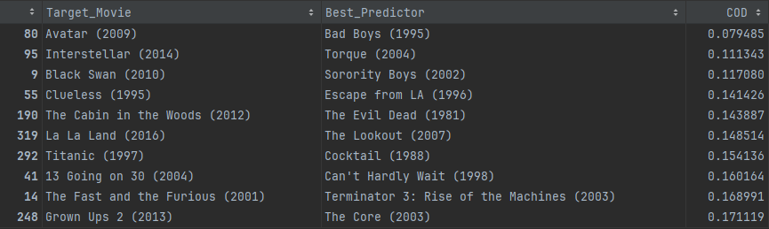
Figure 3
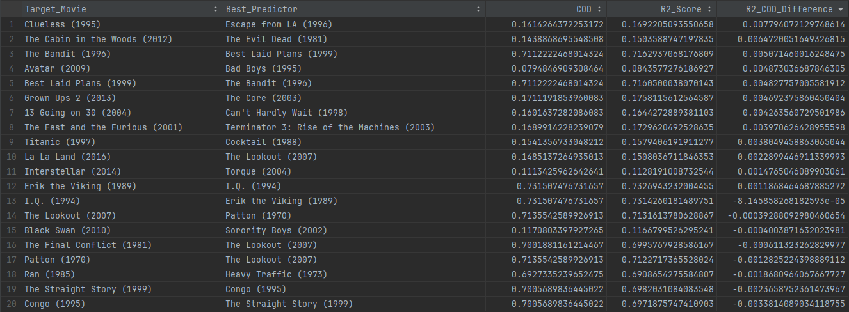
Figure 4
