How to trigger microservice applications within Apama Analytics Builder via HTTP request

In some cases, while developing a business rule using Apama Analytics Builder it is very useful to trigger actions of a pre-deployed microservice to get further calculations or information of a 3rd party system

For doing this a HTTP communication between Apama Analytics Builder workbench and microservices is recommended.

**Requirements:**

* A Cumulocity tenant with a suitable apama-ctrl microservice subscribed (custom blocks are not supported with apama-ctrl-starter).
* An uploaded microservice with http access endpoints
* Software AG Designer with a local install of Apama (either Software AG suite or Community Edition)
* Http example block as draft, checkout at <https://github.com/SoftwareAG/apama-analytics-builder-block-sdk/blob/master/samples/blocks/HttpOutputBlock.mon>.

**Preparation steps**

1. Open the Analytics Builder example project from GitHub with the Http sample monitor using Software AG Designer.
2. Extend the http request functionality by the access endpoint of your microservice. For example, defining a new GET function, e.g. to get a calculated uuid-value from the microservice, it would look like this:

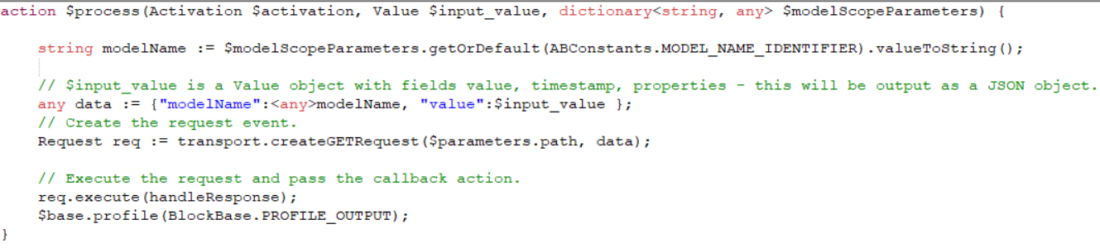

1. Deploy your http block to your Cumulocity tenant using the Apama Command Prompt like described in <https://github.com/SoftwareAG/apama-analytics-builder-block-sdk/blob/master/doc/030-BuildingExtensions.md>.

Build and upload an extension to a Cumulocity IoT instance.

Apama cmd prompt:

analytics_builder build extension --input samples/blocks --output sample-blocks.zip

analytics_builder upload extension --cumulocity_url https://demo.cumulocity.com/ --username tenantID/user --password <password> --input <path to zip file>

1. Go back to your Cumulocity tenant and open the Analytics Builder App. Create a new Model and search for your Analytics Block name.
2. Add your block to your analytics workflow and use the http response for further analytics or e.g. send the output as new measurement or event.