Max Krause

Kreause electric cars  3 Cherrywood Cres Llanarth

Krause Electric Cars Detailed design report

# Contents:

Concept Map 3

User-friendly Navigation and Interface: 3

Content Clarity: 3

Professional Design Reflective of Brand: 3

Validation of HTML and CSS Files: 3

Folder Structure for File Organization: 3

Index – Main Page 4

About: 4

Resume 4

Web Skills 4

Products 4

Car1 4

Car2 4

Gallery 4

CSS Design: 5

Navigation Map & Structure Chart 11

Story Boards 12

Index – Main Page 12

About: 13

Resume 14

Web Skills 15

Products 16

Car1 17

Car2 18

Gallery 19

Testing Plan: 22

Functional Testing: 22

Compatibility Testing: 22

Performance Testing: 22

Performance Testing: 22

Code consistency and quality testing. 22

Index.html 22

Web Skills.html 25

Products.html 26

Falcon.html 27

Skyline.html 28

Gallery.html 29

Style.CSS 30

**This page is left blank intentionally.**

# Concept Map

In order to ensure an efficient and user-friendly interface, a number of design elements must be carefully considered when creating a website for Krause electric cars. The basic qualities required to create a website of that kind are described in this report, with an emphasis on technical integrity, visual appeal, content clarity, and usability. In order to make sure that the marker can see the styling, I have chosen to use a wide range of conflicting colours for this assignment.

### User-friendly Navigation and Interface:

For any website to be useable by people and kept in and of a manner that allows for this navigation and interface must be taken into account at the design stage to ensure this requirement is met.

Users should be directed to the various sections of the website that are of greater importance with clear and concise use of the tools web developers have at their disposal.

### Content Clarity:

The information on the website should be clear, concise, and educational, giving users all the knowledge they need to understand Krause Electric Cars. This comprises:

Concise Descriptions: Product, service, and company information should be described succinctly to avoid confusing visitors with too much information.

Visual Aids: By including pertinent photos and videos, you can visually engage visitors and highlight important points, which will improve their comprehension of Krause Electric Cars, such as a logo image.

### Professional Design Reflective of Brand:

The website should have a professional feel to it and should represent the brand identity of Krause Electric Cars.

Components of Branding: The website's use of the Krause electric cars logo, colour scheme, and typography upholds brand recognition and brand consistency.

Clean Design: A design style that is simple and uncluttered helps to project professionalism and keeps visitors from becoming sidetracked or confused.

### Validation of HTML and CSS Files:

Ensuring the validity of external CSS files and HTML is essential. To find and correct any mistakes or inconsistencies, validation will be carried out using W3C Markup Validation Service and the W3C CSS Validation Service fro both my HTML code and CSS.

### Folder Structure for File Organization:

Maintainability and accessibility are improved by arranging graphics, text, HTML files, and other resources in a sensible folder structure.

Best practices consist of:

Different Folders: For the use case of keeping related and unrelated content easily accessible and organised as well as differentiated, I will create distinct folders for images, documents, CSS files, and HTML files aswell as any other assets I may use.

Descriptive Naming: To ensure clarity and ease navigation, give folders and files descriptive names pertinent to their expected content this way they are easily identifiable in future.

For a more detailed and professional feel for the website and more overall applicable content I have opted to add extra pages for more informed navigation my initial concept is as follows:

### Index – Main Page

This will act as the landing page for the website displaying majority of the navigation In the body aswell as other key navigation requirements in the to be designed header.

### About:

An expanded about page containing neater, better formatted text, I am planning to use a fixed container width in order to achieve this.

### Resume

For this variant of the website rather than using href for my resume and my feedback form I plan to integrate a PDF embedded into the browser to which it can be viewed and downloaded.

### Web Skills

The web skills page will be mainly unchanged with minor styling fixes added to brin git upto speed with the new website theme.

### Products

The products page will contain information regarding the services Krause electric cars offers in regards to vehicular restoration, I may transition this into a portfolio page in

### Car1

An example of the work that the company has been able to produce with a detailed breakdown of what has been done to keep styling up to date.

### Car2

An example of the work that the company has been able to produce with a detailed breakdown of what has been done to keep styling up to date.

### Gallery

A large page that has will contain all of the images used across the page with descriptive captions and alt text.

# CSS Design:

The header section is comprised of two sections “header’ which has the following CSS

header {

background-color: #241E20;

color: #fff;

padding: 10px ;

display:flex;

justify-content: space-between;

align-items: center;

} and “.container_head”.

.container_head {

background-color: #241E20;

padding: 20px;

}

Using “header” to organise my buttons and “.container_head” to contain and format my banner image.

The body section makes use of a CSS Element

.container_body {

background-color: #D3D3D3;

padding: 20px;

This allows me to place one large container as my body section with a nice off white colour and 20px padding all round within this I can include extra sections such as the section just prior to the footer.

.container {

max-width: 1200px;

margin: 0 auto;

padding: 20px;

box-sizing: border-box;

color: #fff;

}

.portfolio {

display: grid;

grid-template-columns: repeat(auto-fit, minmax(250px, 1fr));

gap: 20px;

}

.portfolio-item {

background-color: #black;

box-shadow: 0 2px 4px rgba(0, 0, 0, 0.1);

border-radius: 8px;

overflow: hidden;

transition: transform 0.3s ease;

}

.portfolio-item:hover {

transform: translateY(-5px);

}

.portfolio-item img {

width: 100%;

height: auto;

display: block;

}

.portfolio-item-content {

padding: 20px;

}

.portfolio-item-title {

font-size: 1.2rem;

margin-bottom: 10px;

color: black;

}

.portfolio-item-description {

font-size: 0.9rem;

color: #241E20;

}

This section used these CSS rules to format and create nice buttons that include images or videos for nice navigation of the website.

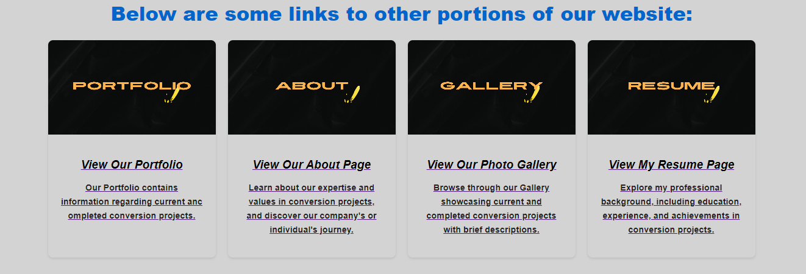

My Footer contains basic styling elements such as a background colour, padding and text alignment.

footer {

background-color: #241E20;

color: #fff;

padding: 10px 0;

justify-content: space-between;

text-align: center;

}



# Navigation Map & Structure Chart

The Navigation Map & Structure Chart are too large to be included in this document so please access them in the documents folder or below in the attached .zip.



The Navigation Structure begins on the home page (Index.html) and lays out the main clickable features on the home page that lead to other areas of the webpage via means of navigation, the home page will consist of buttons within the header that will take the user to the main pages of the website, This will include Home, Resume, Web Skills, About and Gallery. I have included extra containers in the body as supplementary navigation method to this I will include secondary navigation items which include images within containers with brief descriptions about the page to better represent the page the customer is about to navigate to.

Navigation continues from index to Resume; on this page the customer is greeted with the same header design as well as a pdf viewer embed of my resume this will allow them to download it as well as view and scroll between pages of my resume as any browser pdf viewer would handle it. Following this If the user scrolls down they will be greeted with a table including my subject and results – for the purposes of this I have only included ITC 293 as my account is on hold and I cannot access my results. Following this scrolling further down will reveal an embedded form the user can sue to leave feedback on the resume.

Following on from resume we continue to the about page the user will be greeted with the same header and banner design shortly below this will be a short blurb about Krause Electric Cars and their industry statement as well as the content from assessment 2 this will be neatly formatted into a container to keep the paragraph to a fixed page width. The same styling will apply to the assessment 2 content.

Completing navigation from the about page leaves the user with one more menu item to click, that being the gallery item, the gallery page will use containers formatted as gallery items each displaying the images that are being used across the website in a neat 3 wide format scrolling until there are no more images to display, each container will have a caption section which will have a description in place to describe the contents of the image to the user.

Extras:

Extra navigation points come in the form of footer containers at the bottom of some of the main pages these will use looped videos to create an eye catching effect. This will be mainly used to gather attention to the Portfolio page for the business allowing the business to show off their conversion projects and explain their worksmanship.

# Story Boards

### Index – Main Page

### 

This will act as the landing page for the website displaying majority of the navigation In the body as well as other key navigation requirements in the to be designed header.

Body content for this page will mostly consist of information about what the brand can achieve and what they strive to do.

On each major page I would like to implement videos displayed within containers that draw in the users eye encouraging navigation to other areas of the website.

### About:

### Resume

### Web Skills

### Products

### Car1

### Car2

### Gallery

# Testing Plan:

## Functional Testing:

Test all links to ensure they navigate to the correct pages.

Verify forms (Feedback Form) for proper submission and validation.

Check interactive elements such as buttons, hyperlinks, and images for functionality.

## Compatibility Testing:

Test the website on different browsers (Chrome, Firefox, Safari, Edge) to ensure compatibility.

Test on different devices to ensure responsiveness.

Verify compatibility with different operating systems (Windows, MacOS).

## Performance Testing:

Test website loading times.

Check for any slow-loading elements or pages.

## Performance Testing:

HTML & CSS Validation.

# Code consistency and quality testing.

Index.html

About.html

Resume.html

Web Skills.html

