Index:

Contains links or navigation to different sections or pages my website.

Acts as the starting point for accessing other pages.

May include a brief overview or summary of the website's content.

Main Page:

Central hub of the website.

Provides an overview of the website's purpose and content.

Includes links or navigation to various sections such as about, resume, web skills, etc.

MK_A1_About:

Provides detailed information about the purpose of the website.

Could feature a photo or other visual elements to complete the page.

MK_A1_Resume:

Will Most likely have a link to my resume as displaying page content so long is inadequate.

Web Skills:

Will display certain aspects of html to display ones competency within web development.

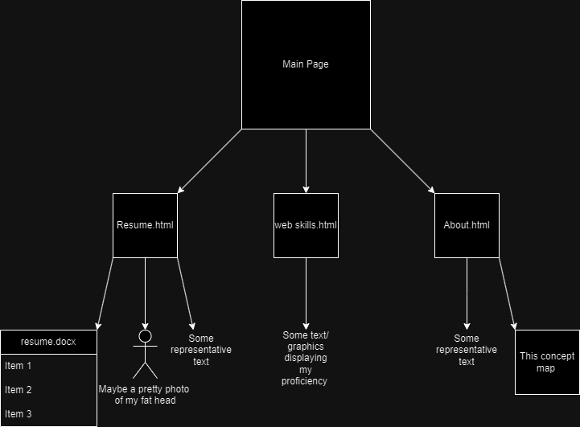Introduction:

In order to ensure an efficient and user-friendly interface, a number of design elements must be carefully considered when creating a website for Krause electric cars. The basic qualities required to create a website of that kind are described in this report, with an emphasis on technical integrity, visual appeal, content clarity, and usability. In order to make sure that the marker can see the styling, I have chosen to use a wide range of conflicting colours for this assignment.

1. User-friendly Navigation and Interface:

This is essential to make sure users can quickly browse the website and locate the information they need. Important sections consist of:

Users should be directed to the various sections of the website, such as About Us, Products, Services, Contact, etc., by clear navigation menus and labels.

2. Content Clarity:

The information on the website should be clear, concise, and educational, giving users all the knowledge they need to understand Krause Electric Cars. This comprises:

Concise Descriptions: Product, service, and company information should be described succinctly to avoid confusing visitors with too much information.

Visual Aids: By including pertinent photos and videos, you can visually engage visitors and highlight important points, which will improve their comprehension of Krause Electric Cars' products.

3. Professional Design Reflective of Brand:

The website should have a professional feel to it and should represent the brand identity of Krause Electric Cars. This includes:

Components of Branding: The website's use of the Krause electric cars logo, colour scheme, and typography upholds brand recognition and brand consistency.

Clean Design: A design style that is simple and uncluttered helps to project professionalism and keeps visitors from becoming sidetracked or confused.

4. Validation of HTML and CSS Files:

Ensuring the validity of external CSS files and HTML is essential to preserving technical compatibility and integrity across various web browsers. To find and correct any mistakes or inconsistencies, validation should be carried out using resources like the W3C Markup Validation Service and the W3C CSS Validation Service.

5. Folder Structure for File Organization:

Maintainability and accessibility are improved by arranging graphics, text, HTML files, and other resources in a sensible folder structure. Optimal procedures consist of:

Different Folders: For the purpose of keeping related content easily accessible and organised, create distinct folders for images, documents, CSS files, and HTML files.

Descriptive Naming: To ensure clarity and ease navigation, give folders and files descriptive names.

In summary, usability, content clarity, visual appeal, and technical integrity must all be carefully considered when creating a portfolio website for Krause electric vehicles. Through the implementation of the previously mentioned characteristics and adherence to industry best practices, the resultant website will proficiently exhibit the Krause electric cars brand and its offerings, all the while offering users an effortless and captivating experience.

Main:

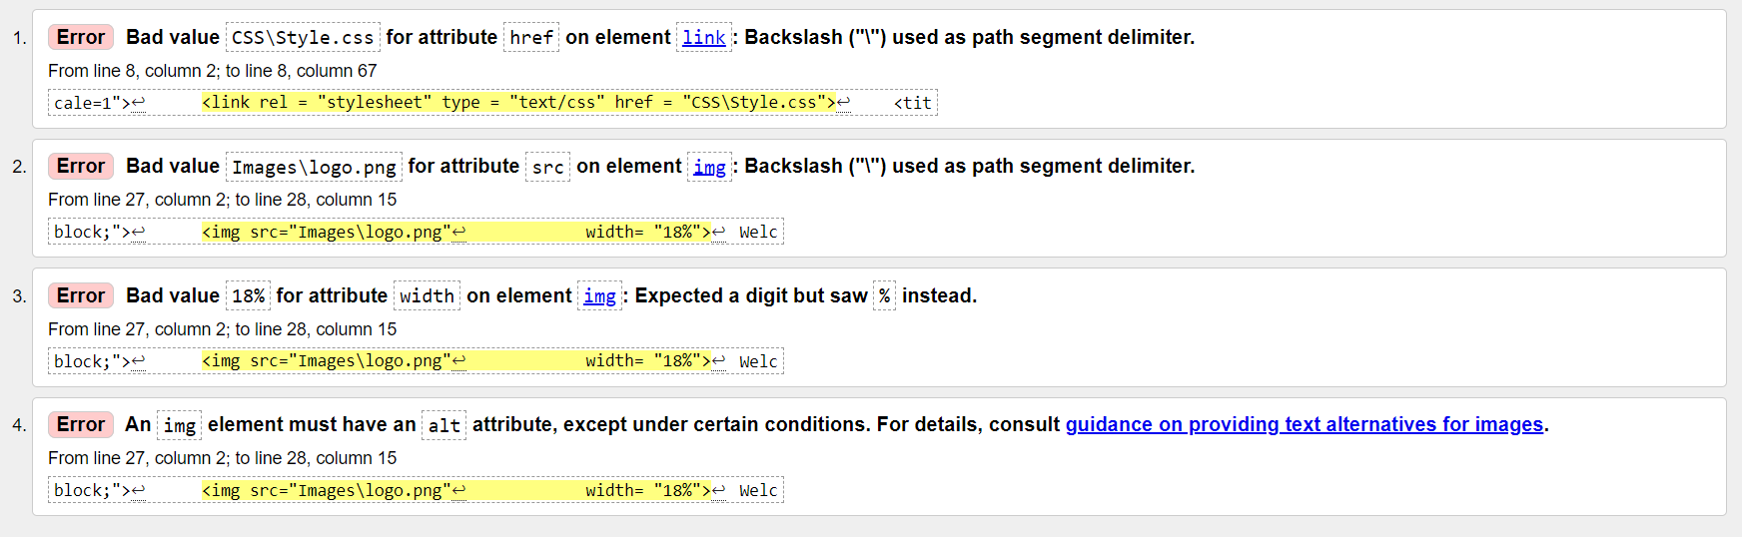

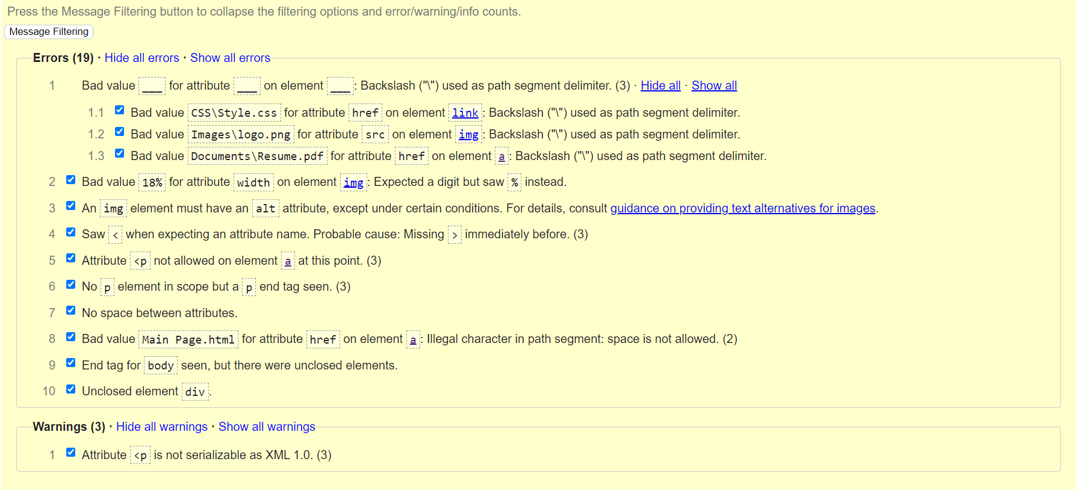Resume

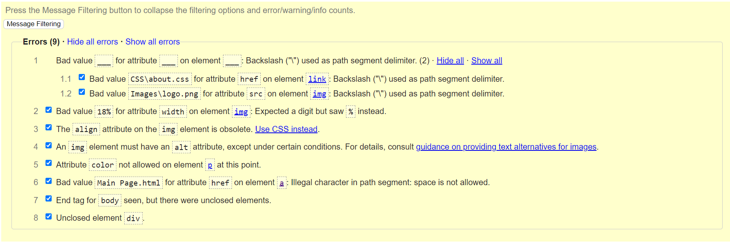About

Web skills

Index

CSS

