Index:

Contains links or navigation to different sections or pages my website.

Acts as the starting point for accessing other pages.

May include a brief overview or summary of the website's content.

Main Page:

Central hub of the website.

Provides an overview of the website's purpose and content.

Includes links or navigation to various sections such as about, resume, web skills, etc.

MK_A1_About:

Provides detailed information about the purpose of the website.

Could feature a photo or other visual elements to complete the page.

MK_A1_Resume:

Will Most likely have a link to my resume as displaying page content so long is inadequate.

Web Skills:

Will display certain aspects of html to display ones competency within web development.

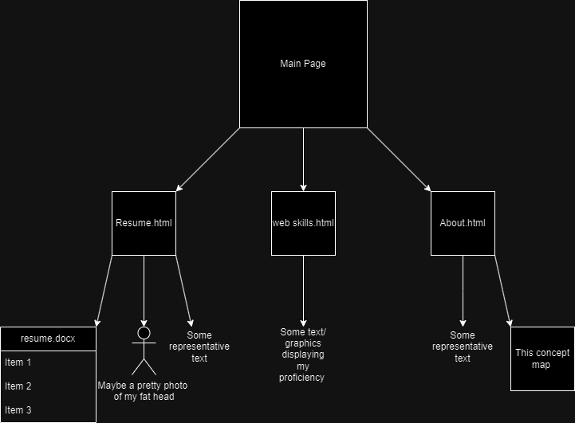Introduction:

In order to ensure an efficient and user-friendly interface, a number of design elements must be carefully considered when creating a website for Krause electric cars. The basic qualities required to create a website of that kind are described in this report, with an emphasis on technical integrity, visual appeal, content clarity, and usability. In order to make sure that the marker can see the styling, I have chosen to use a wide range of conflicting colours for this assignment.

1. User-friendly Navigation and Interface:

For any website to be useable by people and kept in and of a manner that allows for this navigation and interface must be taken into account at the design stage to ensure this requirement is met.

Users should be directed to the various sections of the website that are of greater importance with clear and concise use of the tools web developers have at their disposal.

2. Content Clarity:

The information on the website should be clear, concise, and educational, giving users all the knowledge they need to understand Krause Electric Cars. This comprises:

Concise Descriptions: Product, service, and company information should be described succinctly to avoid confusing visitors with too much information.

Visual Aids: By including pertinent photos and videos, you can visually engage visitors and highlight important points, which will improve their comprehension of Krause Electric Cars, such as a logo image.

3. Professional Design Reflective of Brand:

The website should have a professional feel to it and should represent the brand identity of Krause Electric Cars.

Components of Branding: The website's use of the Krause electric cars logo, colour scheme, and typography upholds brand recognition and brand consistency.

Clean Design: A design style that is simple and uncluttered helps to project professionalism and keeps visitors from becoming sidetracked or confused.

4. Validation of HTML and CSS Files:

Ensuring the validity of external CSS files and HTML is essential. To find and correct any mistakes or inconsistencies, validation will be carried out using W3C Markup Validation Service and the W3C CSS Validation Service fro both my HTML code and CSS.

5. Folder Structure for File Organization:

Maintainability and accessibility are improved by arranging graphics, text, HTML files, and other resources in a sensible folder structure.

Best practices consist of:

Different Folders: For the use case of keeping related and unrelated content easily accessible and organised as well as differentiated, I will create distinct folders for images, documents, CSS files, and HTML files aswell as any other assets I may use.

Descriptive Naming: To ensure clarity and ease navigation, give folders and files descriptive names pertinent to their expected content this way they are easily identifiable in future.

Main:

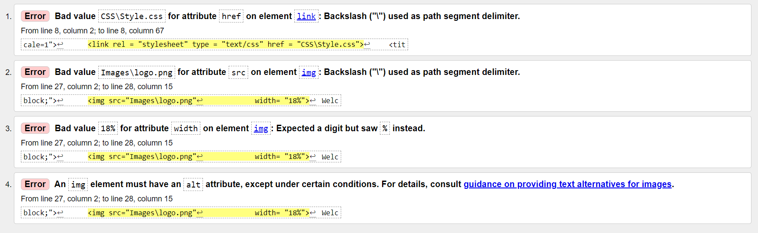

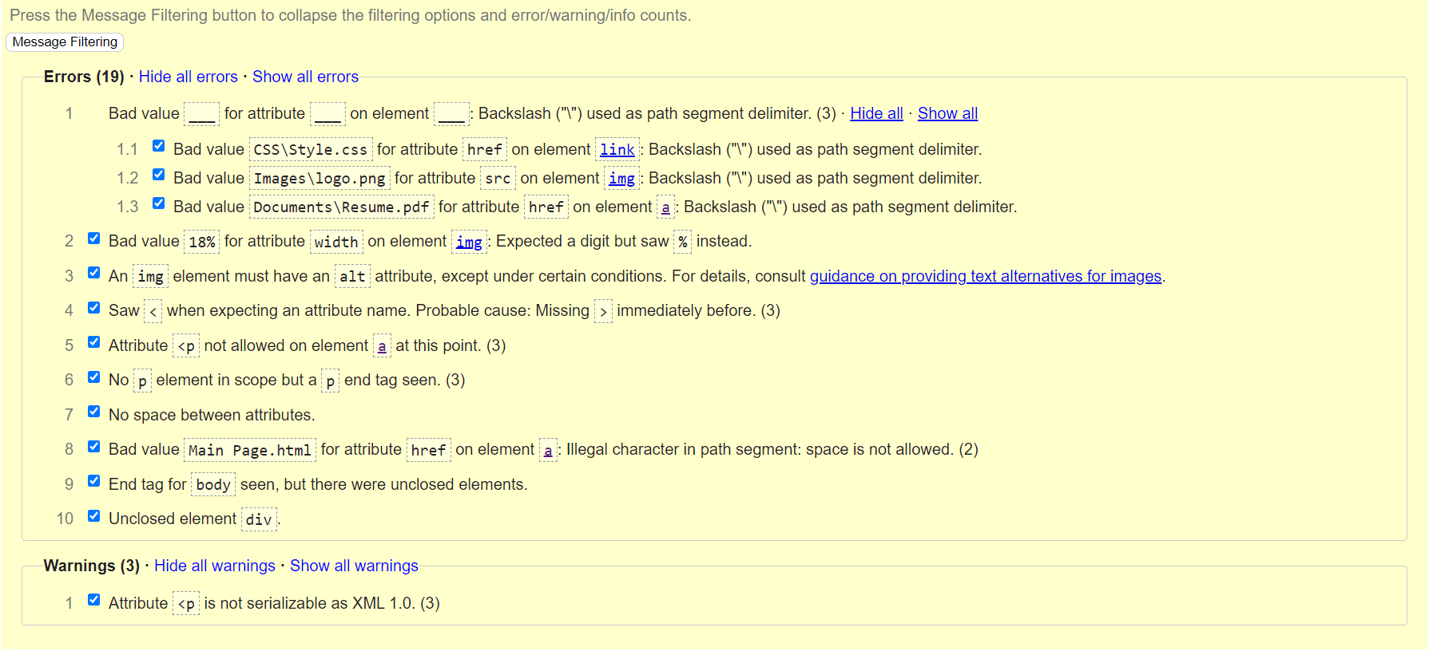Resume

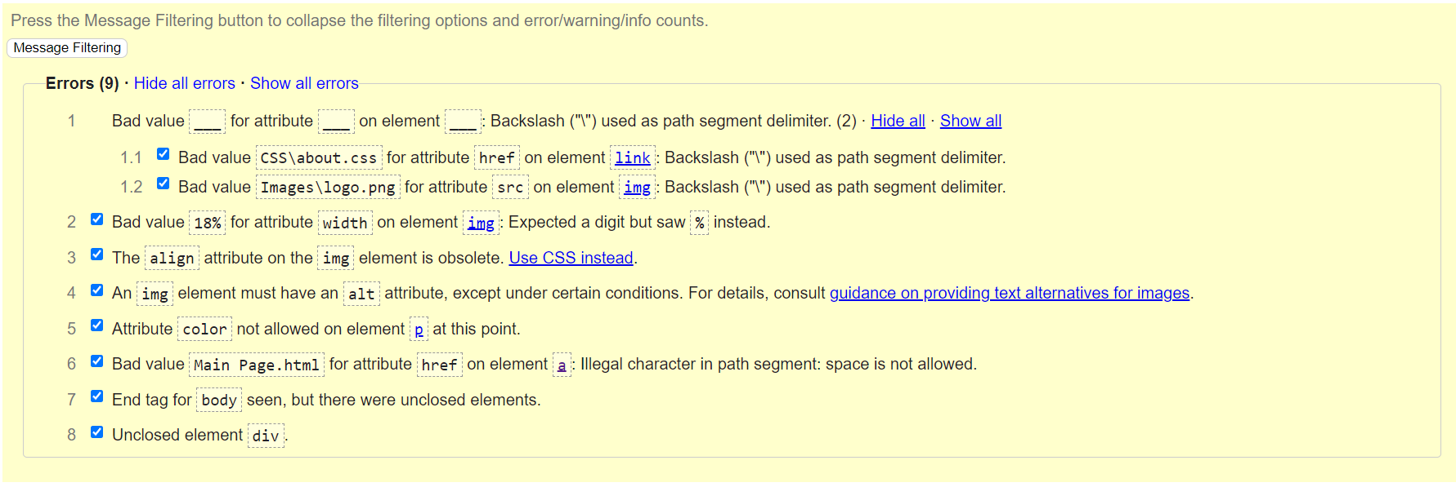About

Web skills

Index

CSS

