The Algorithms Used in the Supertile Simulation System (Draft)

Yunhui Fu
10/6/2008

Tiles are some squares with four glues at each of the sides. Supertiles are the complex structure composed by some tiles. The tiles have to combine with each other in each edge with the dovetailed glue. All of the tiles and supertiles are two-dimension.

The X-Y coordinate system we used in this paper is defined by comparing the sequence of the array structure of C language. The items of the array are placed in the memory one by one, left to right and up to down. The positive orientation of the Y axis is from bottom to up; the positive orientation of the X axis is from left to right. The start value of the axis is 0. There are some examples of the coordinates: (0,0), (0,1), (1,0), (0, 2).

To simulate the supertile system, we use a array which records all types of the supertiles created during the simulation and it's quantity. In each loop, two types of supertile(can be the same type) is pick out randomly to test if them could mesh with each other. If the two supertiles could mesh with each other, the new supertile will be stored in the array.

Two tests are important in this simulation system. One is Equivalence Testing, another one is Mesh Testing.

- Equivalence Testing (ET)
The goal of the testing is to judge if two supetile is equal. The supertiles are placed at random orientation. The supertile have to rotate at most four times to compare with another supertile before draw the conclusion that the two supertils are equal or not.

This type of testing is used in the statistic of the numbers of created supertiles.

- Mesh Testing (MT)
To test if two supertile could be engaged with each other at a given tempreture. We should consider the condition that one supertile should not enter the hollow in the center of other supertile. (If this type of testing will consume much of the time, we can consider to cache the result, such as store it to database, such as sqlite.)

Let's say that one of supertile is named Base which is tested, another one is named Test.
The orientation of one supertile is the rotate times of the supertile from the origin state in the list table. Each of the rotate angle is 0, 90, 180 and 270 degree. After each rotate, the Test supertile will try to mesh with the Base supertile. Thus the Test supertile have to rotate four times to mesh with the Base supertile.

Let's say that the testing at the edge is named Sliding Testing(ST). There will be four times Sliding Testing for each orientation of Test supertile. The begin position for the Test supertile to test if it can mesh with the Base supertile have to be at the outer side of the Base edge because of the geometry shape. For each of the Sliding Testing, the Test supertile is placed at the edge of the Base supertile, with only one point of the area adjoin with. Then it will be tested for meshing with Base, which is called Plumb Testing(PT). After one Plumb Testing, the Test supertile will move to the next point of the same direction of Sliding Testing.

Say that MaxTestX is the maximum length of Test, and MaxTestY is the maximum width of Test; MaxBaseX is the maximum length of the Base, and MaxBaseY is the maximum width of the Base. As the figure show, Base is fixed at the position (MaxTestX, MaxTestY).

There will be two start positions for the Test to start Sliding Testing, the position (0,0) and (MaxTestX + MaxBaseX, MaxTestY + MaxBaseY). The Test will test four times of the sliding testing. The Test will slide to two directions for each position; The sliding testing will also try the positions at the plumb of the direction of sliding.

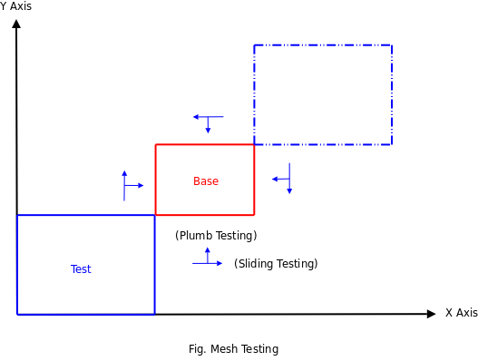

The two testing algorithms will use some small algorithms list below:

- Rotate the supertile
This algorithm is used at the ET and MT. The supertile have four positions after rotating under the two-dimension.

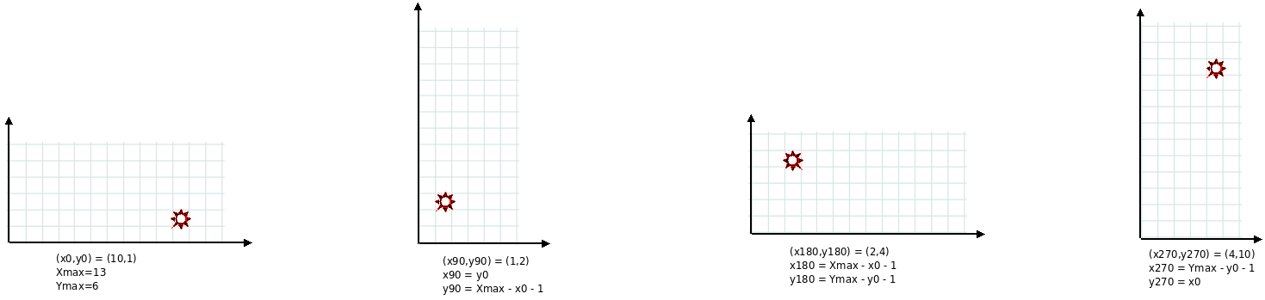
Let's say that the origin state of one supertile:
The maximum length is Xmax; The maximum width is Ymax; The related position of one tile of the supertils is (x0,y0).
After 90 degree of rotating, the position of the tile related to the new supertile will change to:
X90 = y0; Y90 = Xmax - 1 - x0;
After 180 degree of rotating, the position of the tile related to the new supertile will change to:
X180 = Xmax - 1 - x0; Y180 = Ymax - 1 - y0;
And after 270 degree of rotating, the position of the tile related to the new supertile will change to:
X270 = Ymax - 1 - y0; Y270 = x0;

- The overlapped range of two supertile
The program only need to check the overlapped range of two supertiles when apply the Mesh Testing.

Let's say two supertiles, Test and Base, which is defined previous, will be tested. The maximum length of Base is MaxBaseX and the maximum wide of Base is MaxBaseY. The maximum length of Test is MaxTestX and the maximum wide of Test is MaxTestY. To avoid the negative value, the Base supertile is placed at (MaxTestX, MaxTestY). The Test can be placed (the top-left position (x0,y0) of the Test rectangle) at any position at the range of ([0,MaxTestX+MaxBaseX), [0,MaxTestY+MaxBaseY)). See the figure.

Two basic conditions should be considered when calculate the overlap range. Let's consider the situation on the X axis. The two condition is that the length of the Test is less or large than that of Base.
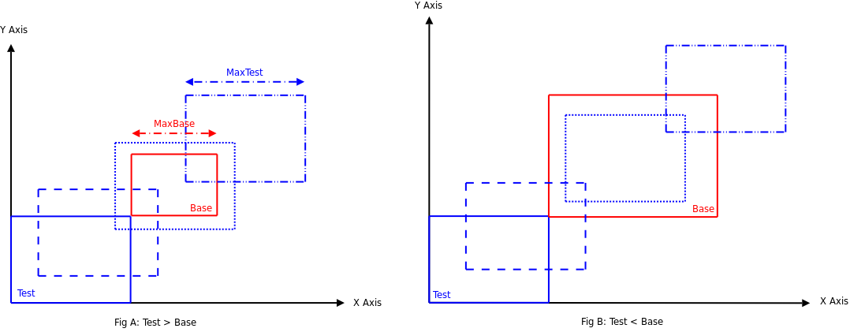

 | The Range of X0 | The Absolute Position of the Overlaped Area (PX_{abs})
Length_{Test} < Length_{Base} | [0, MaxBaseX) | [MaxTestX, MaxTestX + x0)
Length_{Test} < Length_{Base} | [MaxBaseX, MaxTestX) | [MaxTestX,MaxTestX+MaxBaseX)
Length_{Test} < Length_{Base} | [MaxTestX, MaxTestX + MaxBaseX) | [x0, MaxTestX + MaxBaseX)
Length_{Test} > Length_{Base} | [0, MaxTestX) | [MaxTestX, MaxTestX + x0)
Length_{Test} > Length_{Base} | [MaxTestX, MaxBaseX) | [x0, MaxTestX + x0)
Length_{Test} > Length_{Base} | [MaxBaseX,MaxTestX + MaxBaseX) | [x0, MaxTestX + MaxBaseX)

 | The Range of Y0 | The Absolute Position of the Overlaped Area (PY_{abs})
Width_{Test} < Width_{Base} | [0, MaxBaseY) | [MaxTestY, MaxTestY + y0)
Width_{Test} < Width_{Base} | [MaxBaseY, MaxTestY) | [MaxTestY,MaxTestY+MaxBaseY)
Width_{Test} < Width_{Base} | [MaxTestY, MaxTestY + MaxBaseY) | [y0, MaxTestY + MaxBaseY)
Width_{Test} > Width_{Base} | [0, MaxTestY) | [MaxTestY, MaxTestY + y0)
Width_{Test} > Width_{Base} | [MaxTestY, MaxBaseY) | [y0, MaxTestY + y0)
Width_{Test} > Width_{Base} | [MaxBaseY,MaxTestY + MaxBaseY) | [y0, MaxTestY + MaxBaseY)

We can use the following formula to calculate the position of the point related to each supertile:
Test: P_{abs} - x0
Base: P_{abs} - MaxTest

So we use the absolute position to denote the position of the tiles.

- Plumb Testing
The Plumb Testing(PT) is the core algorithm of the system. We can use this algorithm to find out all of the position that two supertiles can mesh with. The algorithm could be described by the following pseudo-code:
1. push the start point to the stack STK.
2. if the stack STK contains data, do:
2.1 pop one position POS from the stack STK
2.2 if this point POS is not detected, by searching the bitmap BITM_G, then do:
2.2.1 reset the bitmap of the whole coordinate, BITM_L
2.2.2 get the overlap region of two supertile Test and Base
2.2.3 check each of the Test's tiles in the overlap region:
2.2.3.1 check each of the 4 sides of the tile, if there exist tile of Base:
2.2.3.1.1 get the glue value of tile, both of Test and Base.
2.2.3.1.2 if the glues are equal, then the total of the glue value CNTGLUE +=glue;
2.2.3.1.3 the number of Base's tile which is abut with the Test's tile in this direction add 1: CNTTILE[direction] ++
2.2.4 if the CNTGLUE >= temperature then the POS is one of the candidates, do:
2.2.4.1 save the position POS to the list RETCAND
2.2.5 for each of the four directions, check the CNTTILE[direction], if CNTTILE[direction] = 0, then there are no tiles of Base, the Test super can move to this direction to detect the mesh, so do the next steps:
2.2.5.1 if the position at BITM_G and the position at BITM_L both are not set, do:
2.2.5.1.1 push the next position in this direction to the stack STK.
2.2.5.1.2 set the bit at the position POS in the BITM_L
2.2.6 set the bit at the position POS in the BITM_G

After this procedure, we can check the RETCAND to see if there exist the position at which the Test supertile could mesh with the Base supertile.

// updated: add the algorithm of splitting supertiles at a given temperature
To support the multi-stage supertile simulation that the temperature will be changed for difference stages, the splitting algorithm of supertile should be implemented.

1 find out all of the sub-supertiles in which the total glue strength between any tiles is not less than the temperature.
2 combine two sub-supertiles whenever there exist the total glue strength that is not less than the temperature
3 re-check the list until there are not combination any more
4 output the sub-supertile list

