The Proposal of the Supertiles Simulation System

Yunhui Fu, SID20009163
Fall 2008, CSCI6360

The Background of the software

The self-assemble is one of the branch of the DNA computing. Adleman (1994) put effort to how the molecular system could be convert to a difficult mathematical problem. And Winfree introduced the concept of combination of self-assembly and tiling to support the physics of computation by self-assembly.

Base on the work of predecessors, Prof. Schweller develop staged self-assembly in his peper [abs-0803-0316]. The traditional theory of the self-assembly model is two-dimensional tile system. The tile is the basic building block in this model which is called Wang tiles [Wan61]. The tile is non-rotatable and have glue on each of the four edges. Two tiles could stick with each other on one side which have affinity and thus the supertile created. One tile or supertile could join with another tile or supertile when the sum of the glue along the attachment is larger than the predefined temperature t.
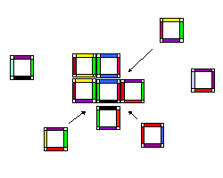
Fig 1 The tile system

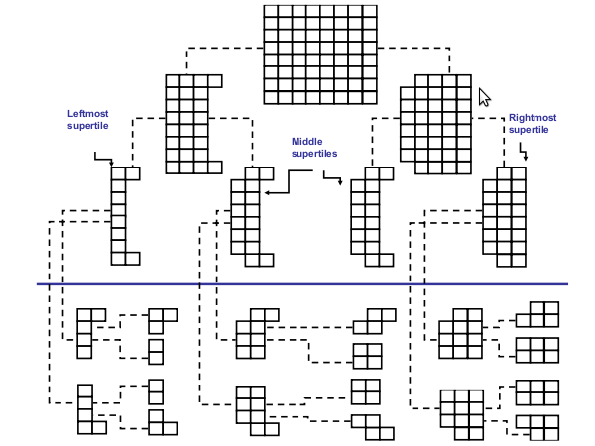
Fig 2. Decomposition tree for 8×8 square in the jigsaw technique

The Requirements
To test and verify the theory, a software platform is demanded to simulate the model of the theory. The system could simulate not only the model of the theory, but also the unfrequented area of the directions of the theory. For example, the two-dimensional tile system is very hot currently, but there is not much written about the triple-dimensional tile system. We can use the simulation system to explore the new way of the theory, observe the processing of the simulation and find some interesting new problems.

A user could setup the initial environment of one simulation, such as editing the original tiles, setting the temperature of the system, etc. After checking the result of simulation, the user could also examine the supertile's history by animating the display.

The system could be extended to simulate the 3D structure of the supertiles. To do so, we can extend the algorithms and display functions used in the system from 2D to 3D. This type of extension will be done after this project.

The Tools and Technique Used in the Project
The OpenGL API is used for displaying of the tiles and supertiles. We use the C language because we want to get good performance. We use wxWidgets – one open source GUI library – instead of GLUT because it is cross-platform and can handle complex user graphic interface.

Milestone
According to the requirement, there are three stages of the project.
Stage 1: 10/15 - 10/28 (2 weeks)
Study how to use the wxWidgets with OpenGL. Design the user interface and the function of system. Write a demo for the wxWidgets. Implement the basic user interface.

Stage 2: 10/29 - 11/11 (2 weeks)
Implement the function of simulation; Display the result of simulation.

Stage 3: 11/12 - 11/18 (1 week)
Animate the displaying of the supertile's formative history.

Reference

[Win98] | Erik Winfree. Algorithmic Self-Assembly of DNA. PhD thesis, California Institute of Technology, Pasadena, 1998.
[KaoS08] | Ming-Yang Kao, Robert Schweller: Randomized Self-Assembly for Approximate Shapes. Proceedings of the 35th International Colloquium on Automata, Languages and Programming (ICALP 2008).
[abs-0803-0316] | Erik D. Demaine and Martin L. Demaine and Sándor P. Fekete and Mashhood Ishaque and Eynat Rafalin and Robert T. Schweller and Diane L. Souvaine: Staged Self-Assembly:Nanomanufacture of Arbitrary Shapes with O(1) Glues. Proceedings of the 13th International Meeting on DNA Computing (DNA13), Memphis, Tennessee, June 4-8, 2007, pp. 46-55.
[Wan61] | Hao Wang. Proving theorems by pattern recognition—II. The Bell System Technical Journal, 40(1):1–41, January 1961.

The pictures are taken from the paper [abs-0803-0316].

