FINAL CAPSTONE REPORT

AI Powered Household Energy Consumption Prediction and Monitoring System
Next day forecasting and responsible household energy monitoring

Main conclusion
The selected XGBoost model improved test MAE by 35.0 percent over the seasonal-naive baseline. It is a credible next-day forecasting prototype, but its original warning logic detected only 5 of 23 high-use days. The proposed dashboard therefore presents forecasts as advisory estimates and requires local Philippine validation before dependable bill-shock alerts.

Author | Edixon D. Yu Jr.
Program | Postgraduate Diploma in Artificial Intelligence and Machine Learning
Project type | Supervised time-series regression with advisory warning logic
Repository | https://github.com/yhingyu/capstone
Date | September 2026

Executive Summary
Many households see their electricity use mainly through a monthly bill. That timing can limit the opportunity to respond when consumption is rising. The problem became particularly relevant in the Philippine and Meralco context during the 2026 public discussion of bill shock, when higher rates and household usage combined to increase financial pressure. This project addresses only the consumption component: it forecasts daily household electricity use and supports earlier, advisory monitoring. It does not reproduce an official Meralco bill.
The analysis used the UCI Individual Household Electric Power Consumption dataset, containing 2,075,259 minute-level observations from one household in France between December 2006 and November 2010. After cleaning, coverage filtering and daily aggregation, 1,417 daily records were usable. Time-aware feature construction yielded 1,147 complete modeling rows and 22 selected predictors.
Five forecasting approaches were evaluated: persistence, seasonal naive, Ridge Regression, Random Forest and XGBoost. Model selection used chronological validation rather than the final test period. XGBoost achieved the lowest validation MAE and was evaluated once on 173 chronologically later test observations. It produced an MAE of 3.7232 kWh, RMSE of 5.1040 kWh, MAPE of 18.73 percent and R squared of 0.5458. Its MAE was approximately 35 percent lower than the seasonal-naive baseline.
Forecast performance did not translate into a reliable high-consumption alarm. The original warning rule achieved 71.43 percent precision but only 21.74 percent recall, detecting 5 of 23 high-use test days. High-use days also had more than twice the MAE of normal days. This is the most important operational limitation and determines the recommended deployment posture: forecasting demonstration first, silent validation second, and customer alerts only after prospective calibration.
The proposed proof-of-concept dashboard converts the model into an understandable monitoring experience. It combines historical consumption, a next-day forecast, a prediction interval, a rolling household baseline, configurable advisory levels, important forecast drivers and optional cost estimation based on a user-supplied rate. The design is local-first and clearly labels outputs as estimates. A working local deployment, monitoring plan and demonstration media belong to the optional deployment step.

Key Results
Measure | Result | Interpretation
Final test MAE | 3.7232 kWh | Average absolute next-day error
MAE improvement | 35.0% | Improvement over seasonal-naive baseline
Test MAPE | 18.73% | Above the aspirational 15% target
Prediction-band coverage | 93.06% | Observed coverage for a nominal 90% band
Warning precision | 71.43% | Most generated warnings were correct
Warning recall | 21.74% | Most high-use days were missed

Contents
1 Introduction and Philippine Context
2 Problem Understanding and Success Criteria
3 Data Collection and Understanding
4 Data Preparation Exploratory Analysis and Feature Engineering
5 Model Implementation and Evaluation
6 Explainability Ethical AI and Fairness
7 Energy Monitoring Dashboard Proof of Concept
8 Business Value Implementation Strategy and Monitoring
9 Final Communication Deliverables
10 Limitations Conclusions and Recommendations
Appendices and References

1 Introduction and Philippine Context

1.1 Household visibility problem
Electricity is used by approximately 26.47 million Filipino households, equivalent to 94.8 percent of households in 2023 [1]. In the National Capital Region, housing, water, electricity, gas and other fuels represented 27.3 percent of family expenditure in the preliminary 2025 Family Income and Expenditure Survey, although that percentage combines several household cost categories [2]. Meralco serves more than eight million customers across its franchise area [3].
A conventional meter records cumulative energy use, but the bill is normally prepared from monthly meter readings [4]. Households can inspect meters or estimate appliance use, yet neither approach automatically predicts the next day. The business opportunity is therefore earlier consumption visibility: forecast daily use, compare it with a household baseline, and provide enough time for a user to review discretionary consumption.

1.2 Bill shock and scope
In July 2026, the reported Meralco residential rate was PHP 14.8261 per kWh, compared with PHP 13.2730 per kWh in January, an increase of about 11.7 percent [6]. Public discussion and proposed inquiries addressed rising rates, meter concerns and consumer protection. The Energy Regulatory Commission also suspended collection of the Green Energy Auction Allowance for several months to ease costs [8][9].
Scope boundary
A higher bill can reflect consumption, tariff changes, taxes, adjustments or other regulated charges. This capstone predicts consumption in kWh. Any peso estimate in the dashboard must use a clearly stated user-supplied rate and must never be presented as an official Meralco bill.

1.3 Project objective
The project develops and evaluates a machine-learning system that forecasts the next day of household electricity consumption and supports proactive monitoring through a dashboard. The primary data science task is supervised regression because the target is a continuous value measured in kWh. The warning is an application rule derived from the regression forecast, not a separately trained classifier.

2 Problem Understanding and Success Criteria

2.1 Problem statement
Many households have limited visibility into accumulated electricity consumption before the monthly bill arrives. The proposed system uses historical measurements to forecast next-day consumption, compare the forecast with recent household behavior, identify unusually high expected use, and communicate results through an understandable monitoring interface.

2.2 Technical definition
Component | Definition
Primary task | Supervised time-series regression
Target | Next-day total household electricity consumption in kWh
Forecast horizon | One day ahead
Primary metric | Mean Absolute Error in kWh
Supporting metrics | RMSE, MAPE, R squared and prediction interval coverage
High-use event | Actual use above 120% of the preceding 30-day mean
Warning measures | Precision, recall, F1 score and specificity

2.3 Success criteria and outcome
Criterion | Target | Outcome | Status
Baseline improvement | At least 10% lower MAE | 35.0% lower than seasonal naive | Achieved
Relative error | MAPE at or below 15% | 18.73% | Partial
Unseen evaluation | Chronological held-out test | 173 later daily observations | Achieved
Warning recall | At least 80% | 21.74% | Not achieved
Warning precision | At least 75% | 71.43% | Near target
Business savings | Pilot evidence | No prospective Philippine pilot | Not measured

The forecasting goal was achieved, but the warning and business goals were not fully achieved. The honest project conclusion is therefore a promising forecasting prototype rather than a deployment-ready bill-shock alert system.

3 Data Collection and Understanding

3.1 Dataset
The project used the UCI Individual Household Electric Power Consumption dataset [11]. It contains one-minute electrical measurements from one household in Sceaux, France. The public dataset is appropriate for demonstrating the complete machine-learning lifecycle, but it is not representative of Meralco customers or the Philippine population.
Dataset property | Observed value
Rows | 2,075,259
Measurement columns | 7
Start timestamp | 16 December 2006 17:24
End timestamp | 26 November 2010 21:02
Rows with missing measurements | 25,979 or 1.2518%
Invalid timestamps | 0
Duplicate timestamps | 0
Daily aggregation rows | 1,442
Daily kWh values missing | 9
Median daily coverage | 100%

3.2 Data dictionary
Variable | Type | Unit | Description
Global active power | Continuous | kW | Household active power averaged by minute
Global reactive power | Continuous | kW | Household reactive power averaged by minute
Voltage | Continuous | V | Minute-average voltage
Global intensity | Continuous | A | Minute-average current intensity
Sub metering 1 | Continuous | Wh | Kitchen-related sub-metering channel
Sub metering 2 | Continuous | Wh | Laundry-related sub-metering channel
Sub metering 3 | Continuous | Wh | Water-heater and air-conditioner channel

3.3 Data-quality interpretation
All seven measurement variables shared the same 25,979 missing observations, suggesting missing measurement intervals rather than unrelated field-level omissions. Potential outliers were retained unless clearly invalid because peaks can represent genuine high-use behavior. Removing plausible peaks would make the model appear more accurate while weakening its relevance to bill-shock monitoring.

4 Data Preparation Exploratory Analysis and Feature Engineering

4.1 Reproducible preprocessing
Stage | Implemented decision | Reason
Parsing | Combined date and time into a validated timestamp index | Supports chronological processing
Missing values | Interpolated only short gaps of 60 minutes or less | Avoids inventing long missing periods
Daily quality | Retained days with at least 95% minute coverage | Improves daily target reliability
Aggregation | Converted active power to daily kWh | Matches the next-day household target
Duplicates | Checked timestamp duplicates | Prevents double counting
Outliers | Preserved plausible high values | High-use events are operationally important
Leakage control | Shifted history before rolling calculations | Ensures only earlier information predicts the future

4.2 Engineered features
The analysis created 42 candidate predictors. Feature families included lagged daily energy, rolling means and ranges, recent changes, exponentially weighted history, calendar signals, voltage variability and other domain-derived summaries. Filter and embedded evidence reduced the final input to 22 features. PCA was fitted as a dimensionality-reduction diagnostic, but the final model retained interpretable selected features rather than replacing them with principal components.
Feature family | Examples | Value
Lagged consumption | 1, 7, 14, 21 and 28-day lags | Captures persistence and weekly history
Rolling behavior | 7, 14 and 30-day mean min and max | Represents recent baseline and range
Recent movement | 7-day change and 7-day exponential mean | Represents direction and recency
Calendar | Day of week month year cosine and time index | Represents recurring and long-term patterns
Electrical behavior | Previous-day voltage variability | Adds a non-consumption operational signal

4.3 Chronological experimental design
Split | Rows | Period | Use
Training | 802 | 16 Jan 2007 to 30 May 2009 | Fitting and time-series cross-validation
Validation | 172 | 31 May 2009 to 23 Feb 2010 | Model and hyperparameter selection
Test | 173 | 24 Feb 2010 to 25 Nov 2010 | One-time final evaluation

5 Model Implementation and Evaluation

5.1 Candidate models and tuning
Two simple baselines and three machine-learning models were compared. Ridge Regression provided a regularized linear benchmark, Random Forest represented bagged nonlinear trees, and XGBoost represented gradient-boosted trees. Hyperparameters were tuned with five chronological cross-validation splits. The final algorithm was chosen only from validation performance, preserving the test period for unbiased final evaluation.
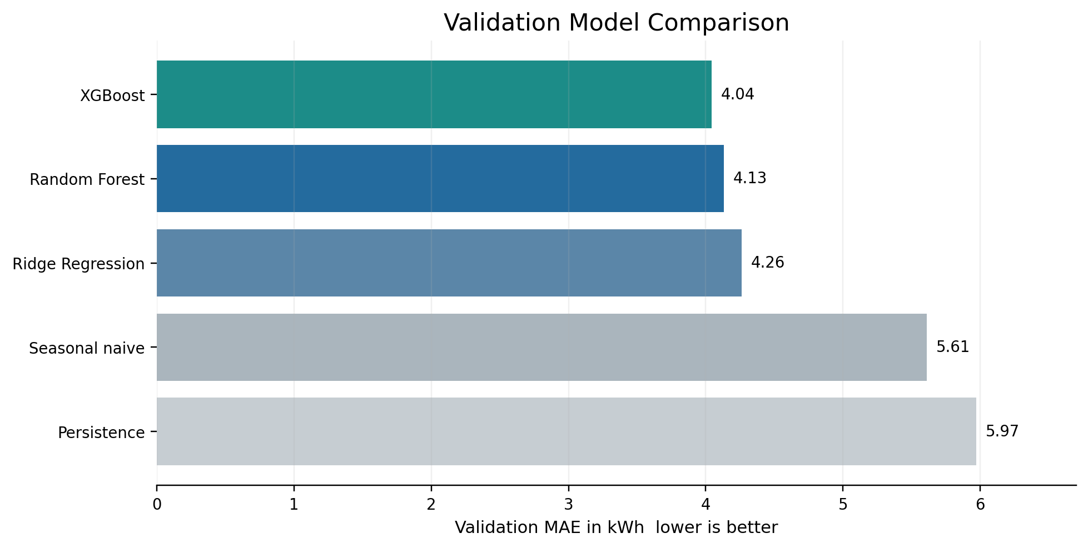
Figure 1. XGBoost achieved the lowest validation MAE among evaluated methods.
Model | Validation MAE | RMSE | MAPE | R squared
XGBoost | 4.0415 | 5.3451 | 16.77% | 0.6353
Random Forest | 4.1311 | 5.3706 | 17.36% | 0.6318
Ridge Regression | 4.2613 | 5.5355 | 18.65% | 0.6089
Seasonal naive | 5.6091 | 7.1561 | 23.23% | 0.3463
Persistence | 5.9696 | 7.9306 | 23.13% | 0.1972

5.2 Final test results
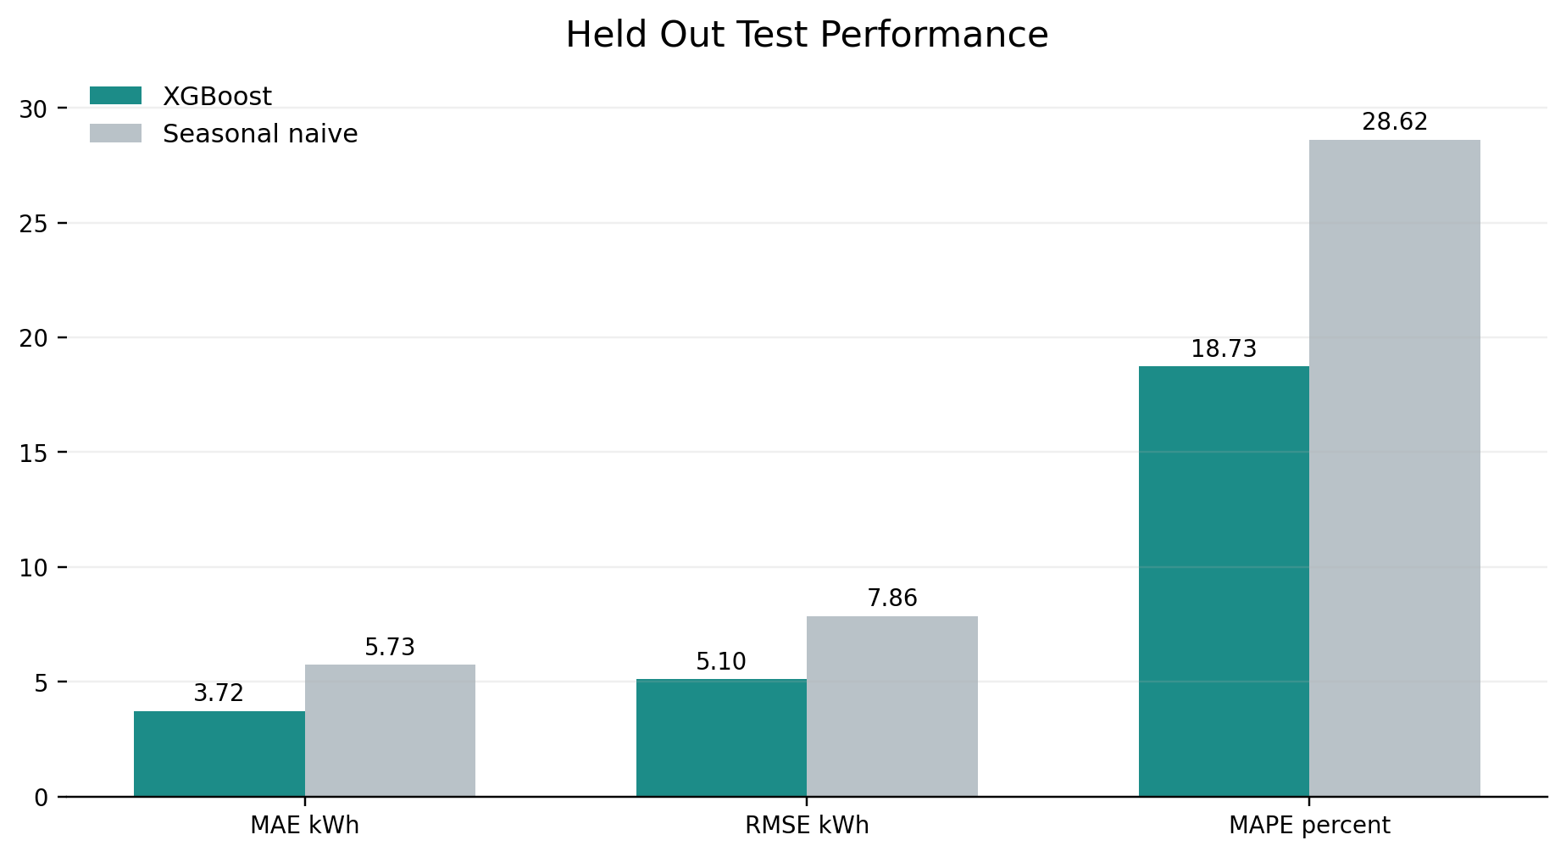
Figure 2. Final XGBoost test errors were lower than the stronger seasonal-naive baseline.
XGBoost achieved a test MAE of 3.7232 kWh compared with 5.7282 kWh for the seasonal-naive baseline, a 35.0 percent improvement. The bootstrap 95 percent confidence interval for test MAE was 3.2278 to 4.2559 kWh. A calibrated nominal 90 percent prediction band used a radius of plus or minus 8.677 kWh and covered 93.06 percent of test observations.

5.3 Warning evaluation
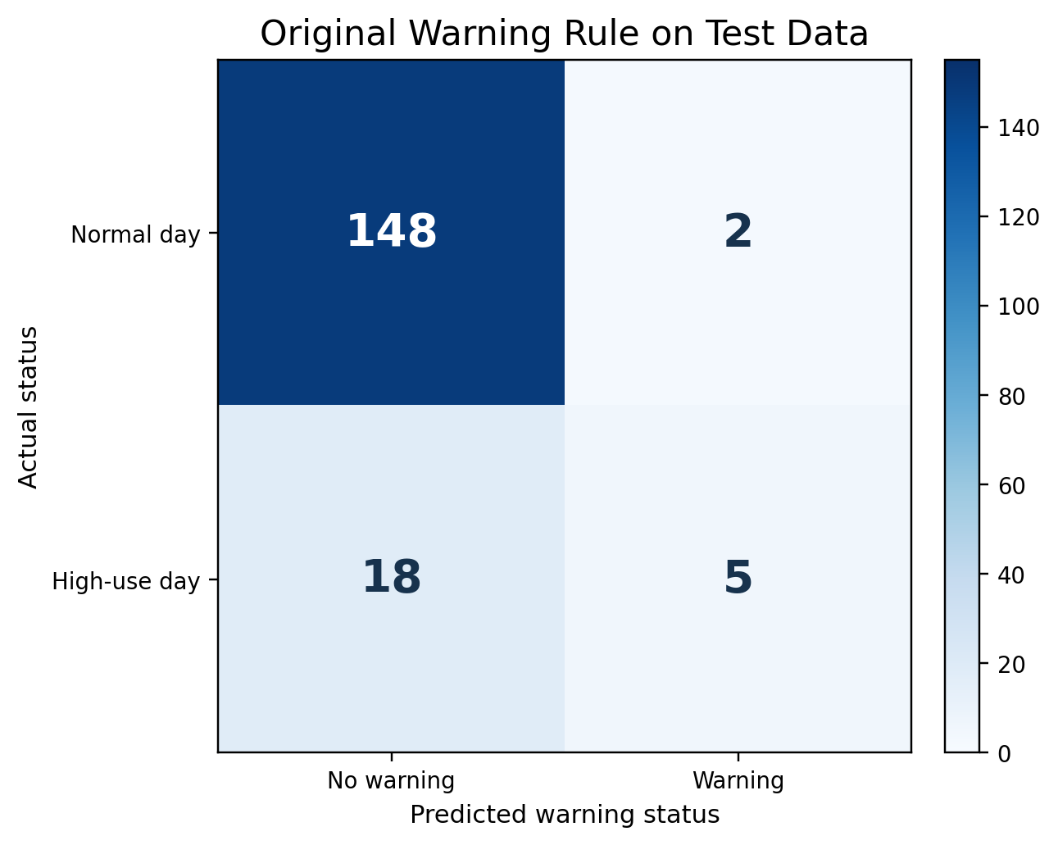
Figure 3. The original rule produced few false alarms but missed 18 of 23 high-use days.
Metric | Result | Target | Interpretation
Precision | 71.43% | 75% | Close to target
Recall | 21.74% | 80% | Insufficient for dependable alerts
F1 score | 33.33% | Not preset | Weak balance between precision and recall
Specificity | 98.67% | Not preset | Normal days were rarely flagged
High-use days detected | 5 of 23 | At least 80% | 18 high-use days were missed

Decision
Use the model for forecast demonstration and monitoring research. Do not describe the current rule as a dependable bill-shock alarm. Warning thresholds must be calibrated prospectively, with recall and alert fatigue evaluated together.

6 Explainability Ethical AI and Fairness

6.1 Explainability
Model behavior was examined with SHAP, LIME, partial dependence plots, individual conditional expectation curves and permutation importance. The strongest signals included previous-day consumption, the seven-day exponentially weighted history, annual seasonality, recent rolling maxima and previous-day voltage variability. These explanations describe statistical associations and should not be interpreted as causal relationships.

6.2 Leakage overfitting and generalization
Leakage controls passed: splits were chronological, target and warning outcomes were excluded from predictors, consumption-derived variables used lagged or shifted windows, scaling occurred inside the Ridge pipeline, and XGBoost was selected before final testing. Training, validation and test MAE were 4.8782, 4.0415 and 3.7232 kWh respectively. The result does not show classic overfitting, although geographic transfer and temporal drift remain major risks.

6.3 Operational subgroup audit
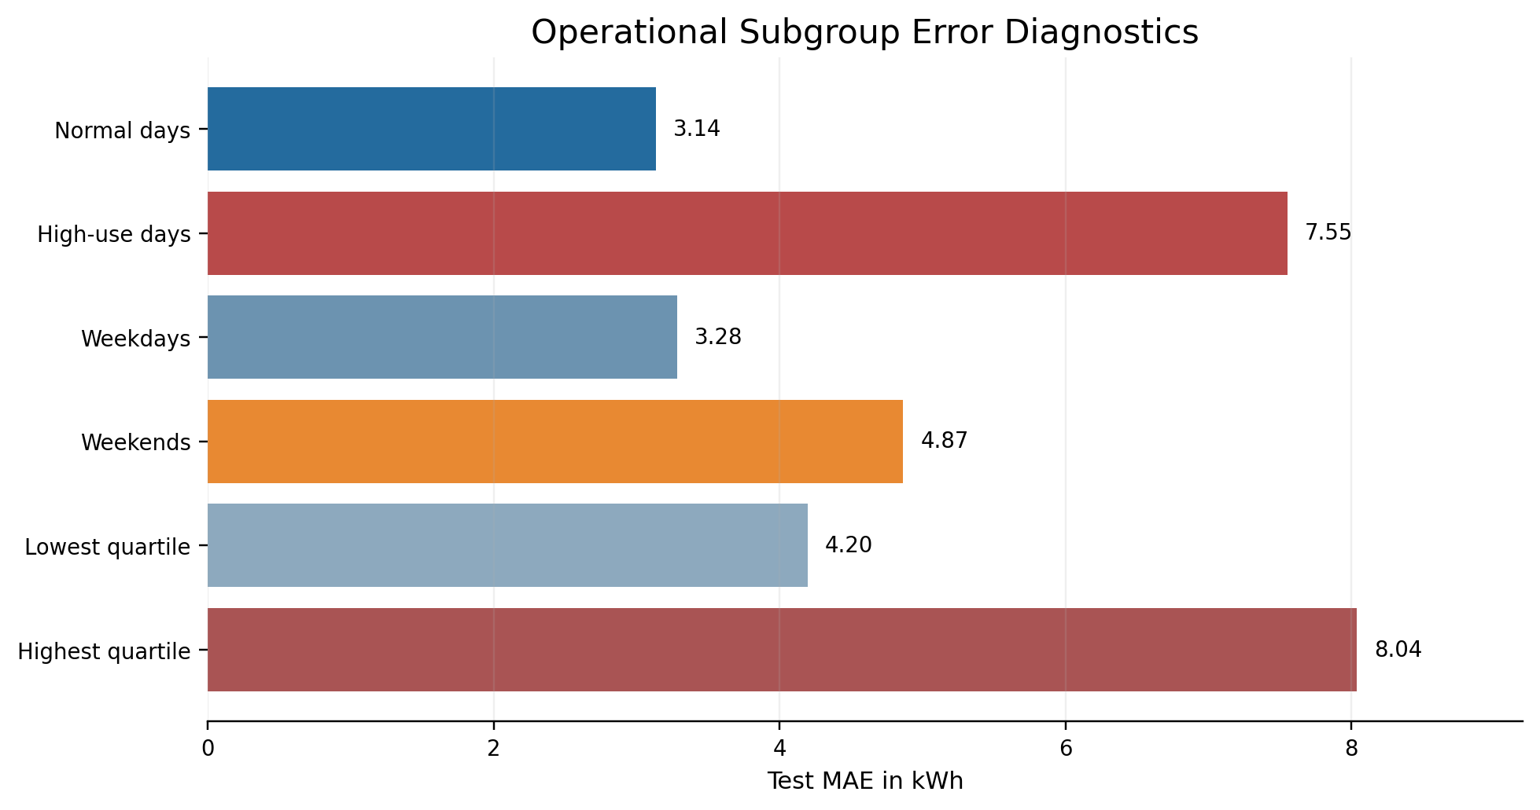
Figure 4. Error was substantially higher for high-use and highest-quartile days.
Test MAE was 3.1358 kWh on normal days and 7.5540 kWh on high-consumption days. The model underpredicted 91.3 percent of high-consumption days. Weekend MAE was also higher than weekday MAE. These operational groups reveal robustness problems, but they are not protected demographic groups.

6.4 Fairness limitation
The source data contains no gender, race, age, income or socioeconomic-status fields and represents only one anonymous household. Demographic parity, equalized odds and disparate impact therefore cannot be validly estimated for protected groups. No sensitive labels were inferred. Fairness-style calculations across season, weekday or weekend and consumption bands were used only as operational diagnostics and must not be presented as evidence of demographic fairness.
Risk | Evidence | Mitigation
Geographic transfer | One household in France | Collect consented multi-household Philippine data and retrain
High-use under-detection | Recall 21.74% and 18 false negatives | Evaluate quantile forecasts or a cost-sensitive warning classifier
Privacy | Energy traces can reveal occupancy routines | Minimize data encrypt storage restrict access and define retention
Alert fatigue | Lower thresholds increase false positives | Use configurable tiers and monitor opt-outs and false alerts
Temporal drift | Behavior appliances seasons and rates change | Monitor error and recalibrate on a defined schedule
Automation reliance | Users may treat estimates as official | Label estimates show uncertainty and retain manual judgment

7 Energy Monitoring Dashboard Proof of Concept

7.1 Purpose and user value
The proof of concept translates the forecasting pipeline into a household-facing monitoring experience. Its role is to make historical consumption and model uncertainty visible early enough for a user to review behavior. It is not a utility billing portal and does not control appliances automatically.
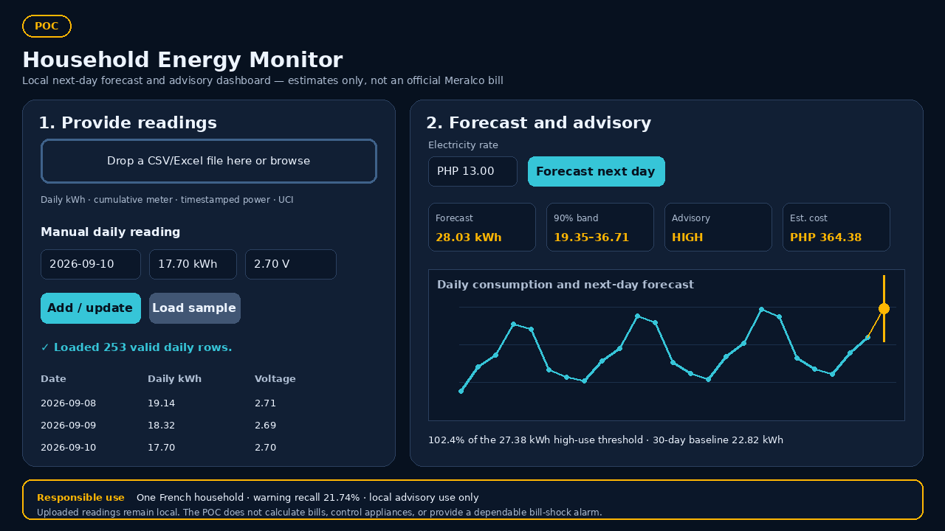
Figure 5. Final Dockerized Dash proof-of-concept dashboard using the included demonstration data.

7.2 Dashboard components
Component | Implemented behavior | User purpose
Reading input | CSV or Excel upload plus manual date, daily kWh and optional voltage variability | Use exported meter data or enter readings without changing code
Input normalization | Daily kWh, cumulative meter, timestamped power and original UCI minute-reading formats | Convert supported sources into a consistent daily history
History validation | At least 30 consecutive daily readings are required for rolling and lag features | Prevent a forecast when the required feature history is incomplete
Next-day forecast | Predicted kWh from saved model version step4-xgboost-1.0.0 | Plan the following day's discretionary electricity use
Prediction uncertainty | 90% prediction band displayed beside the point forecast | Interpret the estimate with its expected uncertainty
Advisory level | NORMAL, WATCH, MODERATE or HIGH based on forecast utilization of the configured threshold | Prioritize attention without claiming a dependable bill-shock alarm
Cost estimate | Estimated daily and projected 30-day cost using a user-entered PHP per kWh rate | View an illustrative, explicitly non-official cost estimate
Trend and responsible use | Daily history chart, forecast point, baseline explanation and limitations | Compare recent use with the forecast and understand the POC's limits
In the included demonstration, the saved model forecasts 28.03 kWh for the next day, with a 90% prediction band of 19.35-36.71 kWh. The forecast is 102.4% of the configured 27.38 kWh high-use threshold, producing a HIGH advisory. At PHP 13.00 per kWh, the illustrative daily estimate is PHP 364.38. These values demonstrate the application workflow and are not an official Meralco bill.

7.3 Implemented advisory logic
The application sets the high-use threshold at 120 percent of the preceding 30-day mean. It then compares the point forecast with that threshold: below 80 percent is NORMAL, 80 to below 90 percent is WATCH, 90 to below 100 percent is MODERATE, and 100 percent or higher is HIGH. These configurable tiers support user awareness; they are not validated safety thresholds or a dependable bill-shock alarm.
Level | Implemented rule | Interpretation
NORMAL | Forecast is below 80% of the high-use threshold | Usage is below the early-awareness range
WATCH | Forecast is 80% to below 90% of the high-use threshold | Review planned discretionary use
MODERATE | Forecast is 90% to below 100% of the high-use threshold | Consumption is approaching the high-use threshold
HIGH | Forecast is at or above the high-use threshold | High-use advisory with prediction uncertainty shown

Calibration requirement
The tier boundaries must be calibrated on validation or pilot data before operational use. The Step 5 post-hoc margin of 0.85 increased exploratory recall to 47.83 percent but reduced precision to 26.83 percent; it is not an unbiased replacement for the original test result.

7.4 Implemented local proof-of-concept architecture
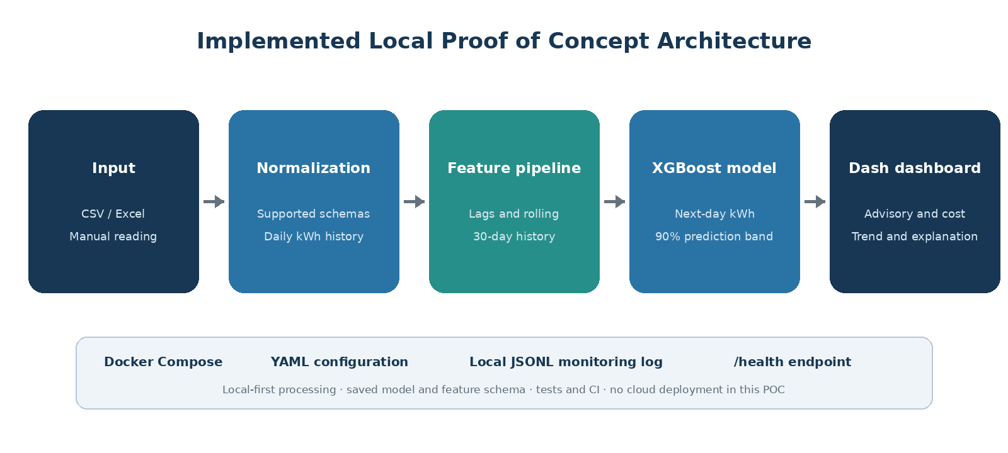
Figure 6. Implemented local Docker flow from household readings to forecast and advisory monitoring.
The completed local application uses Dash and is packaged with Docker Compose. It loads the saved Step 4 XGBoost model and feature-column configuration, validates and normalizes uploaded or manually entered readings, reproduces the training feature logic, and records each forecast with its source and model version in a local JSON Lines monitoring log. Configuration is stored in YAML, the service exposes a /health endpoint, and automated tests and CI checks support reproducibility. Cloud deployment remains a recommended production option and is not implemented in this POC.

7.5 IoT inputs and connected appliance monitoring
The implemented POC accepts manual daily readings and CSV or Excel uploads. It normalizes daily consumption, cumulative meter, timestamped power and original UCI formats into a common daily time series. Direct utility, whole-home, circuit-level and appliance-level IoT feeds remain future enhancements and are not shown as completed dashboard capabilities.
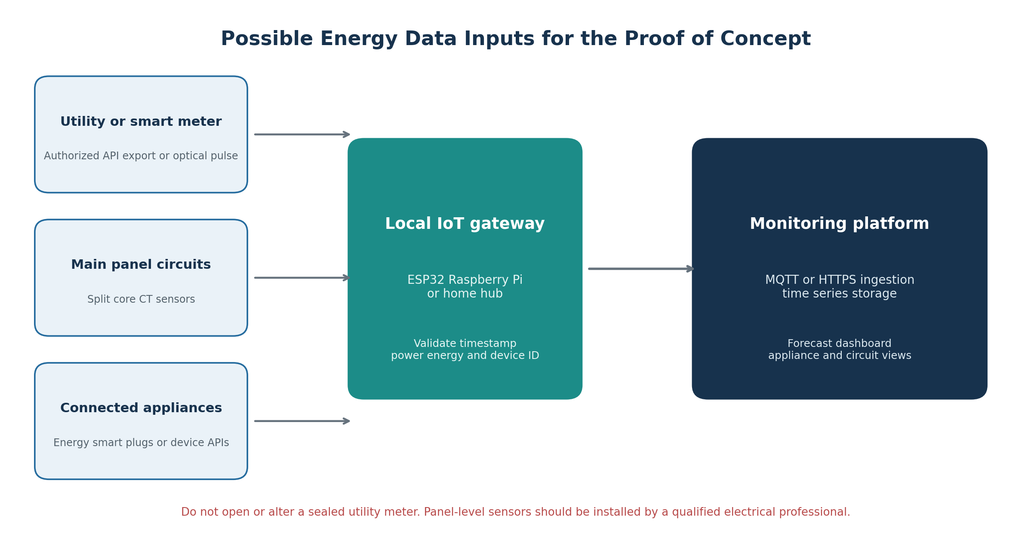
Figure 7. IoT input options can be introduced progressively without making the model dependent on one hardware vendor.
Input option | Coverage | Advantages | Important constraints
Manual meter reading or CSV upload | Whole home | Lowest-cost starting point and easy to audit | Not real time and requires user effort
Authorized utility or smart-meter export | Whole home | Uses utility-grade measurements when customer access exists | Availability and interval depend on utility permission and supported interfaces
Optical LED pulse sensor | Whole home | Non-invasive reading of compatible meter pulse output [12][13] | Requires a visible compatible pulse indicator and correct pulses-per-kWh setting
Split-core CT sensor at main feed | Whole home | Near-real-time power without cutting the conductor | Panel access and calibration; professional installation strongly recommended
Multi-channel CT monitor | Circuit level | Separates air-conditioning kitchen lighting and other circuits | Higher hardware cost and panel installation
Energy-monitoring smart plug | Appliance level | Measures plug load watts runtime and kWh directly | Only suitable for appliances within the plug rating; not for hard-wired loads
Smart appliance local or cloud API | Appliance level | Can provide operating state mode and energy data | Vendor access connectivity and privacy vary
Non-intrusive load monitoring | Estimated appliance level | Attempts to infer device signatures from whole-home power | Research feature; uncertain identification must be clearly labeled

7.5.1 Recommended PoC sequence
1. Begin with CSV upload and manual meter readings so the complete forecasting workflow can be demonstrated without hardware dependency.
2. Add one or two energy-monitoring smart plugs for high-interest appliances such as a refrigerator television workstation or window air conditioner, provided the device rating is suitable.
3. Add a whole-home optical pulse sensor when the installed meter exposes a compatible LED pulse without opening or modifying the meter.
4. For circuit or main-feed monitoring, use split-core CT hardware installed and reviewed by a qualified electrical professional.
5. Request authorized utility or smart-meter access only through documented customer or partnership channels; never bypass a sealed meter or protected interface.

7.5.2 IoT integration and data model
A local gateway such as an ESP32, Raspberry Pi or supported home hub can publish readings through MQTT [14] or send them through HTTPS. The backend should reject duplicate or out-of-order samples, retain source quality flags and aggregate minute-level power into daily kWh using the same definitions as the training pipeline. A minimum event should contain timestamp, household or device identifier, source type, active power in watts when available, interval energy in Wh or cumulative energy in kWh, quality status and firmware or integration version.
Electrical and data safety
The application must not encourage users to open a service panel, alter wiring or tamper with a sealed utility meter. CT and hard-wired monitoring equipment should be installed by a qualified electrical professional and used within manufacturer ratings. Device identifiers, occupancy-revealing energy traces and cloud credentials must be minimized, encrypted and access-controlled.

7.6 Minimum PoC acceptance criteria
- A user can upload valid CSV or Excel history or add a daily reading manually without editing source code.
- The application normalizes supported schemas and requires at least 30 consecutive daily readings.
- The saved XGBoost model generates a next-day kWh forecast and a 90% prediction band.
- The dashboard displays daily history, the next-day forecast, recent baseline, threshold utilization and advisory status.
- The monitoring log records the input source, model version, forecast, interval, baseline, threshold and cost estimates.
- The local service exposes a health endpoint and retains prediction events through the Docker data mount.
- The interface explains the threshold comparison, 30-day baseline and any feature-quality warning in plain language.
- All cost values are marked as estimates calculated from a user-entered PHP per kWh rate.
- Errors are handled without exposing private data or silently producing a forecast.
- The deployment guide documents setup, model version, input schema and limitations.

8 Business Value Implementation Strategy and Monitoring

8.1 Value hypothesis
The business hypothesis is that earlier and clearer consumption information can help households notice unusual patterns and act before the billing period ends. The current dataset can establish forecast accuracy, but it cannot prove behavior change, avoided kWh or peso savings. Those outcomes require a prospective pilot with Philippine households.
Pilot KPI | Definition | Evidence needed
Forecast MAE | Average next-day absolute error in kWh | Meter observations and model predictions
High-use recall | Share of actual high-use days warned in advance | Predefined prospective warning rule
Alert precision | Share of warnings followed by an actual high-use day | Alert and outcome log
Engagement | Share of users who view or acknowledge advisories | Consent-based interaction events
Avoided kWh | Difference from a credible counterfactual or control | Pilot design with comparison method
Estimated savings | Avoided kWh times documented applicable rate | Transparent rate source and method
Alert fatigue | Dismissal mute or opt-out rate | User controls and event log
Subgroup performance | Error and warning metrics for approved groups | Diverse data with adequate sample sizes

8.2 Phased implementation roadmap
Phase | Objective | Exit condition
1 Local demonstration | Run the saved model through the dashboard on prepared data | Repeatable local forecast and documented setup
2 Silent Philippine pilot | Collect forecasts without sending customer alerts | Local accuracy drift and privacy checks completed
3 Advisory pilot | Send configurable alerts to consenting users | Acceptable recall precision engagement and opt-out results
4 Controlled expansion | Increase households and monitor diverse groups | Stable performance and approved governance review
5 Production decision | Assess value cost security and utility integration | Evidence supports deployment and rollback plan

8.3 Monitoring and rollback
A deployed pilot should log model version, feature schema, prediction timestamp, predicted kWh, interval, warning level and later actual kWh. Monitoring should track input validity, missing-feature rate, MAE, interval coverage, warning recall, precision, alert volume and subgroup error. A rollback plan should preserve the previous approved model and configuration, support disabling alerts independently of forecasts, and document the conditions that trigger retraining or withdrawal.

9 Final Communication Deliverables
Step 6 produced two audience-specific presentations. The technical deck contains 11 slides covering data preparation, leakage controls, feature engineering, model comparison, final metrics, explainability and fairness. The business deck contains 10 slides focused on household value, forecast quality, warning limitations, risks, pilot KPIs and phased strategy.
Audience | Deliverable | Primary emphasis
Technical peers | Technical Presentation Household Energy.ipynb | Methods reproducibility metrics and model limitations
Executives and stakeholders | Business Presentation Household Energy.pptx | Value risk strategy pilot decisions and responsible use
Assessors and reviewers | This consolidated final report | Evidence across Steps 1 to 6 and the dashboard PoC

9.1 Communication principles
- Lead with the 35 percent MAE improvement while reporting the absolute 3.7232 kWh error.
- Separate forecasting quality from warning quality; the latter remains inadequate.
- Use Philippine context to motivate the problem without claiming that French household results generalize locally.
- Present financial benefit as a pilot hypothesis rather than realized ROI.
- Keep the system advisory, show uncertainty and explain that it is not an official Meralco bill.

10 Limitations Conclusions and Recommendations

10.1 Limitations
- The dataset covers one household in France and does not establish performance for Philippine households.
- The observation period ends in 2010 and may not reflect current appliances, behaviors or climate patterns.
- No weather, household composition, income, tariff or appliance-control data was available.
- Protected demographic fairness could not be measured.
- High-use days were less common and were frequently underpredicted.
- The dashboard is an implemented local proof of concept; operational deployment still requires Philippine pilot validation, security hardening and production monitoring.
- Business savings and behavior change have not been measured prospectively.

10.2 Conclusions
The project successfully demonstrates an end-to-end, reproducible machine-learning lifecycle for next-day household energy forecasting. XGBoost was selected through chronological validation and materially outperformed both naive baselines on the untouched test period. Explainability analysis identified recent consumption as the dominant predictive signal, and uncertainty analysis provided a calibrated range around forecasts.
The project also identifies a critical boundary: average forecasting accuracy is not sufficient for dependable high-use warnings. The original rule had high specificity but low recall, and error increased sharply on the days that matter most for bill-shock prevention. This finding strengthens rather than weakens the project because it directly informs responsible application design and the next experimental steps.
The implemented local dashboard is positioned as a transparent monitoring assistant. It provides data upload and manual entry, forecasts, history, uncertainty, configurable advisory levels, illustrative costs and plain-language threshold explanations while avoiding official billing claims. With a carefully governed Philippine pilot, the prototype can become a credible foundation for household energy decision support.

10.3 Priority recommendations
1. Pilot the implemented local dashboard with consented Philippine household data and verify the complete saved-model feature pipeline.
2. Conduct a silent pilot using consented data from diverse Philippine households.
3. Develop a dedicated high-use warning model or quantile forecast that explicitly values recall.
4. Calibrate advisory tiers on validation or pilot data and monitor alert fatigue.
5. Measure technical performance and household outcomes separately.
6. Repeat privacy, security and fairness reviews before any wider deployment.

Appendix A Reproducibility Guide
The public repository is available at https://github.com/yhingyu/capstone. The project uses Python 3.11 and provides both environment.yml and requirements.txt. Raw data is intentionally excluded from version control.
Order | Artifact | Purpose
1 | outputs/reports/01_Problem_Understanding_and_Framing.docx | Problem and success criteria
2 | notebooks/02_data_collection_and_understanding.ipynb | Download inspect and document data
3 | notebooks/03_preprocessing_eda_feature_engineering.ipynb | Clean engineer select and split
4 | notebooks/04_model_implementation_and_comparison.ipynb | Tune compare evaluate and save model
5 | notebooks/05_bias_fairness_analysis.ipynb | Explain audit and propose mitigations
6 | presentations directory | Technical and business communication

Environment commands
conda env create -f environment.yml
conda activate household-energy-capstone
jupyter lab
Run the notebooks in numerical order from the repository root. The data-collection notebook downloads and extracts the UCI dataset. Later notebooks reproduce processed files, selected features, model artifacts, metrics and ethical-AI outputs.

Appendix B Model Configuration
Parameter | Selected XGBoost value
n estimators | 400
maximum depth | 2
learning rate | 0.01
subsample | 0.8
column sample by tree | 0.65
minimum child weight | 5
L1 regularization alpha | 1.0
L2 regularization lambda | 1.0
random state | 42

The final saved model was retrained on the combined training and validation periods after model selection, then evaluated once on the final test period.

Appendix C Requirements Traceability
Capstone step | Evidence in project | Report section
Step 1 Problem framing | Business problem task type metrics KPIs scope | Sections 1 and 2
Step 2 Data understanding | Source quality summary and dictionary | Section 3
Step 3 Preprocessing and EDA | Cleaning features selection PCA and chronological split | Section 4
Step 4 Model implementation | Baselines tuned models test metrics saved artifacts | Section 5
Step 5 Ethical AI and bias | SHAP LIME PDP ICE limitations audits mitigations | Section 6
Step 6 Communication | Technical and business presentations | Section 9
Application PoC | Dashboard mockup logic architecture and acceptance criteria | Section 7

References
[1] Philippine Statistics Authority. Percentage of Households Using Electricity Increased. 27 May 2025. https://psa.gov.ph/content/percentage-households-using-electricity-increased
[2] Philippine Statistics Authority. National Capital Region Recorded the Highest Average Annual Family Income in 2025 Preliminary Family Income and Expenditure Survey. 26 August 2026. https://psa.gov.ph/statistics/income-expenditure/fies
[3] Manila Electric Company. Annual Report 2024 About the Company. https://www.meralco.com.ph/2024-annual-report/about-the-company
[4] Manila Electric Company. About Your Meter. https://www.meralco.com.ph/residential/billing-payment/understanding-your-bill/about-your-meter
[5] Manila Electric Company. Manage Your Monthly Consumption. https://www.meralco.com.ph/residential/bright-ideas/bright-ideas/manage-your-monthly-consumption
[6] Philippine News Agency. Another Senate Resolution Seeks Probe into Bill Shock and Power Rate Hikes. 14 July 2026. https://www.pna.gov.ph/articles/1279376
[7] Philippine News Agency. Higher Fuel Prices Push Meralco Rates Up in July. 10 July 2026. https://www.pna.gov.ph/articles/1279195
[8] Energy Regulatory Commission. ERC Suspends Collection of GEA All to Help Ease Power Costs. 8 May 2026. https://erc.gov.ph/Press-Singular/84924
[9] Energy Regulatory Commission. ERC Extends Suspension of GEA All Collection for July to August 2026. 29 June 2026. https://www.erc.gov.ph/Press-Singular/85065
[10] Manila Electric Company. Bill Breakdown Frequently Asked Questions. 2026. https://www.meralco.com.ph/residential/billing-payment/understanding-your-bill/bill-breakdown-faqs
[11] Hebrail G and Berard A. Individual Household Electric Power Consumption. UCI Machine Learning Repository. https://doi.org/10.24432/C58K54/
[12] OpenEnergyMonitor. Pulse Counting Documentation. https://docs.openenergymonitor.org/electricity-monitoring/pulse-counting/index.html
[13] OpenEnergyMonitor. Optical Utility Meter LED Pulse Sensor. https://shop.openenergymonitor.com/optical-utility-meter-led-pulse-sensor/
[14] MQTT. MQTT Standard for IoT Messaging. https://mqtt.org/

