**CPSC 483 PROJECT 1**

Yong Kim

- Assignment  
To implement ID3 without any ML libraries and packages

1. **Environment**R / R-studio
2. **Usage**

1. Execute R-studio  
2. Execute **library(“tidyverse”)**

3. Execute **ID3_YKim.R**  
4. Import any data set  
5. Convert the type of the data set using   
**data_set <- as.data.frame(data_set)**

6. Execute **ID3(data_set)**

1. 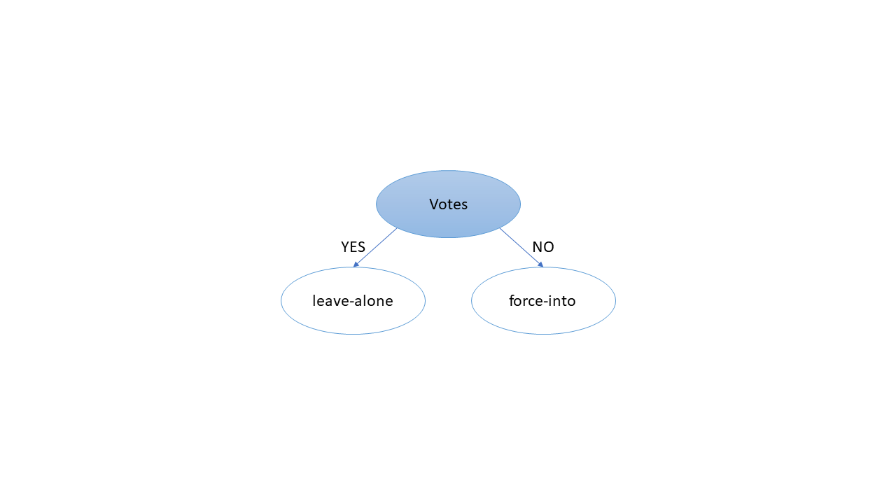**Draw the tree**
2. **What will the decision tree result, for the following:**

|  |  |  |  |
| --- | --- | --- | --- |
| **HAS a JOB** | **HAS an INSURANCE** | **VOTES** | **ACTION** |
| no | yes | yes | **leave-alone** |
| yes | no | yes | **leave-alone** |
| no | yes | no | **force-into** |