**MultiCast(V1.00.00)**

HimawariCast data reception software from Novra S300D

**Function:**

Writes files into target directory, which receivers from S300D receiver.

**Example:**

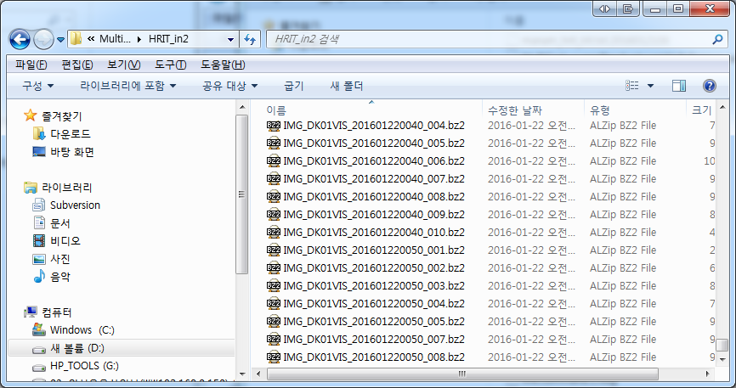

**Extra description:**

**-** Only one instance can be executable.

- Error containing data is not wrote.

**Components:**

|  |  |  |
| --- | --- | --- |
| **Type** | **File Name** | **Function** |
| Execution | MultiCast.bat | Batch file.  Example: MultiCast.exe 239.0.0.1 8001 |
| Execution | MultiCast.exe | Execution file |
| Setting File | MultiCast.conf | Configuration file |
| Library | Qt5Core.dll | Qt Library |

**MultiCast.conf Configuration**

This config file can be wrote in multi lines. Each line must consist of 3 items.

In case of example like this HRIT, D:/MultiCast/HRIT, yes

* **HRIT**: First items must be one among, HRIT, HRIT_in, HRIT_tmp, LRIT, MANAM, SATAID, SATAID_image, SATAID_Obs
* **D:/MultiCast**: Target directory where file will be wrote.
* **yes**: Whether create subdirectory or not.

Above example describes that if reception data is HRIT, write the reception into sub directory of *D:/MultiCast/HRIT/*. The sub directory will be created automatically, if it doesn't exists. Refers the JMA homepages regarding the available type of DATA.

A reception data can be wrote one more target. This configuration can be utilized for saving the data to reception processing s/w and Data Center like below example.

MANAM,D:/MultiCast/MANAM,no

MANAM,D:/MultiCast/MANAM2,no

**How to run:**

\INSTALLATION PATH\MultiCast.bat <enter>

Or

\INSTALLATION PATH\MultiCast.exe 239.0.0.1 8001 <enter>

( 239.0.0.1 8001 This two values are identical parameter for HimawariCast. Refers JMA Homepage )

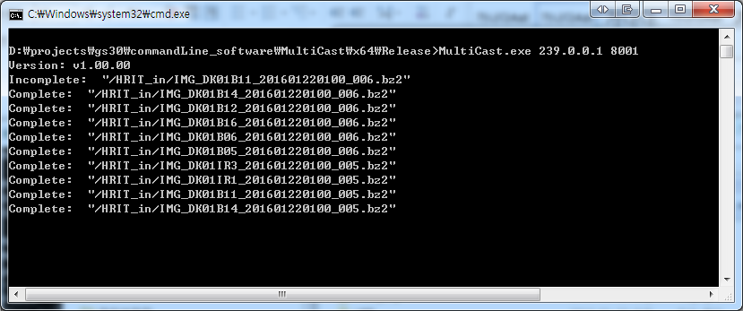

Once Multicast runs, log will be shown. Each means like below

* **Incomplete:** This file contains losing data. This file will not be saved because decompression is not available.
* **Complete:** Data is ok. This file will be saved.
* **Overflow:** This file may conation error. This file will be saved.