**CAN(Canaan)**

- Who is Canaan?

<https://canaan.io/>

<https://investor.canaan-creative.com/>

- Products

Mining machines:

A12

A11

A10

AI Chips

Kendryte K210

Kendryte K510(Will release next year)

- CEO: Nangeng Zhang

bachelor’s degree, electronic information engineering, Beihang University

master’s degree, software engineering, Beihang University

Ph.D degree at Beihang(drop the school, start bitcoin mining machine)

<https://www.youtube.com/watch?v=KcqYJZQEzps>

- How Canaan make money?

To understand how Canaan make money, we need to understand how mining works and what are the challenges.

There are several factors could affect mining profits:

1. Bitcoin price
2. Bitcoin halving (<https://academy.binance.com/zh/halving>)比特币产出减半
3. Bitcoin network total hash rate 全网算力(<https://www.blockchain.com/charts/hash-rate>)

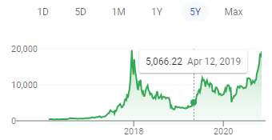 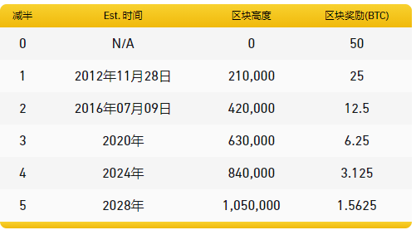 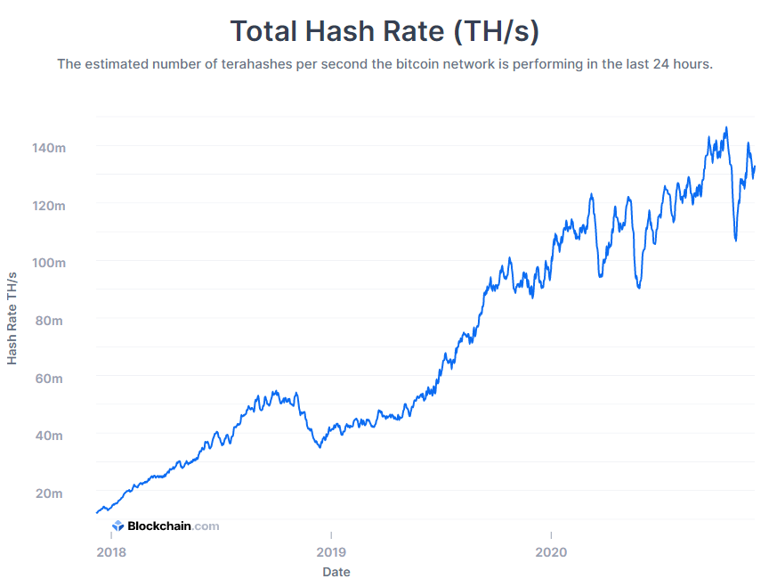

1. Mining machine hash rate, how fast it can compute. ( https://www.asicminervalue.com/)
2. Mining machine power consumption, how much electricity it needs

Machine Power Efficiency = electricity/hash rate

Based on above list, Canaan products are in top tier, but not a lot advantage.

Here are the relationships:

* If machine you have consume less power and compute fast, you can make more profits than those “old machines”.
* However, when new powerful machines join the network, the whole network total hash rate increase, which made the competition between miners much higher and mining become difficult -> less profit.
* When bitcoin price goes up, more people want to mine the coin and total network hash increase, depends on the bitcoin price / total network hash, if total hash increase much more than bitcoin price, miner won’t be profit.
* When Bitcoin halving happen, less bitcoin will be produced in future, and miner profit less.

How these factors affect Canaan profit?

You can simply think when more people want to mine the bitcoin, that’s when Canaan has more profit, and the profit usually delay for couple months or even longer. The reason is when people see bitcoin price goes up, they start purchasing mining machine, willing to pay higher price. If Canaan machines out of stock, it will take couple months for chip to ready from TSMC, Samsung, STATS and etc. Then final assembly machine and delivery to customers.

Challenge: What if bitcoin price goes down a lot?

People will stop mining, because you pay more for electricity than the coins value you get. People will pay less for the machine, you can calculate “fair” market machine price based on total network hash, bitcoin price and electricity price.

If a machine cost $15,000, one-year electricity cost $5,000 and you can get 1 bitcoin/year, assume one bitcoin worth $20,000, You will break even after a year. If bitcoin price reduced to $15,000, minus the electricity cost $5,000. You might only be willing to pay $10,000 for the machine. As time goes, more powerful, cheaper machines will join the network, your profitability will get less and less.

This is what happened to the Canaan since COVID, bitcoin price drop, they have to reduce the price to sell the machines, the supply chain is hard, cost for machines goes up and company struggling to make profit or even survive.

One big change they made since Q2, Q3 2020 is planning to mine themselves (cooperate with other people, Canaan provide machines, share the profits). This actually break this down circle. When bitcoin price drop, instead of cheap selling the machine, they can use inventory machines to mine bitcoins. The more bitcoin price drop and the more machine they will deploy for mining, vice versa. In this way, when bitcoin price goes up, they could have a very good return from selling bitcoin and not selling their machines too cheap.

Chips.

Initially, Canaan mainly developed FPGA(Field Programmable Gate Arrays) products, later it focus on ASIC(Application Specific Integrated Circuits) released Avalon Blockchain in 2018. ASIC give lower cost, better performance and low power consumption, however, it takes long time to market. After floor planning, hand off to foundry and need to wait 1 – 3 months

RISC(Reduced Instruction Set Computing) vs CISC(Complex Instruction Set Computing)

ARM, RISC-V vs X86  
<https://new.qq.com/omn/20191229/20191229A09X5D00.html>

Check above link to know the Instruction Set Architecture difference and why Canaan AI chip use RISC-V, for summary,

1. RISC-V is open source, no need to pay license fee/royalty fees.
2. RISC low power consumption, good for edge computing, IoT stuff.
3. Modular design.

Advantages of K210 AI chips.

<https://www.youtube.com/watch?v=eB1n_Z0SFxk>

K210 AI chip for face recognition.

<https://www.youtube.com/watch?v=yNO-om8t3W0>

Q2 Highlights

* Clearing out entire inventory.
* New mining machines under production have all been pre-ordered.
* Started accepting pre-orders for Q4 2020
* Completed R&D for 8nm chip, 20% improvement. Mass production early September.
* SMIC first-gen N+1 successful tape-out. Test performance has exceeded expectations.
* Expand overseas customer base, , tendering mining firms, involve 10K+ machines
* Partnered with VergeSense, K210 chips will be implement in motion sensors
* DJI selected K210 for STEM education project. Expect implement late 2020.
* UBTECH have begun production testing.
* Working on K510 next generation AI chip. Mass production early 2021

Q3 Highlights

* Cleared out inventory as of July.
* Fabrication process slow, will start deliver at Q4 2020, no significant revenue to Q3.
* R&D expense increased by 23.2%
* Sept 8, share repurchase up to 10 million. As Oct 30, bought back 2 million.
* A12 product 38 J/terahash.
* Large number of pre-sale orders, pre-sale deliveries have been scheduled to Q1 2021. (**45 million**)
* Revenue from U.S. drop sharply, expect recovery from next year
* 4k orders for AI chips from VergeSense
* Won number of tender for government contracts of smart door locks, partnership with Hangzhou smart city, Beijing haidian district.
* Monthly ship 20k – 30k chips. Expect 50k per month next year.
* K510 completed tape out process. Will launch Q1 2021.

**EBON**

<http://mall.ebang.com.cn/>

2017年的时候，随着比特币一度逼近20000美元后，矿机商一时风光无限。比特大陆、嘉楠耘智和亿邦国际作为区块链行业的代表也在2018年首次上榜《2018第二季度胡润大中华区独角兽指数》，其中比特大陆估值700亿元，嘉楠耘智估值200亿元，亿邦国际估值为100亿元。

如今在“三足鼎立”的矿机行业中，老二“嘉楠”和老三“亿邦”均已上市，可是成绩却都不理想，一家独大的“老大”比特大陆如今深陷“宫斗”，它的下一步会怎么走，能否为行业带来转机，也成为了大家关注的一个重点。

比特币矿工周赟透露，翼比特的矿机“大算力的基本都没见过，小算力的都被淘汰了”。

　　周赟所称的大算力机器一般指的是 40 TH/s以上的矿机。当下币价下，随着比特币算力的不断上涨（从去年中至今，比特币的算力已经翻了一倍），算力大、功耗比优秀的矿机越能占优势，而小算力和功耗比不大的矿机（比如S9）将逐渐被淘汰。

　　据官网显示，翼比特的矿机除了 E12 系列其余皆为小算力机器，但即便算力最高的翼比特E12，比较价格相差不大的比特大陆 95T的S19和比特微88T的M30S系列，也足足差了一倍。

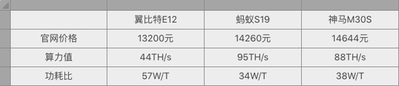

　　其他相同条件下，功耗比越小、算力值越大的矿机能够带来更高的收入。

而功耗比和算力值在很大程度上取决于芯片制程。蚂蚁矿机S19采用的是7nm制程芯片，神马矿机M30则采用8nm芯片，而翼比特E12矿机则是采用10nm芯片。

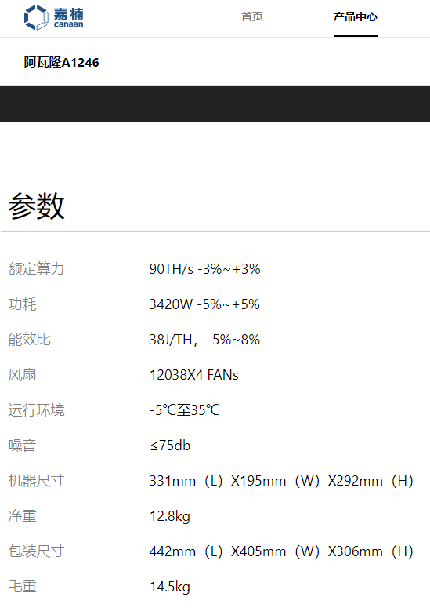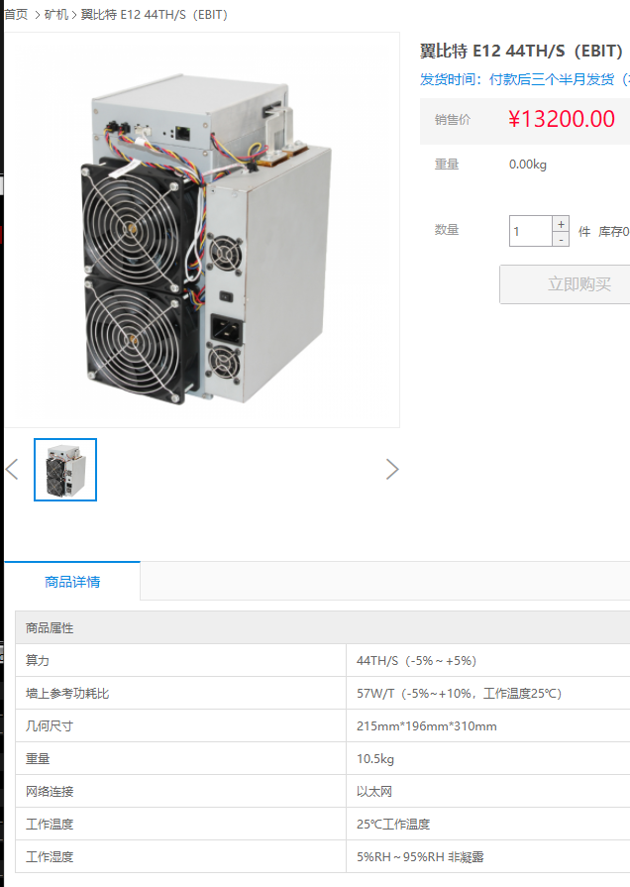

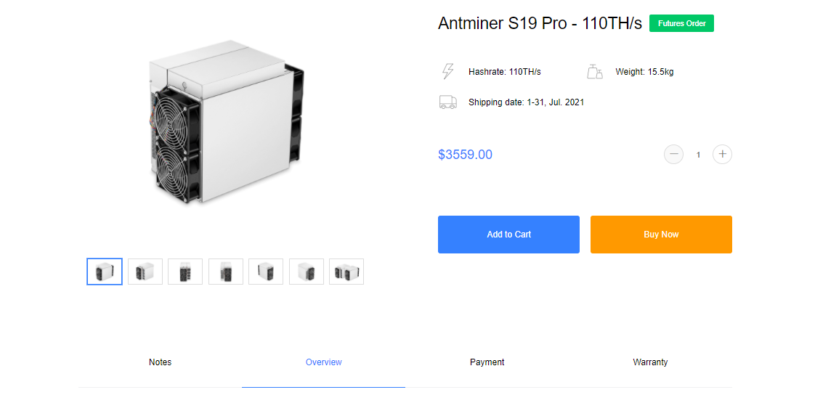

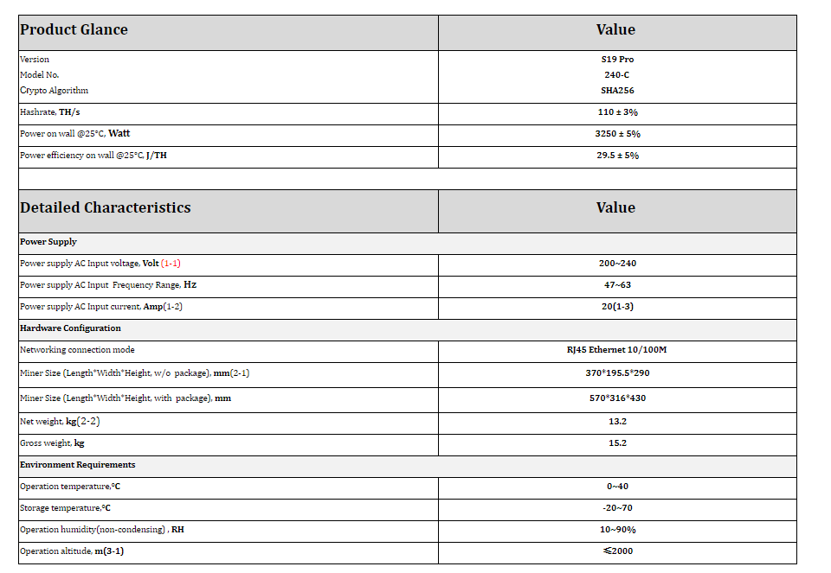

**MARA**

Marathon is a digital asset technology company that mines cryptocurrencies, with a focus on the blockchain ecosystem and the generation of digital assets. We currently operate our proprietary Data Center in Hardin MT with a maximum power capacity of 105 Megawatts. Once fully deployed, the Company will have 21,500 Antminer Bitmain S-19 Pro Bitcoin Miners in operation at this facility. The Company also owns 2,060 advanced ASIC Bitcoin Miners at a co-hosted facility in North Dakota. Marathon owns numerous Patents which the company may seek to monetize in the future.

LAS VEGAS, Dec. 09, 2020 (GLOBE NEWSWIRE) -- Marathon Patent Group, Inc. (NASDAQ:MARA) ("Marathon" or the "Company"), one of the largest enterprise Bitcoin self-mining companies in North America, has entered into a contract with Bitmain to purchase 10,000 Antminer S-19j Pro ASIC Miners.

Under the terms of the agreement, Marathon will receive an initial batch of 6,000 S-19j Pro Miners in August 2021. The remaining 4,000 miners will be delivered in September 2021.

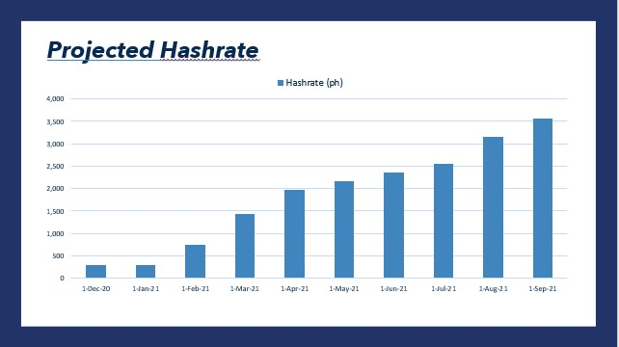



Once all of Marathon’s purchased miners are delivered and fully deployed, the Company’s mining portfolio will consist of 33,560 state of the art ASIC miners, generating 3.56 EH/s. As a result, the Company will be consuming approximately 100 MWs of power, the maximum amount available at the Company’s data center in Hardin, MT.

To continue expanding its operations, the Company is working with its energy partner, Beowulf Energy, to open a renewable energy powered data center in the northeastern United States. This facility will initially provide Marathon with an additional 100 MWs of power and has the potential to increase to 250 MWs of power.

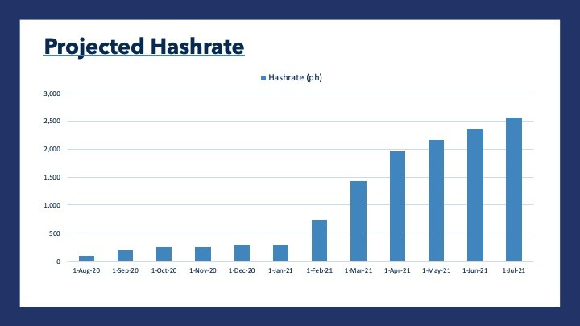

Start to order new miner since summer of 2020.

Most Antminer Bitmain S-19 Pro

(OCTOBER 13, 2020 ) Beowulf will provide power from the Hardin plant to the Data Center at a production cost of $0.028/kWh.

The Data Center will lower Marathon’s aggregate mining cost for electricity and data center management, which is 38% below the Company’s current cost of mining at $0.034/kWh. This low-cost electricity reduces Marathon’s breakeven costs to produce Bitcoin from approximately $7,500 per Bitcoin today to $4,600 per Bitcoin, dramatically improving the Company’s future profitability. (bitcoin half on May 11, 2020).



Also need onside mining machine cost

The Montana based operation should be up and running by July next year(July 2021) and should set Marathon up to “deliver as much as 1.5% of the entire bitcoin network hash.” (In layman’s terms: the computing power required to secure the network).

(2020 Q3) During Q3, the company purchased more than 20,000 new mining ASICs.

Marathon is also holding more bitcoin than ever before.

The value of bitcoins held by the firm has more than quadrupled since the previous quarter, reaching $450,000 at the end of Q3. Bitcoin appreciated 17% in Q3 ending the period at $10,600.

“In all previous quarters, we only produced enough BTC that needed to be sold to cover the cost of our operations,” a Marathon spokesperson told CoinDesk via email. But because the firm no longer needs to cover operating costs by selling newly minted bitcoins, the company has started to simply hold the assets.

The company reported a Q3 net loss of $1.99 million, or 6 cents a share, compared with the year-ago loss of $754,407, or 12 cents. A surge in the number of shares outstanding to 31.5 million from 6.37 million, accounts for the halving of the per share loss despite the large increase in the dollar figure loss.

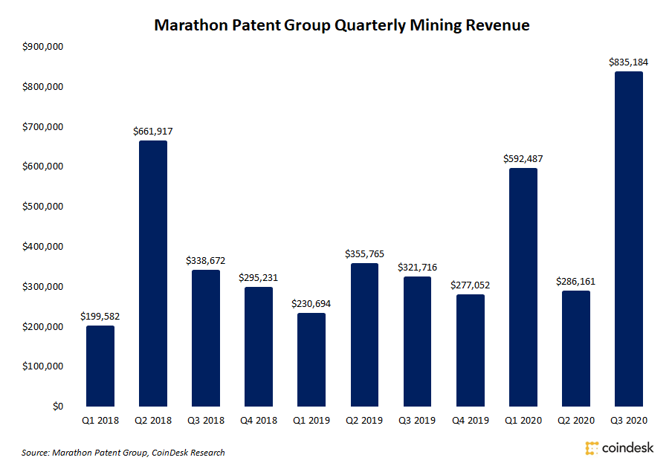

Until Marathon’s announcement, Riot Blockchain was aiming to emerge as the region’s top miner with a 2.3 EH/s hashrate targeted for June 2021 after purchasing 18,640 S-19s this year.

In August the company announced a $23 million deal with Bitmain to buy 10,500 S-19 Pro Miners, which it called a milestone event.

23,000,000/10,500=$2190 each S-19 Pro

|  |  |  |  |  |
| --- | --- | --- | --- | --- |
|  | 2020 |  | 2019 |  |
|  | Q3 | 9month | Q3 | 9month |
| Revenue $ | 835,184 | 1,700,700 | 321,716 | 908,175 |
| operation loss S | 2.E+06 | 5.20E+06 | 8.07E+05 | 2.50E+06 |
| Per share loss $ | 0.06 | 0.28 | 0.12 | 0.37 |
| # of share | 3.33E+13 | 1.86E+13 | 6.73E+12 | 6.76E+12 |
| cash used $ | 1.40E+06 | 3.40E+06 |  |  |
| Cash available 9/30/20$ | 1.73E+07 |  |  |  |
| Cash on 11/12/20 $ | 2.71E+07 |  |  |  |
| Cost of revenue | 1,636,046 |  |  |  |

For 4th quarter, assume

1. Bitcoin price double.
2. Mine same amount bitcoin/month
3. Cost of revenue no change

Revenue $1.6e6 still < Cost of revenue

**RIOT**

Our 100% dedicated bitcoin mining operations is currently located at Coinmint LLP’s Massena, New York facility which houses our currently deployed hardware fleet consisting of 6,040 next generation Bitmain Antminers. We currently have a deployed **hash rate capacity of 456 PH/s** (by comparison: mara <300 PH/s now ) utilizing approximately 16.3 megawatts (MW) of energy.

Riot has 1,000 more S19 Pros scheduled for delivery in early November 2020 which is expected to increase our hash rate capacity to 566 PH/s utilizing approximately 19.7 MW of energy.

We also have 8,000 S19 Pros scheduled for delivery in equal installments over the first four months of 2021. By early May 2021 we are expected to have a total hash rate capacity of **1.45 EH/s (1,446 PH/s)** while utilizing approximately 46 MW of energy. (Mara will be ~2100PH/s)

November 2020 - The third outstanding order consisting of 1,000 S19 Pro (110 TH/s) miners is expected to arrive, which will bring Riot's mining fleet to a total of 7,040 miners, with an expected operational hashing capacity of 566 PH/s.

January – April 2021 - The newly announced order of 8,000 S19 Pro (TH/s) miners are expected to be received and deployed during the first four months of 2021 and are expected to raise Riot's total operational hash rate capacity to 1.45 EH/s (1,446 PH/s). Riot expects to then have a fully deployed fleet totaling approximately 15,040 miners.

202012/21: Riot Blockchain Purchases Additional 15,000 Antminers from Bitmain – Expanding 2021 Total Hash Rate Capacity Over **3.8 EH/s**. Riot Continues Its Bitcoin Mining Hash Rate Growth with Additional Purchase Expanding Total Fleet to 37,640 Next-Generation Bitmain Antminers. (mara max hash rate is planed to 3.5EH/s)

Produced 730 newly minted bitcoins (BTC) during the nine-month period ended September 30, 2020, despite experiencing downtime associated with relocating to Coinmint's facility in the second quarter of 2020, the BTC halving event that occurred in May 2020, and continued increases in network hashrate during 2020.

Produced 508 newly minted bitcoins (BTC) during the six-month period ended June 30, 2020

4.5month*2 + 4.5mon🡪730BTC: ~54 BTC/month after halving

3rd qt only, produced 222BTC, 77BTC/month

Future revenue: 3,888,000-5,328,000

Riot Blockchain, a NASDAQ listed cryptocurrency mining company, announced yesterday that it had purchased an additional 1,000 next-generation Bitmain S19 Pro (110 TH) Antminers for $2.3 million from Bitmain. 2300000/1000=$2300/per S19

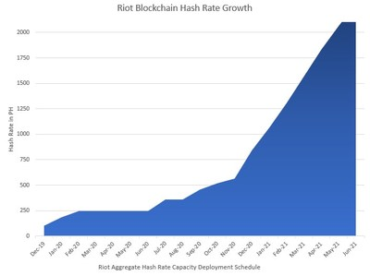

|  |  |  |  |  |
| --- | --- | --- | --- | --- |
|  | 2020 |  | 2019 |  |
|  | Q3 | 9month | Q3 | 9month |
| Revenue 1000$ | 2,462 | 6,790 | 1,740 | 5,637 |
| operation loss $ | 2.E+06 | 1.66E+07 | 1.83E+06 | 1.66E+07 |
| Per share loss $ | 0.04 | 0.46 | 0.08 | 0.93 |
| # of share | 4.29E+13 | 3.61E+13 | 2.29E+13 | 1.79E+13 |
| cash used $ |  | 1.66E+07 |  | 16862000 |
| cash | 3.91E+07 |  | 1.13E+07 |  |
|  |  |  |  |  |
| Cost of revenue |  |  |  |  |

**BTBT**

[**https://seekingalpha.com/article/4396054-bit-digital-crypto-miner-benefiting-from-bitcoin-bull-market**](https://seekingalpha.com/article/4396054-bit-digital-crypto-miner-benefiting-from-bitcoin-bull-market)

**Financial Highlights for the Third Quarter 2020**

Revenue from bitcoin mining business was $7.91 million.

The number of bitcoins earned from bitcoin mining business was 739.51.

The number of miners was 22,869, with 16,964 miners acquired in the third quarter 2020.

The net income from continuing operations of $0.10 million was all from bitcoin mining business, compared to $nil for the third quarter 2019.

The net loss from discontinued operations was $0.10 million for the third quarter 2020, as we disposed of peer-to-peer and car rental business in the PRC, compared with the net loss from discontinued operations of $1.22 millionfor the third quarter 2019.

The net income was $54 and the earnings per share was $0.00 for the third quarter 2020, compared with $3.0 million and $0.20 for the same period last year.

**Financial Highlights for the Nine Months 2020**

Revenue from bitcoin mining business was $8.60 million.

The number of bitcoins earned from bitcoin mining business was 814.23.

The number of miners was 22,869, all miners acquired in the nine months 2020.

The net loss from continuing operations of $0.73 million was all from bitcoin mining business, compared to $1.79 million for the nine months 2019.

The net loss from discontinued operations was $3.83 million for the nine months 2020, as we provided full impairment on assets for our discontinued peer-to-peer and car rental business in the PRC, compared with the net loss from discontinued operations of $7.68 million for the nine months 2019.

The net loss was $4.56 million and the loss per share was $0.18 for the nine months 2020, compared with $9.47 million and $0.63 for the same period last year.

February 2020 - We commenced the bitcoin mining business.

April 2020 - We launched 6,004 MicroBT M21S miners with a total hash rate of 310 Ph/s.

July 2020 - We launched an additional 16,865 units of miners, including 800 units Innosilicon T3 miners, 256 Bitmain T17+ miners, 2,200 MicroBT M10 miners, 2,696 MicroBT M20S miners and 10,813 MicroBT M21S miners. The total hash rate reached to 1,250 Ph/s.

September 2020 - We launched an additional 100 MicroBT M21S miners in the United States.

December 2020 - We launched an additional 17,996 units of miners, including 7,025 Antminer S17+ miners, 9,110 Antminer T17 miners, 195 Antminer S17E miners, 32 Antminer S17Pro miners, 105 Antminer S19Pro miners, 1,429 Whatsminer M20S miners and 100 Whatsminer M31S miners.The total hash rate reached to 2,253.5 Ph/s.

Our take is that Bit Digital simply appears undervalued vis-a-vis these comparables. Some of the explanations that could justify such a spread include that some of BTBT's operating facilities are in China while the other companies have announced more aggressive expansion plans. MARA expects to deploy more than 30,000 mining rigs over the next year compared to just 2,060 operational at the end of Q3 and is a stock we have previously been bullish on. MARA also has taken steps to contract electricity at favorable rates with an energy partner as an additional bullish tailwind.

Simply annualizing the Q3 revenue rate for BTBT to $32 million, the stock is trading at a price to sales ratio of **9x**, which will well below 261x for MARA, 103x for RIOT, and 77x for CLSK with the same back of the envelope calculation. The challenge in setting a valuation metric is that the market is currently trading off of sentiment towards the Bitcoin pricing environment as the cryptocurrency has more than doubled over the 3 months. All of the bitcoin miners are generating more bitcoins at higher prices.

