# Qt编译环境配置

# 参考资料

Github：<https://github.com/yhm2046/QtResources>

Qt中文社区：<http://www.qtcn.org/bbs/i.php>

Qt5.9 c++开发指南

异步社区：www.epubit.com

# Ubuntu18.04

## Arm交叉编译环境

参考：QT5.12.1 ARM开发环境搭建 并 移植到RK3399 ubuntu16.04系统运行【完整版】

<https://blog.csdn.net/weixin_44031368/article/details/108076798>

arm编译器：aarch64-linux-gnu

需要下载工具：

**aarch64-linux-gnu-gcc，地址：**<https://www.linaro.org/downloads/>

**qt-everywhere-src-5.12.1.tar.xz** :<http://download.qt.io/official_releases/qt/5.12/5.12.1/single/>

**qt-opensource-linux-x64-5.12.0.run** <http://download.qt.io/official_releases/qt/5.12/5.12.1/>

auto.sh 交叉编译配置脚本

*#!/bin/sh*

*./configure *

*-prefix /home/cnd/Qt/qt-arm \ //输出目录*

*-confirm-license *

*-opensource *

*-release *

*-make libs *

*-xplatform linux-aarch64-gnu-g++ \ //编译器试试*

*-pch *

*-qt-libjpeg *

*-qt-libpng *

*-qt-zlib *

*-no-opengl *

*-no-sse2 *

*-no-openssl *

*-no-cups *

*-no-glib *

*-no-dbus *

*-no-xcb *

*-no-separate-debug-info *

视频演示：

Ubuntu18.04生成arm可执行文件：<https://www.youtube.com/watch?v=UYsx-BYOnek>

# Windows10

将已经交叉编译好的arm qt库以及开发环境部署到windows下，这样就可以实现在windows下开发和编译arm qt程序，再也不用打开虚拟机了

Web: <https://www.jianshu.com/p/5d9e24f7c4e9>

[Windows平台交叉编译Arm Linux平台的QT5.7库](https://www.cnblogs.com/qinwanlin/p/6956833.html)

Tools:

<https://developer.arm.com/tools-and-software/open-source-software/developer-tools/gnu-toolchain/gnu-a/downloads>

arm-none-linux-linux-gcc

qt4_build_arm_qt.zip

qtcreator

reference

qt version wiki: <https://en.wikipedia.org/wiki/Qt_version_history>

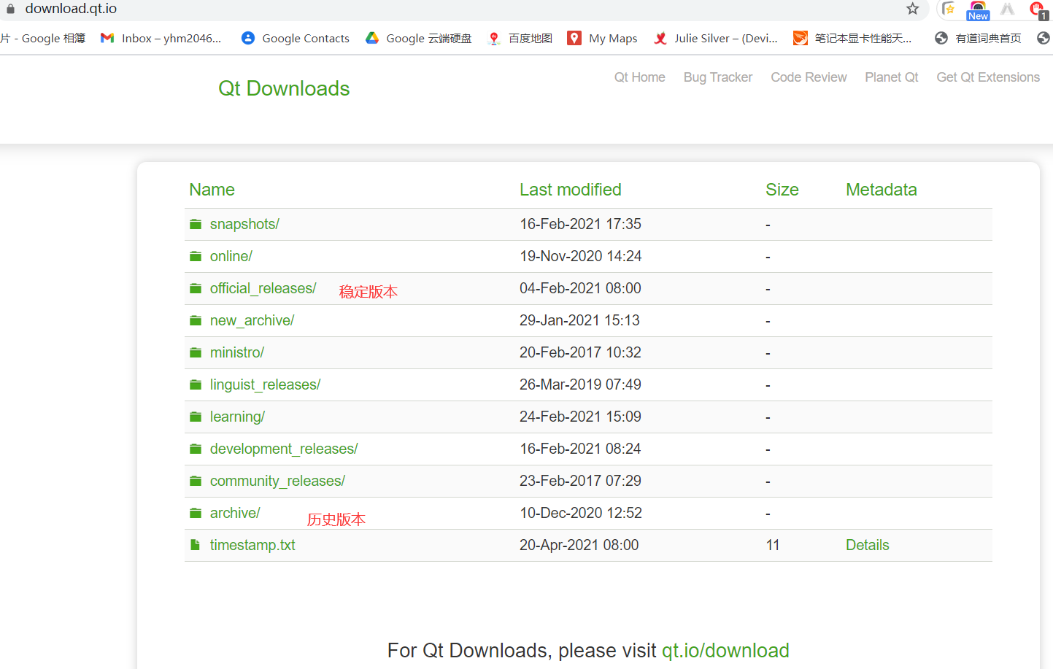

本地下载软件: O:\home\Drive\00_cnd文件\rk3308_linux

## 軟件下載

1. 源码

[qt-everywhere-src-5.12.10](https://download.qt.io/official_releases/qt/5.12/5.12.10/single/qt-everywhere-src-5.12.10.zip) <https://download.qt.io/official_releases/qt/5.12/5.12.1/single/>

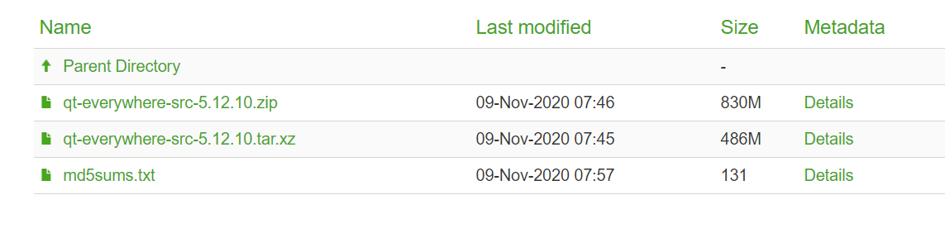

1. ActivePerl-5.32.1-MSWin32-x86-64int-300560.exe <https://www.perl.org/get.html>
2. python-3.9.4.exe <https://www.python.org/downloads>
3. mingw-w64-install.exe <https://sourceforge.net/projects/mingw-w64>
4. gcc-linaro-arm-linux-gnueabihf-4.9-2014.07-20140726_win32.exe

[gcc-arm-10.2-2020.11-mingw-w64-i686-arm-none-linux-gnueabihf.tar.xz](https://developer.arm.com/-/media/Files/downloads/gnu-a/10.2-2020.11/binrel/gcc-arm-10.2-2020.11-mingw-w64-i686-arm-none-linux-gnueabihf.tar.xz?revision=04032fd8-b142-4086-a50f-77bc843647a9&la=en&hash=CFE3143EC78AC9F3F98BD19911B901C129F5B833)

https://releases.linaro.org/archive/14.07/components/toolchain/binaries/

## 交叉编译命令

configure.bat -release -opensource -prefix D:\Qt5.12.10_ARM_Linux -nomake tests -nomake examples -no-opengl -skip qtvirtualkeyboard -xplatform arm-linux-gnueabihf-g++