**EXPERIMENT-2**

**Om Hedau**

**BE-3-25**

* **Part1 : Using sqoop to import data from mysql to hadoop**
* mysql -u root -pcloudera

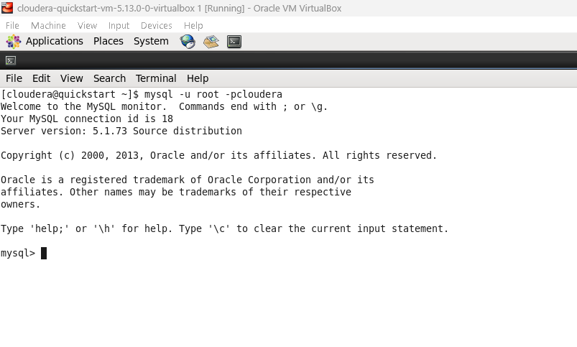

* CREATE DATABASE db;

USE db;

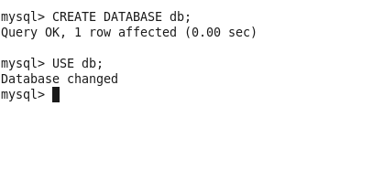

* CREATE TABLE employees (

id INT NOT NULL PRIMARY KEY,

name VARCHAR (20),

deg VARCHAR (20),

salary INT,

dept VARCHAR (10)

);

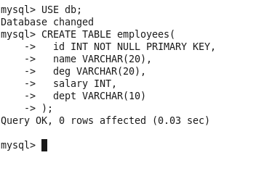

* INSERT INTO employees VALUES (1, ‘Archit Lokhande’, ‘SDE1’, 100000, ‘SD’),

(2, ‘Om Hedau’, ‘Data Analyst’, 75000, ‘DW’),

(3, ‘Shail Patil’, ‘Data Scientist’, 120000, ‘DW’),

(4, ‘Mihir Khatri’, ‘Cyber Expert’, 105000, ‘ST’);

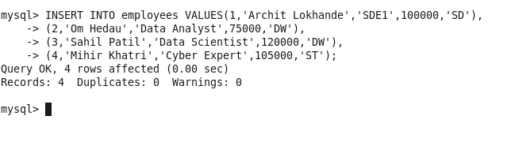

* Exit

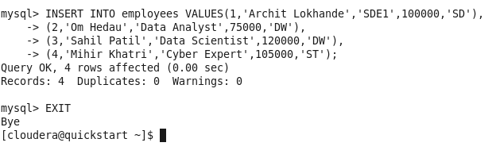

* sqoop import --connect jdbc:mysql://localhost/db --username root --table employees --password cloudera

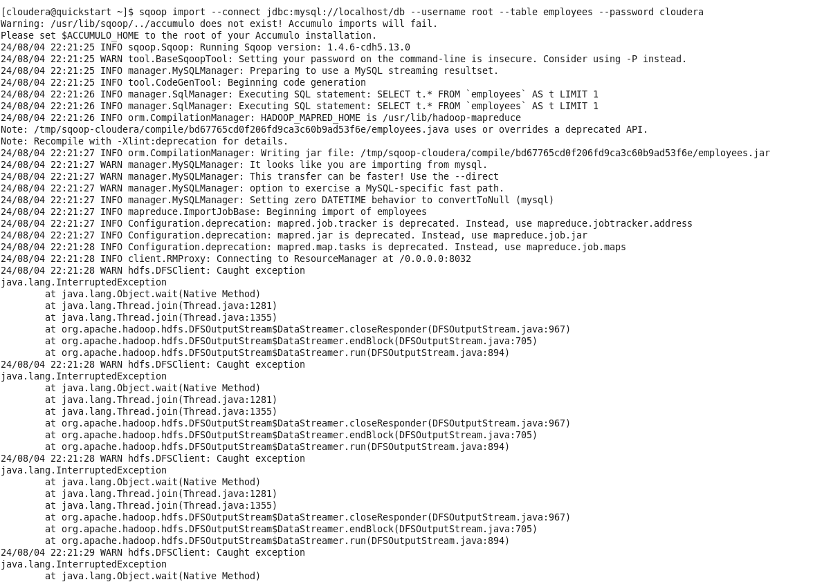

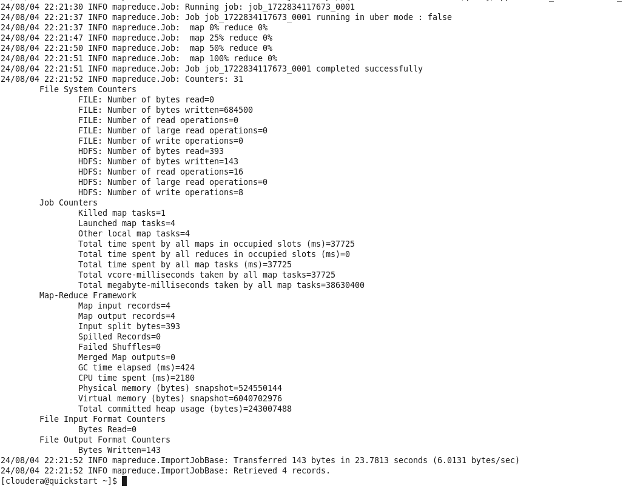

* hadoop fs -ls /user/cloudera/employees

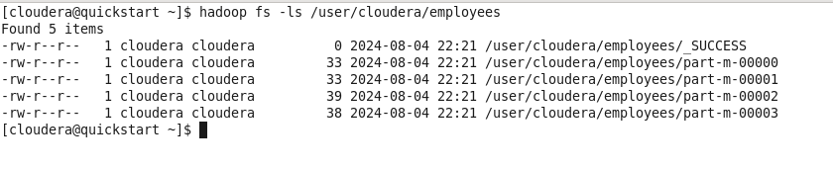

* hadoop fs -ls /user/cloudera/employees/part-m-00000
* hadoop fs -ls /user/cloudera/employees/part-m-00001
* hadoop fs -ls /user/cloudera/employees/part-m-00002

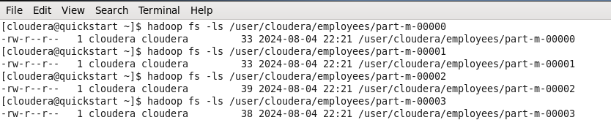

* **Part2 : Using sqoop to export table from Hadoop to mysql**

mysql -u root -pcloudera

Use db;

DROP TABLE employees;

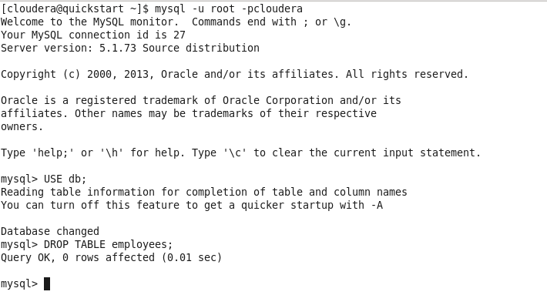

* CREATE TABLE employees (

id INT NULL PRIMARY KEY;

name VARCHAR (20),

deg VARCHAR (20),

salary INT,

dept VARCHAR (10)

);

EXIT;

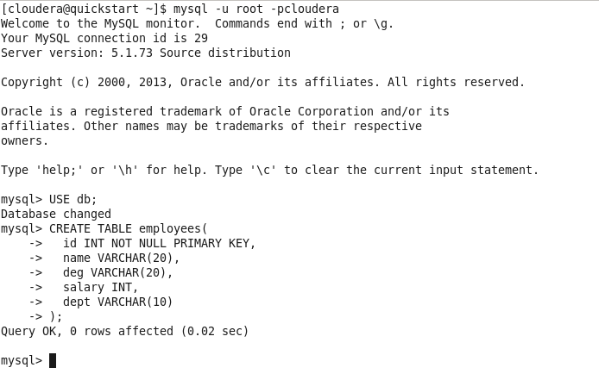

* sqoop export --connect jdbc:mysql://localhost/db-table employees --export-dir /user/cloudera/employees --input-fields-terminated-by ‘,’ --username root --password cloudera

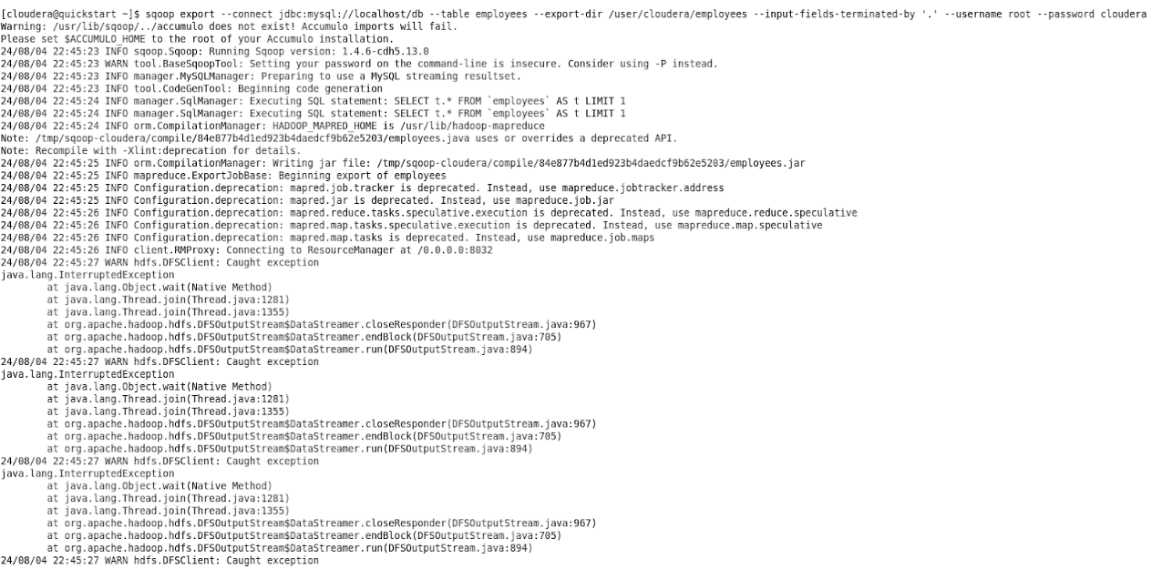

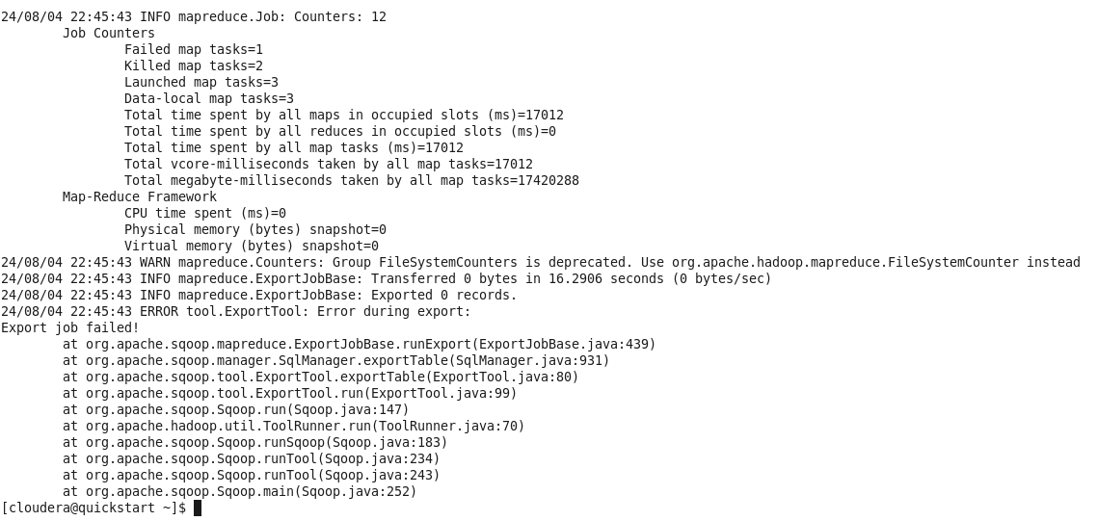

mysql -u root -pcloudera

USE db;

SELECT * FROM employees;

