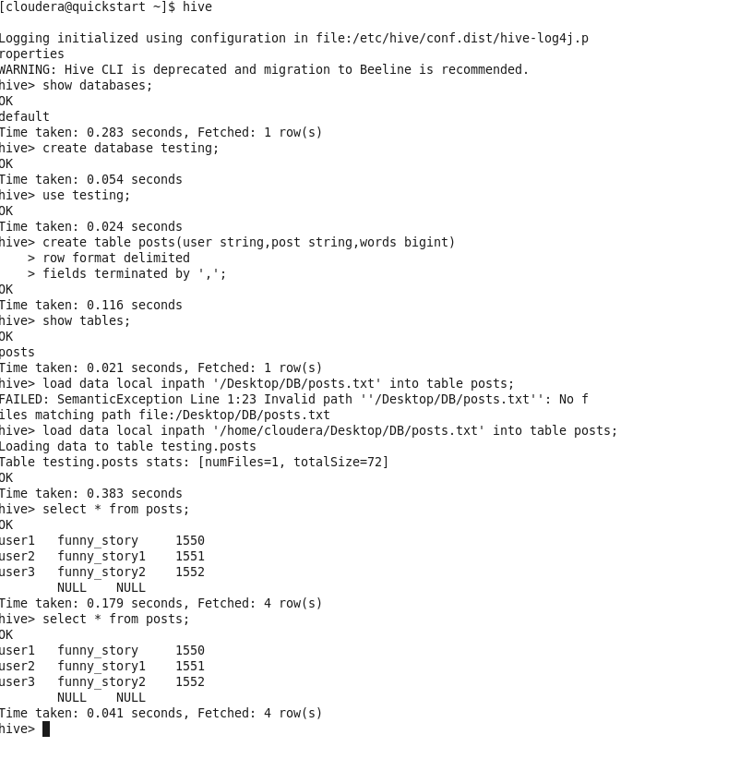

[cloudera@quickstart ~]$ hive

Logging initialized using configuration in file:/etc/hive/conf.dist/hive-log4j.p roperties

WARNING: Hive CLI is deprecated and migration to Beeline is recommended.

hive> show databases;

OK

default

Time taken: 0.283 seconds, Fetched: 1 row(s)

hive> create database testing;

OK

Time taken: 0.054 seconds

hive> use testing;

OK

Time taken: 0.024 seconds

hive> create table posts (user string, post string, words bigint)

OK

> row format delimited

> fields terminated by ',';

Time taken: 0.116 seconds

hive> show tables;

OK

posts

Time taken: 0.021 seconds, Fetched: 1 row(s)

hive> load data local inpath '/Desktop/DB/posts.txt' into table posts;

FAILED: SemanticException Line 1:23 Invalid path ''/Desktop/DB/posts.txt'': No f iles matching path file: /Desktop/DB/posts.txt

hive> load data local inpath '/home/cloudera/Desktop/DB/posts.txt' into table posts; Loading data to table testing.posts

Table testing. posts stats: [numFiles=1, totalSize=72]

OK

Time taken: 0.383 seconds

hive> select from posts;

OK

user1

user2

user3

funny_story

funny_story1

funny_story2

NULL NULL

1550

1551

1552

Time taken: 0.179 seconds, Fetched: 4 row(s)

hive> select * from posts;

OK

user1

user2

user3

funny_story

funny_story1

funny_story2

NULL NULL

1550

1551

1552

Time taken: 0.041 seconds, Fetched: 4 row(s)

hive>