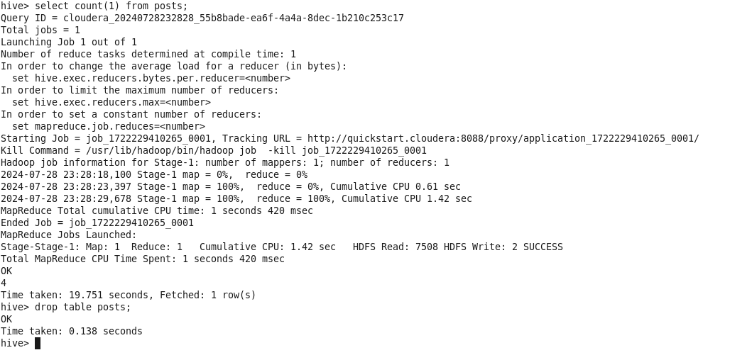

hive> select count(1) from posts;

Query ID = cloudera_20240728232828_55b8bade-ea6f-4a4a-8dec-1b210c253c17 Total jobs

1

Launching Job 1 out of 1

Number of reduce tasks determined at compile time: 1

In order to change the average load for a reducer (in bytes):

set hive.exec.reducers.bytes. per.reducer=<number>

In order to limit the maximum number of reducers:

set hive.exec. reducers.max=<number>

In order to set a constant number of reducers:

set mapreduce.job. reduces=<number>

Starting Job = job_1722229410265_0001, Tracking URL = http://quickstart.cloudera: 8088/proxy/application_1722229410265_0001/ Kill Command = /usr/lib/hadoop/bin/hadoop job -kill job_1722229410265_0001

Hadoop job information for Stage-1: number of mappers: 1; number of reducers: 1

2024-07-28 23:28:18, 100 Stage-1 map = 0%, 2024-07-28 23:28:23,397 Stage-1 map = 100%,

2024-07-28 23:28:29,678 Stage-1 map = 100%,

reduce = 0%

reduce = 0%, Cumulative CPU 0.61 sec reduce = 100%, Cumulative CPU 1.42 sec

MapReduce Total cumulative CPU time: 1 seconds 420 msec

Ended Job = job_1722229410265_0001 MapReduce Jobs Launched:

Stage-Stage-1: Map: 1 Reduce: 1

Cumulative CPU: 1.42 sec

HDFS Read: 7508 HDFS Write: 2 SUCCESS

Total MapReduce CPU Time Spent: 1 seconds 420 msec

OK

4

Time taken: 19.751 seconds, Fetched: 1 row(s)

hive> drop table posts;

OK

Time taken: 0.138 seconds

hive>