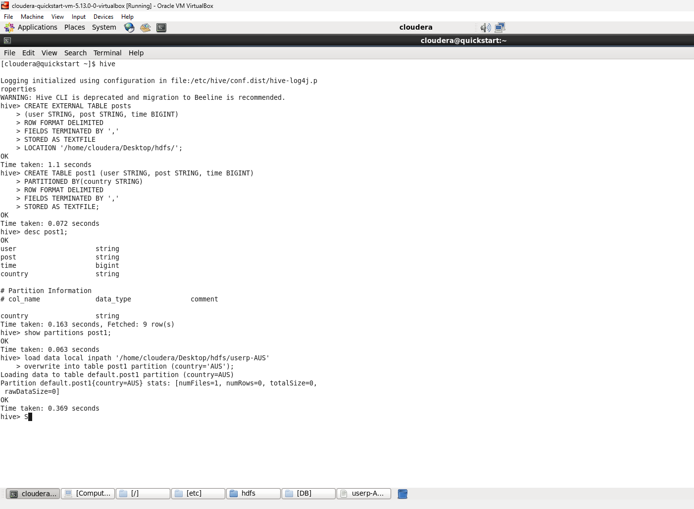

cloudera-quickstart-vm-5.13.0-0-virtualbox [Running] - Oracle VM VirtualBox

File

Machine View Input Devices Help

Applications Places System

File Edit View Search Terminal Help

[cloudera@quickstart ~]$ hive

Logging initialized using configuration in file:/etc/hive/conf.dist/hive-log4j.p roperties

WARNING: Hive CLI is deprecated and migration to Beeline is recommended.

hive> CREATE EXTERNAL TABLE posts

OK

> (user STRING, post STRING, time BIGINT)

> ROW FORMAT DELIMITED

> FIELDS TERMINATED BY

> STORED AS TEXTFILE

> LOCATION '/home/cloudera/Desktop/hdfs/';

Time taken: 1.1 seconds

hive> CREATE TABLE post1 (user STRING, post STRING, time BIGINT)

OK

> PARTITIONED BY (country STRING)

> ROW FORMAT DELIMITED

> FIELDS TERMINATED BY ','

> STORED AS TEXTFILE;

Time taken: 0.072 seconds

hive> desc post1;

OK

user

post

time

country

# Partition Information

# col_name

country

string

string

bigint

string

data type string

comment

Time taken: 0.163 seconds, Fetched: 9 row(s)

hive> show partitions post1;

OK

Time taken: 0.063 seconds

hive> load data local inpath '/home/cloudera/Desktop/hdfs/userp-AUS'

> overwrite into table post1 partition (country='AUS');

Loading data to table default.postl partition (country=AUS)

Partition default.post1{country=AUS} stats: [numFiles=1, numRows=0, totalSize=0, rawDataSize=0]

OK

Time taken: 0.369 seconds

hive> S

cloudera..

[Comput...

[etc]

hdfs

[DB]

userp-A...

**cloudera**

**cloudera@quickstart:~**