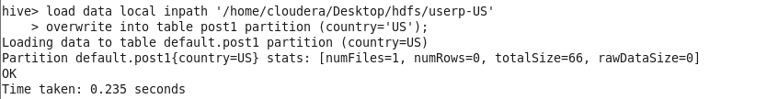

hive> load data local inpath '/home/cloudera/Desktop/hdfs/userp-US'

> overwrite into table post1 partition (country='US');

Loading data to table default.post1 partition (country=US)

Partition default.post1{country=US} stats: [numFiles=1, numRows=0, totalSize=66, rawDataSize=0] OK

Time taken: 0.235 seconds