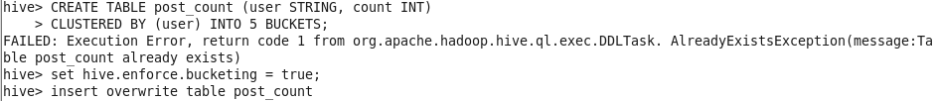

org.apache.hadoop.hive.ql.exec.DDLTask. AlreadyExistsException (message:Ta

hive> CREATE TABLE post_count (user STRING, count INT)

> CLUSTERED BY (user) INTO 5 BUCKETS; FAILED: Execution Error, return code 1 from ble post_count already exists)

hive> set hive.enforce.bucketing = true; hive> insert overwrite table post_count