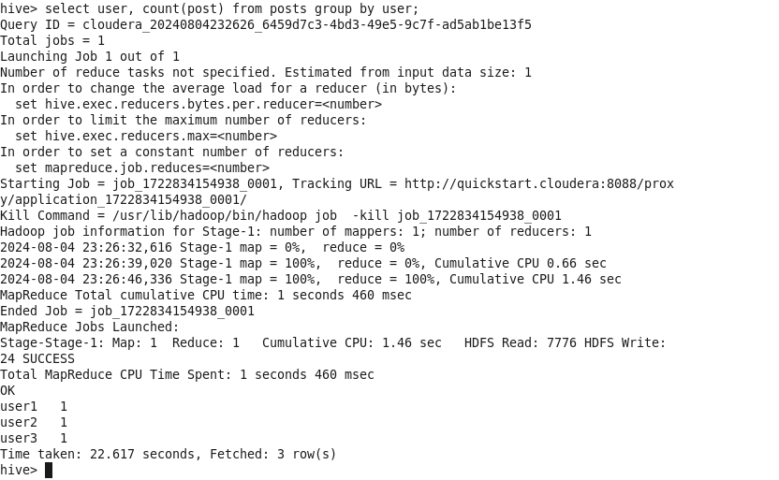

hive> select user, count (post) from posts group by user;

Query ID = cloudera_20240804232626_6459d7c3-4bd3-49e5-9c7f-ad5ab1be13f5 Total jobs = 1

Launching Job 1 out of 1

Number of reduce tasks not specified. Estimated from input data size: 1 In order to change the average load for a reducer (in bytes):

set hive.exec.reducers.bytes. per.reducer=<number>

In order to limit the maximum number of reducers:

set hive.exec. reducers.max=<number>

In order to set a constant number of reducers: set mapreduce.job. reduces=<number>

Starting Job job_1722834154938_0001, Tracking URL =

y/application_1722834154938_0001/

http://quickstart.cloudera: 8088/prox

Kill Command=/usr/lib/hadoop/bin/hadoop job -kill job_1722834154938_0001 Hadoop job information for Stage-1: number of mappers: 1; number of reducers: 1 2024-08-04 23:26:32,616 Stage-1 map 0%, reduce = 0% 2024-08-04 23:26:39,020 Stage-1 map = 100%, 2024-08-04 23:26:46,336 Stage-1 map = 100%,

=

reduce 0%, Cumulative CPU 0.66 sec reduce = 100%, Cumulative CPU 1.46 sec

MapReduce Total cumulative CPU time: 1 seconds 460 msec

Ended Job = job_1722834154938_0001

MapReduce Jobs Launched:

Stage-Stage-1: Map: 1 Reduce: 1 Cumulative CPU: 1.46 sec HDFS Read: 7776 HDFS Write: 24 SUCCESS

Total MapReduce CPU Time Spent: 1 seconds 460 msec

OK

user1 1

user2 1

user3 1

Time taken: 22.617 seconds, Fetched: 3 row(s)

hive>