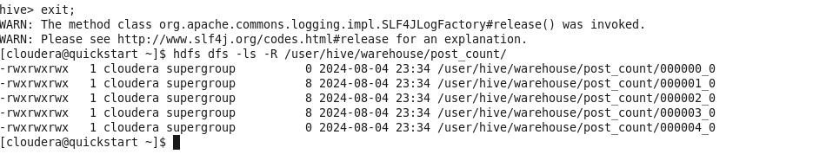

hive> exit;

WARN: The method class org.apache.commons.logging.impl.SLF4JLogFactory#release() was invoked. WARN: Please see http://www.slf4j.org/codes.html#release for an explanation. [cloudera@quickstart ~]$ hdfs dfs -ls -R /user/hive/warehouse/post_count/

-rwxrwxrwx 1 cloudera supergroup -rwxrwxrwx 1 cloudera supergroup -rwxrwxrwx 1 cloudera supergroup -rwxrwxrwx 1 cloudera supergroup 1 cloudera supergroup [cloudera@quickstart ~]$ |

-rwxrwxrwx

02024-08-04 23:34 /user/hive/warehouse/post_count/000000_0

8 2024-08-04 23:34 /user/hive/warehouse/post_count/000001_0

8 2024-08-04 23:34

8 2024-08-04 23:34

/user/hive/warehouse/post_count/000002_0 /user/hive/warehouse/post_count/000003_0

0 2024-08-04 23:34 /user/hive/warehouse/post_count/000004_0