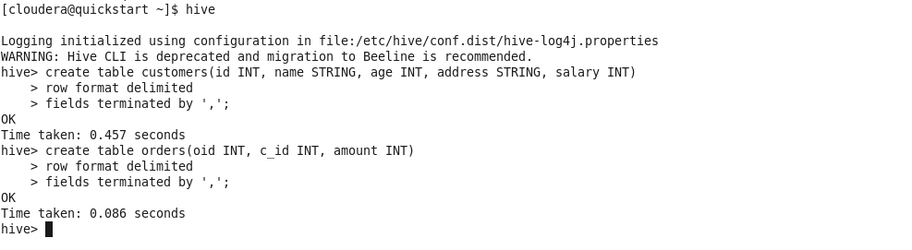

[cloudera@quickstart ~]$ hive

Logging initialized using configuration in file:/etc/hive/conf.dist/hive-log4j.properties WARNING: Hive CLI is deprecated and migration to Beeline is recommended.

hive> create table customers (id INT, name STRING, age INT, address STRING, salary INT) > row format delimited

OK

> fields terminated by ',';

Time taken: 0.457 seconds

hive> create table orders (oid INT, c_id INT, amount INT)

OK

> row format delimited

> fields terminated by ','

Time taken: 0.086 seconds hive>