**Name**: Soham Mahadik

**Roll No**. BE4-B-27

**PRN**: 21UF16438CM092

**Aim :** To implement Principal Component Analysis (PCA).

**Code:**

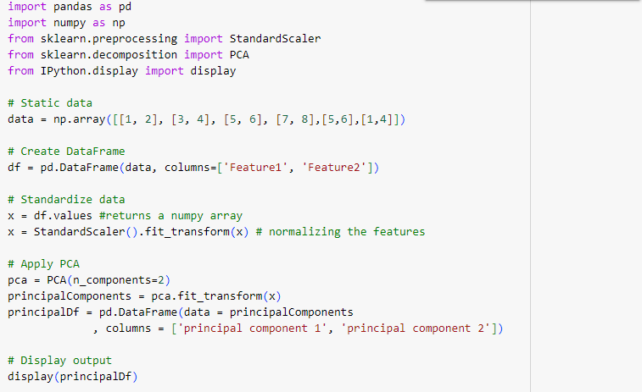

**Output:**

