**Name**: Soham Mahadik

**Roll No**. BE4-B-27

**PRN**: 21UF16438CM092

**Aim:** Implement the following unsupervised learning algorithm: Self-Organizing Maps

**Code:**

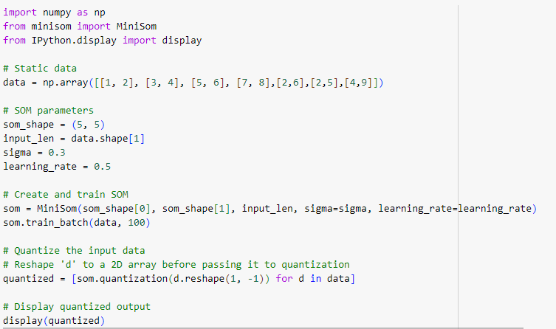

**Output:**

