**Name**: Soham Mahadik

**Roll No**. BE4-B-27

**PRN**: 21UF16438CM092

**Aim :** Implement Newton’s method optimization techniques.

**Code:**

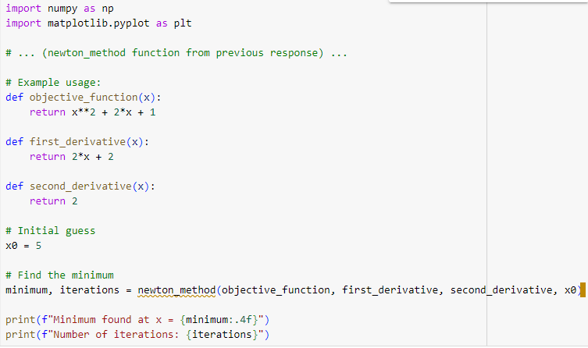

**Output:**

