

Safety Plan Lane Assistance

**Document Version: [RC1]**

**Template Version 1.0, Released on 2017-06-21**



# Document history

|  |  |  |  |
| --- | --- | --- | --- |
| Date | Version | Editor | Description |
| 08.10.2017 | 0.1 | Gustavo Espindola | First draft |
| 11.10.2017 | 1.0 | Gustavo Espindola | Release candidate 1 |
| 18.10.2017 | 1.1 | Gustavo Espindola | Correct assignees in the table. |
|  |  |  |  |
|  |  |  |  |

# Table of Contents

Inhalt

Document history 2

Table of Contents 2

Introduction 3

Purpose of the Safety Plan 3

Scope of the Project 3

Deliverables of the Project 3

Item Definition 4

Operational constraints 5

Goals and Measures 5

Goals 5

Measures 6

Safety Culture 6

Safety Lifecycle Tailoring 7

Roles 7

Development Interface Agreement 8

Confirmation Measures 8

# Introduction

## Purpose of the Safety Plan

This document is intended to create a global structure and to delineate the reach of the safety efforts, and to assign responsibilities for all the parts involved. The outcome of this document shall be a clear item definition and provide an understanding so that each activity of the safety life-cycle can be performed.

## Scope of the Project

For the lane assistance project, the following safety lifecycle phases are in scope:

Concept phase

Product Development at the System Level

Product Development at the Software Level

The following phases are out of scope:

Product Development at the Hardware Level

Production and Operation

## Deliverables of the Project

The deliverables of the project are:

Safety Plan

Hazard Analysis and Risk Assessment

Functional Safety Concept

Technical Safety Concept

Software Safety Requirements and Architecture

# Item Definition

The present plan is targeted to a keep lane assistance feature, this helps the driver in maintaining the traffic lane in case of unwanted deviation, by unwanted we refer to the situation where the driver has not set the change lane light on, and the car is leaving its current lane.

In that situation, the system will correct the course and will alert the driver by vibrating the steering wheel.

The system can be divided in two functionalities:

1. Detect and correct the direction of the vehicle if it’s detected as unintended behavior.
2. Alert the driver about the possible deviation.

The system’s functional architecture is described in the next image:

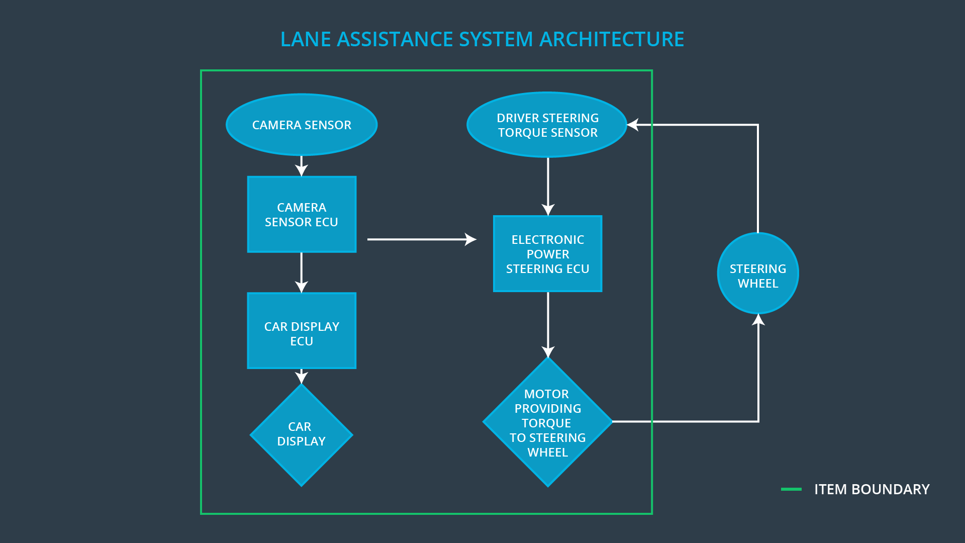

The complete item can be divided by its responsibility in the overall function in the next subsystems:

**Lane detection:**

This system includes the camera sensor and the camera sensor ECU. Its purpose is to detect the lane and alert to the correction and feedback subsystem about it.

**Correction and feedback:**

This system is comprised of driver steering torque sensor, electronic power ECU and the actuation unit which is the motor. It is the responsible of correct the trajectory to stay in the lane and to give feedback to the driver by causing a vibration in the steering wheel.

The car display ECU and the display itself do NOT form part of this system but part of the functionality of the item is reflected on the display as well as in the steering wheel.

**Car Display:**

This display gives the information to the driver regarding the state of the system, whether or not is activated and if it’s activated whether or not the system is applying force control action over the vehicle.

## Operational constraints

The current safety plan is developed with the next assumptions:

* The system has not been tampered.
* The climate conditions are acceptable for driving.
* The road conditions are acceptable for the vehicle and the speed.
* The lanes on the road are visible.
* This system is intended to be used on-road.

# Goals and Measures

## Goals

The main result of this analysis is to reduce the risk up to an acceptable limit, taking into consideration the costs, severity and probability of an incident. The outcome of this analysis is a set of organization rules and processes which will evidence the quality of the system

## Measures

|  |  |  |
| --- | --- | --- |
| Measures and Activities | Responsibility | Timeline |
| Follow safety processes | All team members | Constantly |
| Create and sustain a safety culture | Safety Manager | Constantly |
| Coordinate and document the planned safety activities | Safety Manager | Constantly |
| Allocate resources with adequate functional safety competency | Project Manager | Within 2 weeks of start of project |
| Tailor the safety lifecycle | Safety Manager | Within 4 weeks of start of project |
| Plan the safety activities of the safety lifecycle | Safety Manager | Within 4 weeks of start of project |
| Perform regular functional safety audits | Safety Auditor | Once every 2 months |
| Perform functional safety pre-assessment prior to audit by external functional safety assessor | Safety Manager | 3 months prior to main assessment |
| Perform functional safety assessment | Safety Assessor | Conclusion of functional safety activities |

# Safety Culture

In our company, the client’s safety is above all the concerns, to ensure this we have incorporated this guidelines to every engineer involved in the production process.

* We must prioritize safety above costs and productivity.
  + The cost of a failure increases exponentially as goes through the development phase.
  + A failure can damage the trust of the customer and damage the complete company.
* Every one of us must be accountable for the decisions made in the development.
  + We shall be proud of what is being delivered to our customer, and take responsibility of our mistakes.
* We perform audits on our processes and products to ensure their quality.
  + We must ensure the correctness and completeness of our products at every phase of the production cycle.
* We are constantly updating our knowledge in the newest regulations related to our products.
  + As new technologies emerge new challenges will come with it, we need to stay updated.
* Keep traceability in every requirement, from the design phase to the product delivery.
  + We need to measure the completeness of the implementation and ensure the correct testing of each functionality.

# Safety Lifecycle Tailoring

For this project, as it is an update we won’t cover the complete Safety lifecycle, the elements that will be covered are:

* Concept phase of the safety lifecycle.
* Product development at the system level.
* Product development at the software level.

The next phases are out of the scope for this project:

* Product development at the hardware level.
* Production and operation.

# Roles

|  |  |
| --- | --- |
| Role | Org |
| Functional Safety Manager- Item Level | OEM |
| Functional Safety Engineer- Item Level | OEM |
| Project Manager - Item Level | OEM |
| Functional Safety Manager- Component Level | Tier-1 |
| Functional Safety Engineer- Component Level | Tier-1 |
| Functional Safety Auditor | OEM or external |
| Functional Safety Assessor | OEM or external |

# Development Interface Agreement

The purpose of development interface agreement is to define the boundaries in both, roles and responsibilities in this project as well as the deliverables from each part to ensure completeness and compliance with ISO26262.

The status of the project is the following: Our client has requested to update the system of lane assistance which was developed 2 years ago. The used libraries will be updated to the newest version.

The OEM is responsible to provide the following:

* Previous requirements
  + Functional
  + Non-functional
* Results of compliance audits
* MISRA C compliant source code
* Previous system architecture
* Contact information of functional responsible for the past project

Based on the provided information the OEM expects this company to deliver the next items:

* Updated requirements for the feature
* Evidence of a successful ISO 26262 audit
* Updated source code and compliance quality reports
* Report of requirement/implementation/test traceability
* Contact information of the new functional responsible for the project

# Confirmation Measures

The next confirmation measurements are to be performed to ensure that this project is complaint with the ISO 26262 and that it’s being applied in a way that improves the system safety. These confirmation measurements will be carried out by an external company.

The external company is expected to:

* Ensure project’s compliance with ISO 26262, this implies that the project was executed following the standard.
* Ensure that the project implementation was made following the safety plan.
* Confirm that the changes made in the system to comply the ISO26262 made it safer.

A safety plan could have other sections that we are not including here. For example, a safety plan would probably contain a complete project schedule.

There might also be a "Supporting Process Management" section that would cover "Part 8: Supporting Processes" of the ISO 26262 functional safety standard. This would include descriptions of how the company handles requirements management, change management, configuration management, documentation management, and software tool usage and confidence.

Similarly, a confirmation measures section would go into more detail about how each confirmation will be carried out.