THAMWAY PROT series hardware server software

Summary
- Is connected to the USB interface, PROT for pulsar, it will do AD converter, control of RF low-level control device.
- Control is compatible with the operation of the command line, operations by TCP / IP connection.
- It has a built-in 'Lua5.3interpreter'. You can make a run from the execution and command-line of the script file.
Note：The Programming Languege Lua ( http://www.lua.org )

CAUTION：Do not start NMR software and at the same time. It does not work properly is that compete for control.

Files needed to run
main.exe This is the software of the main file.
Fx2fw.bin This is a firmware file of the USB interface. It transferred to the USB interface on startup. Please put main.exe the same folder.
slow_dat.bin It is a GPIF definition file of USB interface. Please put it in main.exe the same folder.
Operating environment
Windows XP/Vista/7/8/8.1 32bit,64bit
Installation and uninstall
The installer is not required. Please copy to the folder where you want to use the folder that contains the software. Uninstall, please delete the file directly.
DEVICE DRIVERS
Device driver is shared with 'NMR SOFTWARE'.You do not need to re-install.
How to Start software
Please run the main.exe. Since the idea to start by opening a command prompt easy to understand the situation when it was stopped in error or the like is useful.
You can specify the lua script file you want to execute after main.exe
C:> main executefile.lua
TCP/IP port to be used
TCP/IP PORT:5025 It uses to communicate with the PG32 PULSER.
TCP/IP PORT:5026 It uses to communicate with the DV14U25 ADCONVERTER.
TCP/IP PORT:5027 It uses to communicate with the RF Controller.
Delimiter of command
Please take always delimiter character in the command using the TCP/IP. Delimiter, 'CR', 'CR + LF', ';' is one of the three out of.

About numerical value to be used
Integer
If you put a "0x" at the beginning it is regarded as hexadecimal.
If you put a "0" at the beginning it is regarded as octal.
If you put a "0b" at the beginning it is regarded as binary.
Other than the above it will consider the decimal.
Example： 0x123 → 291
0b1100 → 12
0123 → 83
Real
If you put a "u" in the back of the numeric value is regarded as 1e-6(micro).
If you put a "m" in the back of the numeric value is regarded as 1e-3(milli).
If you put a "k" in the back of the numeric value is regarded as 1e+3(kilo).
例: 123k → 123000
1.2u → 0.0000012
QPSK
At the same time I will output a QPSK pulse and transmitted pulse. There are two 'QPSK1' and 'QPSK2'.
TIME
Unit of time is sec.
FREQUENCY
Unit of frequency is Hertz(Hz).
VOLTAGE
Unit of voltage is volt.

About 'Lua' command
This software can also be operated using an internal Lua commands without using the TCP/IP connection. Operate and use the keyboard from the command line.

TCP / IP PORT: 5025 command, you can substitute callPG(“pulsercommand”).
TCP / IP PORT: 5026 command, you can substitute callAD(“AD command”).
TCP / IP PORT: 5027 command, you can substitute callRF(“RF command”).

Example
callPG(“start 10”)
callAD(“startad 256,1,1,0”)
callRF(“RFSWW1”)
callRF(“RFSWW0”)
Checking operation
Necessary software

・The software which can make a telnet connection.
For example“PuTTYtel.exe”
Download site ( http://www.chiark.greenend.org.uk/~sgtatham/putty/ )
( http://www.chiark.greenend.org.uk/~sgtatham/putty/download.html )
・Archive file of “NMRTCP” software.
Expand the compressed file.

1.It will start the NMRTCP \ main.exe deployment location. Startup screen is as follows.

Startup screen

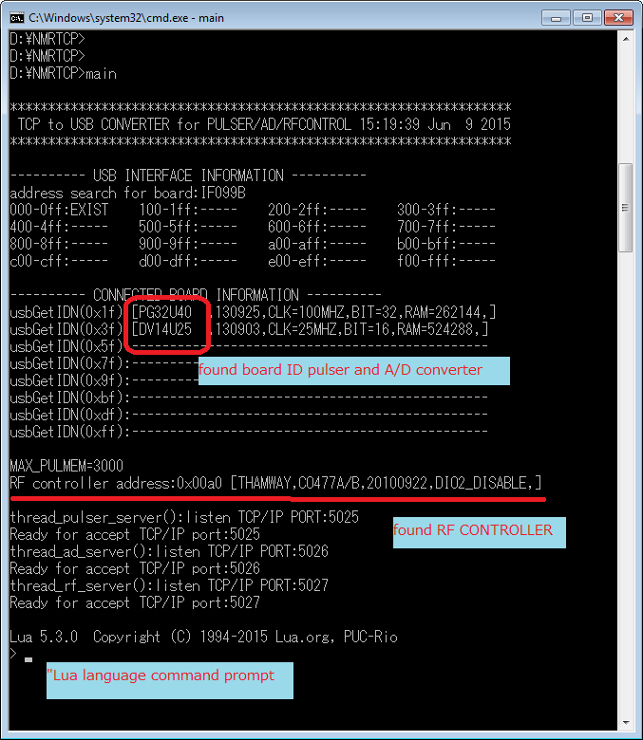
2.At the command prompt "callPG (" * IDN? ")" And I enter. Then the response from the pulsar will come back.

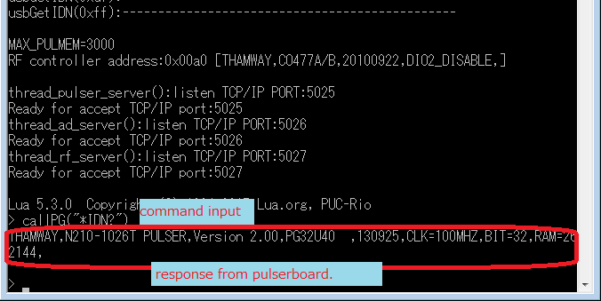
3.The command prompt is the input line of the Lua language.
・It's possible to be keyboard input and make them carry out a script file of direct manipulation and a Lua language.
When the callPG function is changed for the callAD function, it's possible to use the command to A/D.

A Lua language has a official site.( http://www.lua.org/ )
It's possible to make a script and make them carry out beforehand from a command prompt.
Please refer to the dofile function.

When you exit the main.exe, please type CTRL + C or input 'os.exit()'.

4.It is a method for testing TCP/IP connection.
You have to pre-run the main.exe.And start the PuTTYtel.exe.
Set the following, and then press the "Open".

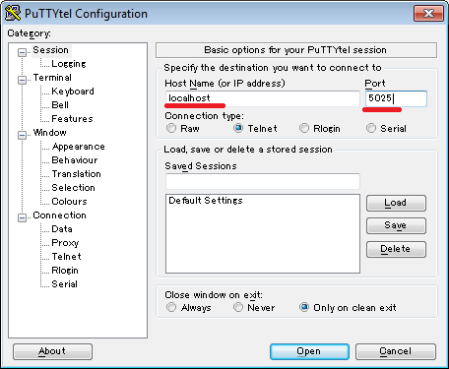
5.It displays the following window to be a successful connection. First press ENTER, please press ENTER to enter the next "* IDN?".
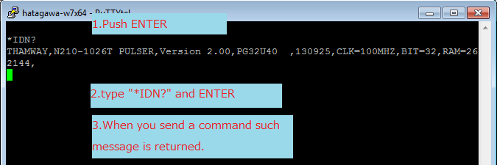
6.You can use the port command of the A / D is changing in 5026 when you want to connect.
If you 5027 port, you can command operations to RFController.
TCP/IP connection, it may end up blocked by security software.
If that does not work, please try to go to after you restart the main.exe Stop the security software.

