THAMWAY PROT series hardwere server software
Lua command section

Start screen image
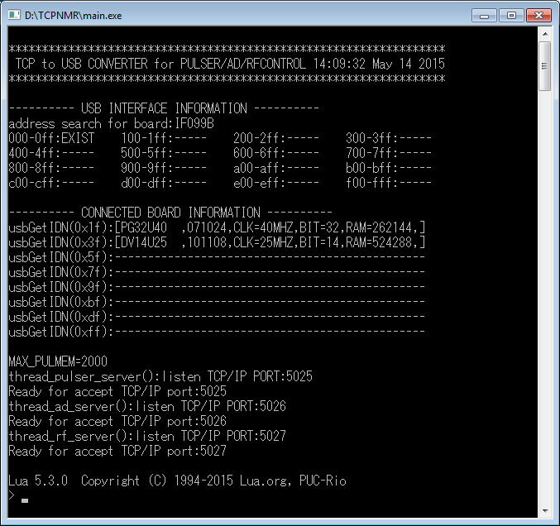

About 'Lua' command
This software can also be operated using an internal Lua commands without using the TCP/IP connection. Operate and use the keyboard from the command line.

TCP / IP PORT: 5025 command, you can substitute callPG(“pulsercommand”).
TCP / IP PORT: 5026 command, you can substitute callAD(“AD command”).
TCP / IP PORT: 5027 command, you can substitute callRF(“AD command”).

Example
callPG(“start 10”)
callAD(“startad 256,1,1,0”)
callRF(“RFSWW1”)
callRF(“RFSWW0”)

Additional Lua language Command Reference
This software has a built-in Lua language interpreter.
It adds a command for hardware operation to the standard Lua language.
System command

To stop for a predetermined period of time.
[Format]
wait1ms( <integer number> )
[Description]
integer number Stop the specified time. milliseconds to stop.

Exit the soft ware
[Format]
os.exit()
[Description]
It will exit the software. This is a standard command of Lua.

Hardware control command
Read data from the I/O port
[Format]
inb( <I/O address> )
inw( <I/O address> )
[Description]
It is used when operating the register of each device directly.
inb() It will read the byte data from the specified address.
inw() It will read the word data from the specified address.
The return value is an integer.

Write data to the I/O port
[Format]
outb( <I/O address> )
outw( <I/O address> )
[Description]
It is used when operating the register of each device directly.
outb() It will write the byte data to the specified address.
outw() It will write the word data to the specified address.

Send a command to the device
[Format]
callPG( <command string> )
callAD( <command string> )
callRF( <command string> )
[Description]
callPG:Send a command to the pulser.
callAD:Send a command to the A/D board.
callRF:Send a command to the RF Controller.
The return value, all will be the string. TCP / IP connection similar message is returned.

[Example]
callPG(“*idn?”)
callAD(“*idn?”)
callRF(“RFSWW1”)

Other command
Execute Lua script file
[Format]
dofile( <FileName> )
[Description]
Run the file specified by FileName.
Separated folder I specified in the "\" instead of "/". This is a standard command of Lua.
[Example]
dofile(“example/myprogram.lua”)
dofile(“d:/example/myprogram.lua”)

