# MySQL 5.7 多实例安装部署实例

1. 背景  
  MySQL数据库的集中化运维，可以通过在一台服务器上，部署运行多个MySQL服务进程，通过不同的socket监听不同的服务端口来提供各自的服务。各个实例之间是相互独立的，每个实例的datadir, port, socket, pid都是不同的。

2. 多实例特点  
  * 有效利用服务器资源，当单个服务器资源有剩余时，可以充分利用剩余的资源提供更多的服务。  
  * 资源互相抢占问题，当某个服务实例服务并发很高时或者开启慢查询时，会消耗更多的内存、CPU、磁盘IO资源，导致服务器上的其他实例提供服务的质量下降。

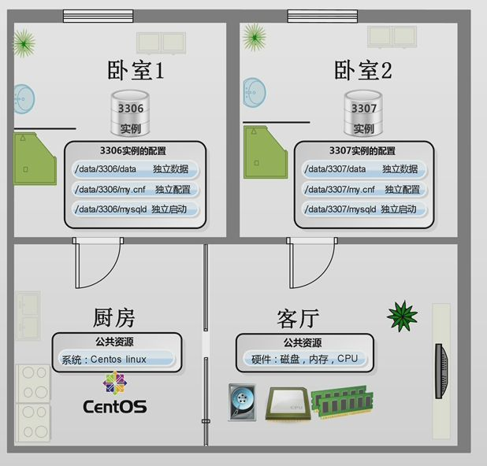

3. 环境 [ 关闭SeLinux ]  
[root@MySQL ~]# cat /etc/[RedHat](http://www.linuxidc.com/topicnews.aspx?tid=10)-release    
CentOS Linux release 7.4.1708 (Core)  
    
[root@MySQL ~]# getenforce    
Disabled

4. 部署 [ 4个实例 ]  
  * 下载 MySQL 5.7 二制包 [ 推荐官方下载 ]　此下载版本大于5.7.5  
[root@MySQL ~]# wget <http://dev.mysql.com/get/Downloads/MySQL-5.7/mysql-5.7.13-linux-glibc2.5-x86_64.tar.gz>

* 解压 MySQL 5.7 二进制包

[root@MySQL ~]# tar zxvf mysql-5.7.13-linux-glibc2.5-x86_64.tar.gz

* 复制配置文件到安装目录  
[root@MySQL ~]# mv mysql-5.7.13-linux-glibc2.5-x86_64/* /usr/local/mysql/

* 创建 MySQL 用户  
[root@MySQL ~]# useradd -r -s /sbin/nologin mysql

* 在 MySQL 二进制包目录中创建 mysql-files 目录 [MySQL 数据导入/导出数据专放目录]  
[root@MySQL ~]# mkdir -v /usr/local/mysql/mysql-files   
mkdir: created directory `/usr/local/mysql/mysql-files'

* 创建多实例数据目录  
[root@MySQL ~]# mkdir -vp /data/mysql_data{1..4}   
mkdir: created directory `/data'   
mkdir: created directory `/data/mysql_data1'   
mkdir: created directory `/data/mysql_data2'   
mkdir: created directory `/data/mysql_data3'   
mkdir: created directory `/data/mysql_data4'

* 修改 MySQL 二进制包目录的所属用户与所属组  
[root@MySQL ~]# chown root.mysql -R /usr/local/mysql

* 修改 MySQL 多实例数据目录与 数据导入/导出专放目录的所属用户与所属组  
[root@MySQL ~]# chown mysql:mysql -R /data/

* 配置 MySQL 配置文件 /etc/my.cnf  
[mysqld_multi]

mysqld = /usr/local/mysql/bin/mysqld

mysqladmin = /usr/local/mysql/bin/mysqladmin

log = /tmp/mysql_multi.log

[mysqld1]

datadir = /data/mysql_data1

# 设置sock存放文件名　[多实例中一定要不同]

socket = /tmp/mysql.sock1

# 设置监听开放端口　[多实例中一定要不同]

port = 3306

# 设置运行用户

user = mysql

# 关闭监控

performance_schema = off

# 设置innodb 缓存大小

innodb_buffer_pool_size = 32M

# 设置监听IP地址

bind_address = 0.0.0.0

# 关闭DNS 反向解析

skip-name-resolve = 0

[mysqld2]

datadir = /data/mysql_data2

socket = /tmp/mysql.sock2

port = 3307

user = mysql

performance_schema = off

innodb_buffer_pool_size = 32M

bind_address = 0.0.0.0

skip-name-resolve = 0

[mysqld3]

datadir = /data/mysql_data3

socket = /tmp/mysql.sock3

port = 3308

user = mysql

performance_schema = off

innodb_buffer_pool_size = 32M

bind_address = 0.0.0.0

skip-name-resolve = 0

[mysqld4]

datadir = /data/mysql_data4

socket = /tmp/mysql.sock4

port = 3309

user = mysql

performance_schema = off

innodb_buffer_pool_size = 32M

bind_address = 0.0.0.0

skip-name-resolve = 0 * 初始化各个实例 [ 初始化完成后会自带随机密码在输出日志中 ]  
[root@MySQL ~]# /usr/local/mysql/bin/mysqld --initialize --user=mysql --basedir=/usr/local/mysql --datadir=/data/mysql_data1

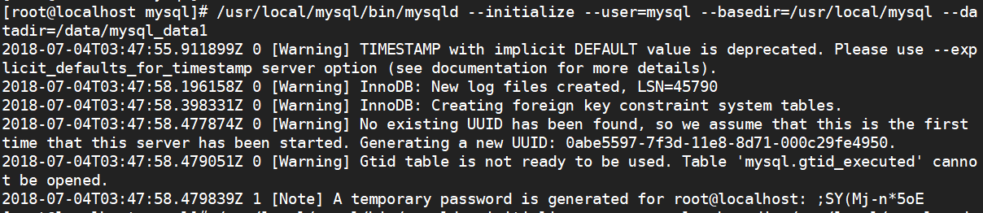  
[root@MySQL ~]# /usr/local/mysql/bin/mysqld --initialize --user=mysql --basedir=/usr/local/mysql --datadir=/data/mysql_data2

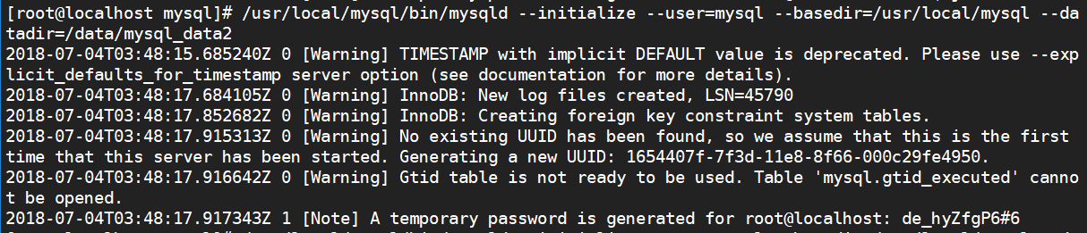  
[root@MySQL ~]# /usr/local/mysql/bin/mysqld --initialize --user=mysql --basedir=/usr/local/mysql --datadir=/data/mysql_data3

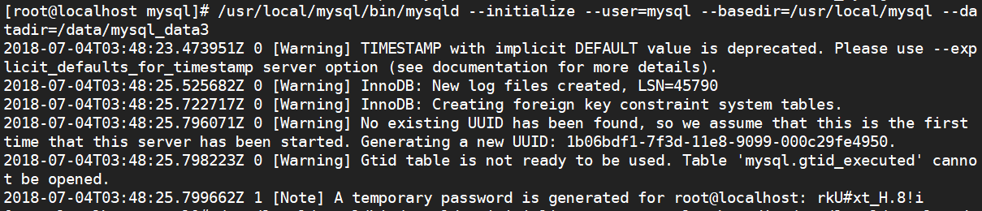  
[root@MySQL ~]# /usr/local/mysql/bin/mysqld --initialize --user=mysql --basedir=/usr/local/mysql --datadir=/data/mysql_data4

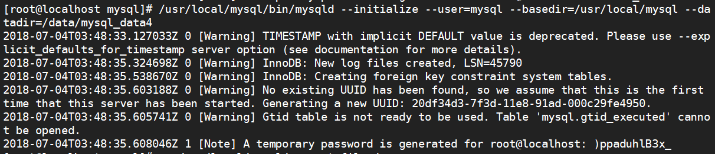

* 各实例开启 SSL 连接  
[root@MySQL ~]# /usr/local/mysql/bin/mysql_ssl_rsa_setup --user=mysql --basedir=/usr/local/mysql --datadir=/data/mysql_data1   
[root@MySQL ~]# /usr/local/mysql/bin/mysql_ssl_rsa_setup --user=mysql --basedir=/usr/local/mysql --datadir=/data/mysql_data2   
[root@MySQL ~]# /usr/local/mysql/bin/mysql_ssl_rsa_setup --user=mysql --basedir=/usr/local/mysql --datadir=/data/mysql_data3   
[root@MySQL ~]# /usr/local/mysql/bin/mysql_ssl_rsa_setup --user=mysql --basedir=/usr/local/mysql --datadir=/data/mysql_data4

* 复制多实例脚本到服务管理目录下 [ /etc/init.d/ ]  
[root@MySQL ~]# cp /usr/local/mysql/support-files/mysqld_multi.server /etc/init.d/mysqld_multi

* 添加脚本执行权限  
[root@MySQL ~]# chmod +x /etc/init.d/mysqld_multi

* 添加进service服务管理  
[root@MySQL ~]# chkconfig --add mysqld_multi

5. 启动测试  
  * 查个多实例状态  
[root@MySQL ~]# /etc/init.d/mysqld_multi report

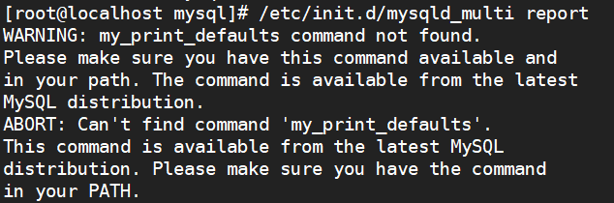

[root@MySQL ~]# export PATH=/usr/local/mysql/bin:$PATH  
Reporting MySQL servers   
MySQL server from group: mysqld1 is not running   
MySQL server from group: mysqld2 is not running   
MySQL server from group: mysqld3 is not running   
MySQL server from group: mysqld4 is not running

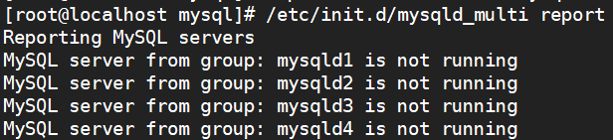

* 启动多实例  
 [root@MySQL ~]# /etc/init.d/mysqld_multi start

* 查看多实例状态  
Reporting MySQL servers   
MySQL server from group: mysqld1 is running   
MySQL server from group: mysqld2 is running   
MySQL server from group: mysqld3 is running   
MySQL server from group: mysqld4 is running

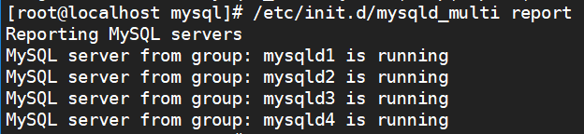

* 查看实例监听端口  
[root@MySQL ~]# netstat -lntp | grep mysqld   
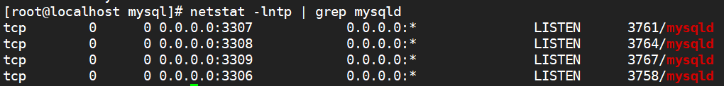

## 6. 连接测试

密码在刚刚初始化最后，有个默认密码，使用默认密码进入，更改set password 更改密码，才能使用root权限  
　 * 实例1  
[root@MySQL ~]# /usr/local/mysql/bin/mysql -S /tmp/mysql.sock1  -p'z+Ilo*>s:3kw'   
mysql: [Warning] Using a password on the command line interface can be insecure.   
Welcome to the MySQL monitor.  Commands end with ; or \g.   
Your MySQL connection id is 6   
Server version: 5.7.18   
    
Copyright (c) 2000, 2017, [Oracle](http://www.linuxidc.com/topicnews.aspx?tid=12) and/or its affiliates. All rights reserved.   
    
Oracle is a registered trademark of Oracle Corporation and/or its   
affiliates. Other names may be trademarks of their respective   
owners.   
    
Type 'help;' or '\h' for help. Type '\c' to clear the current input statement.   
    
mysql> set password = '123456';   
Query OK, 0 rows affected (0.00 sec)

　 * 实例2  
[root@MySQL ~]# /usr/local/mysql/bin/mysql -S /tmp/mysql.sock2  -p'b*AHUrTgu1rl'   
mysql: [Warning] Using a password on the command line interface can be insecure.   
Welcome to the MySQL monitor.  Commands end with ; or \g.   
Your MySQL connection id is 7   
Server version: 5.7.18   
    
Copyright (c) 2000, 2017, Oracle and/or its affiliates. All rights reserved.   
    
Oracle is a registered trademark of Oracle Corporation and/or its   
affiliates. Other names may be trademarks of their respective   
owners.   
    
Type 'help;' or '\h' for help. Type '\c' to clear the current input statement.   
    
mysql> set password = '123456';   
Query OK, 0 rows affected (0.00 sec)