**PAKI DOUBLE CHECK PRE**

**LOGIN FORM  
  
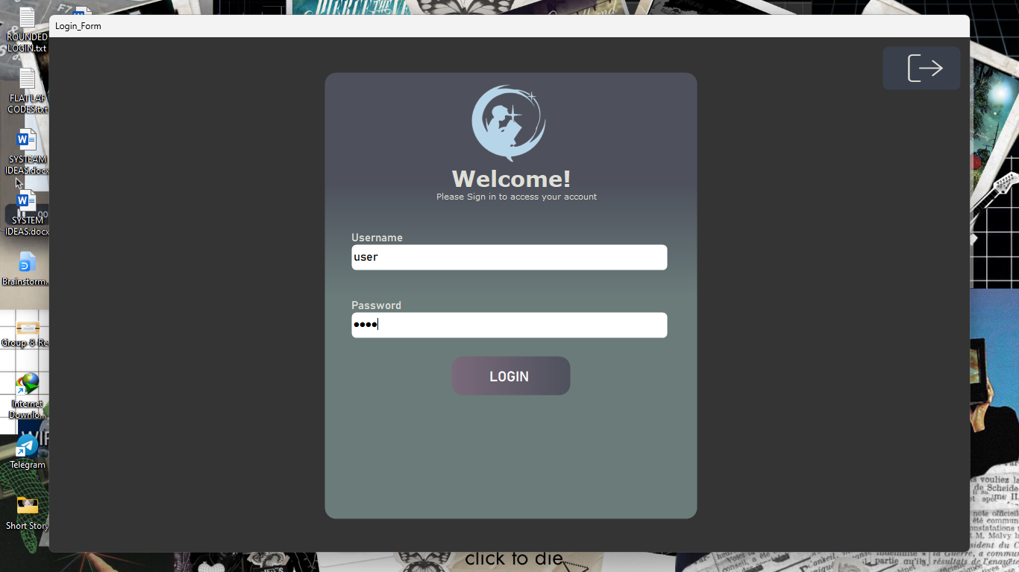**

**Function: A user can input his/her credentials to login in Celestial Catalog Library Management System**

____________________________________________________________________________________

**DASHBOARD FORM**  
  
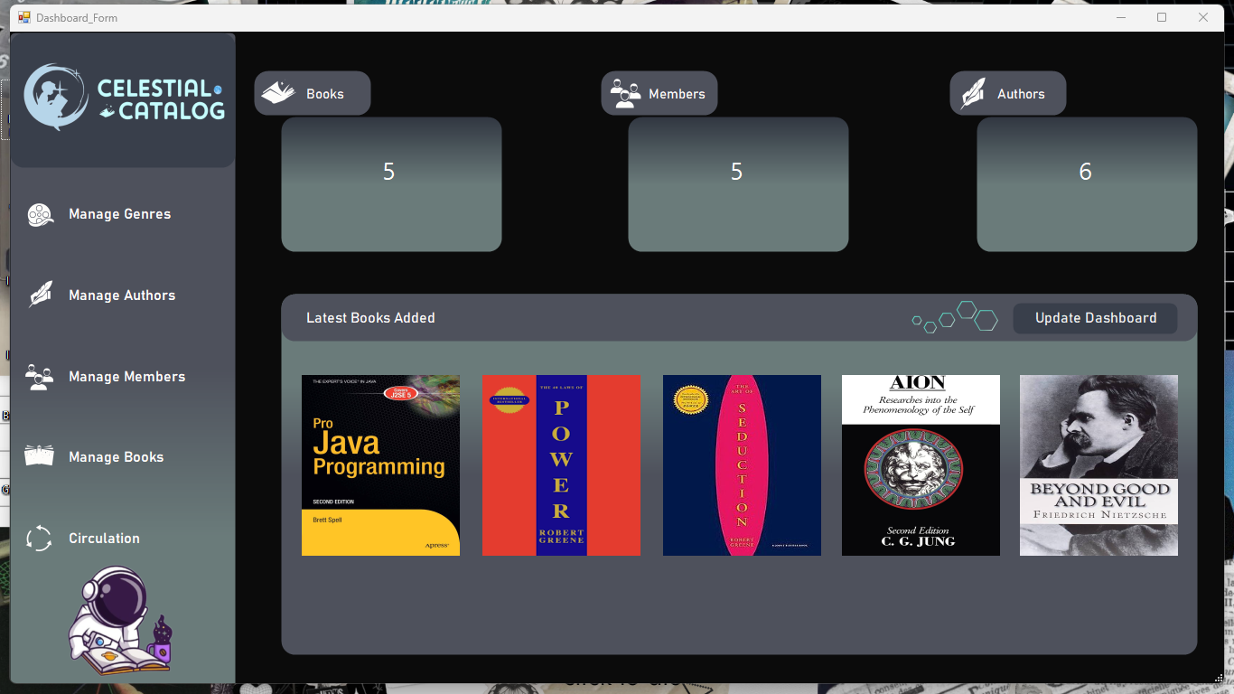 **Function: Displays an overview dashboard providing essential information and quick access to various functionalities within the library management system.**

**MANAGE GENRE FORM  
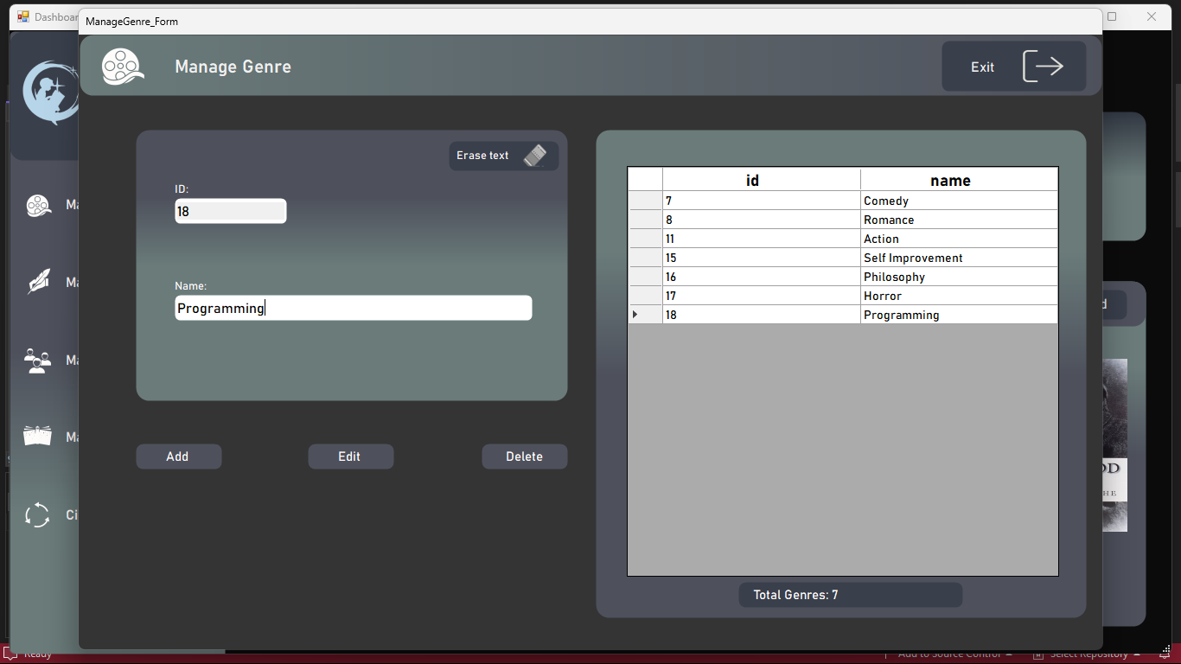**

**Function: Provides a user interface for managing book genres. This could include adding, editing, and deleting genres.**

**MANAGE AUTHOR FORM**

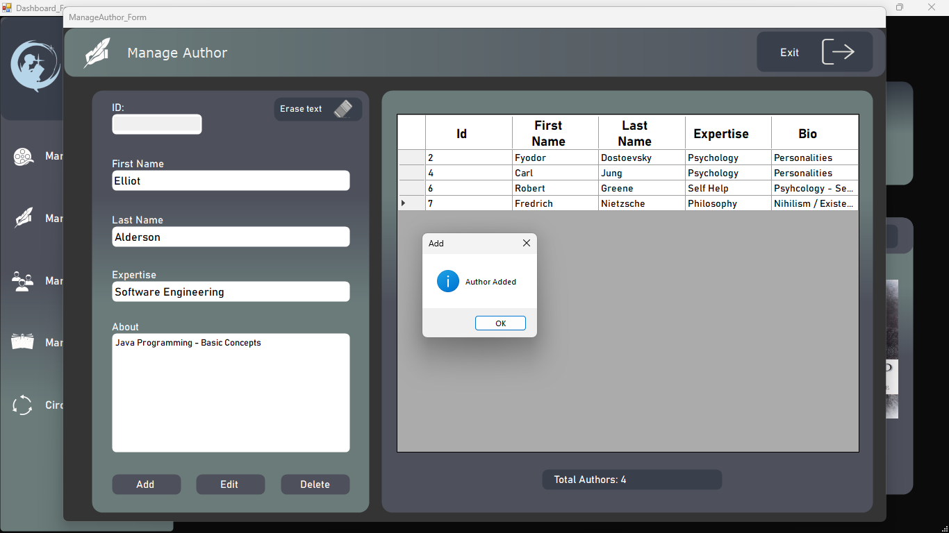

**Function: Offers a platform for managing information related to authors. Users can add, edit, and delete author details.**

**MANAGE MEMBER FORM**

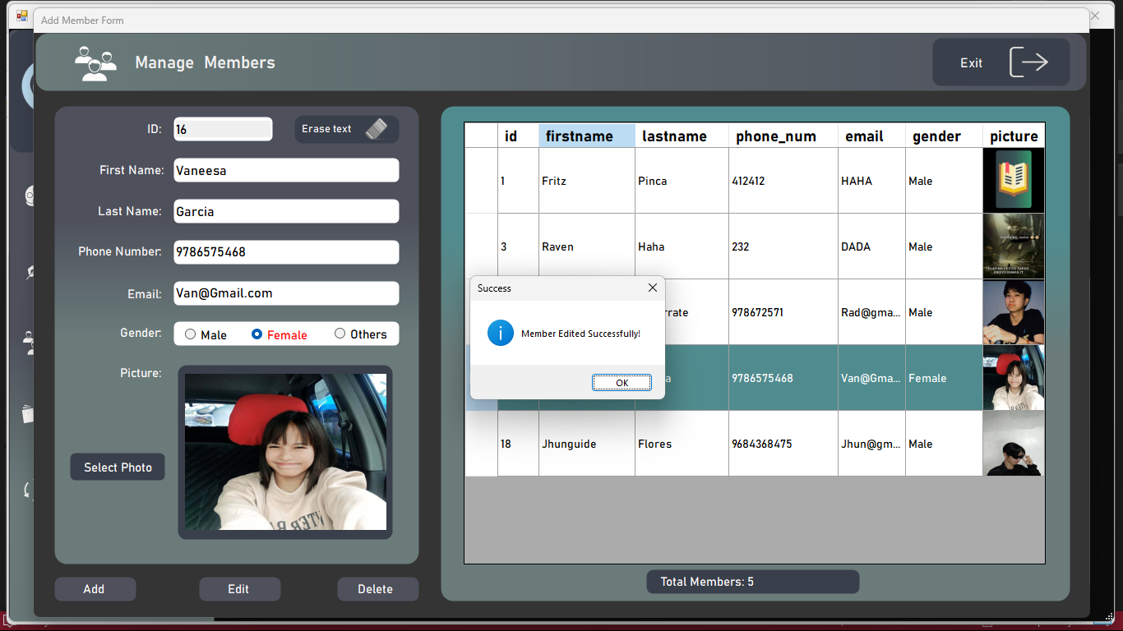

**Function: Allows administrators to manage library members, including adding new members, editing existing member details, and removing members.**

**MANAGE BOOK BUTTON – MANAGE BOOK FORM PORTAL**

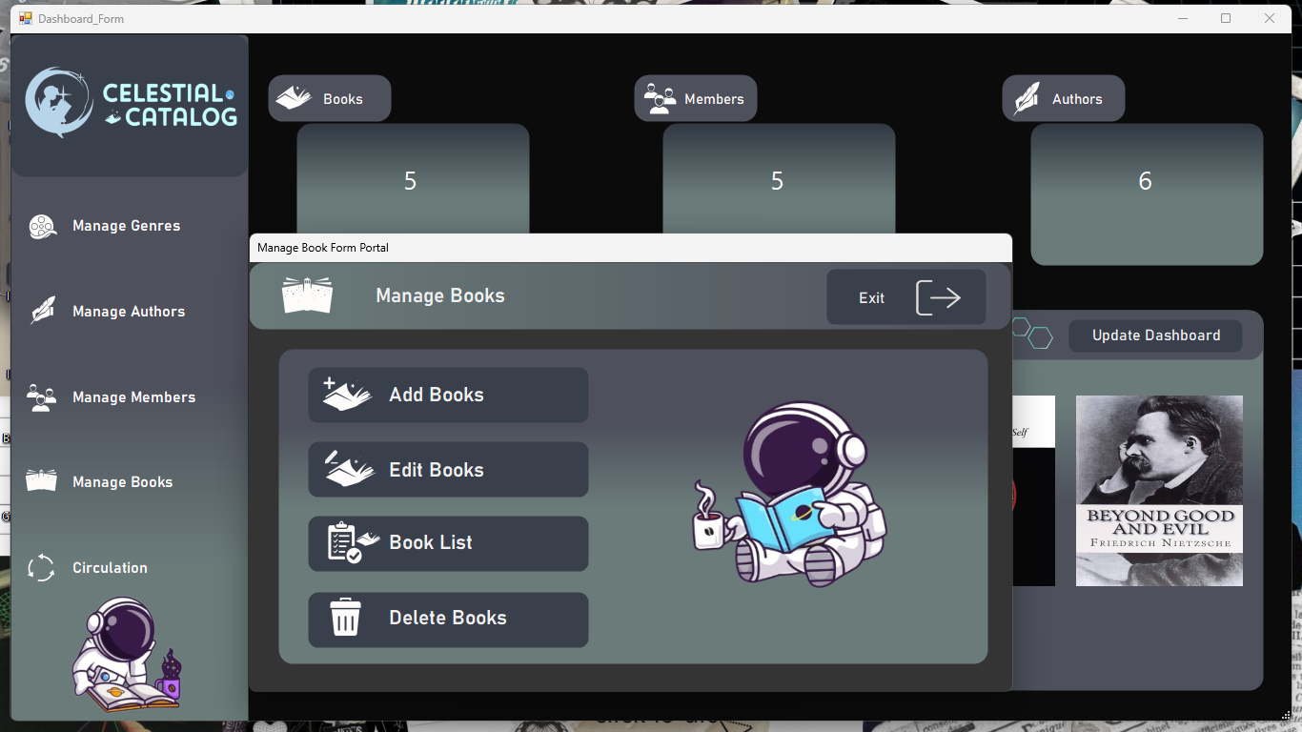

**Function: Acts as a button or link to open a portal or form for managing book-related operations.**

**ADD BOOK FORM  
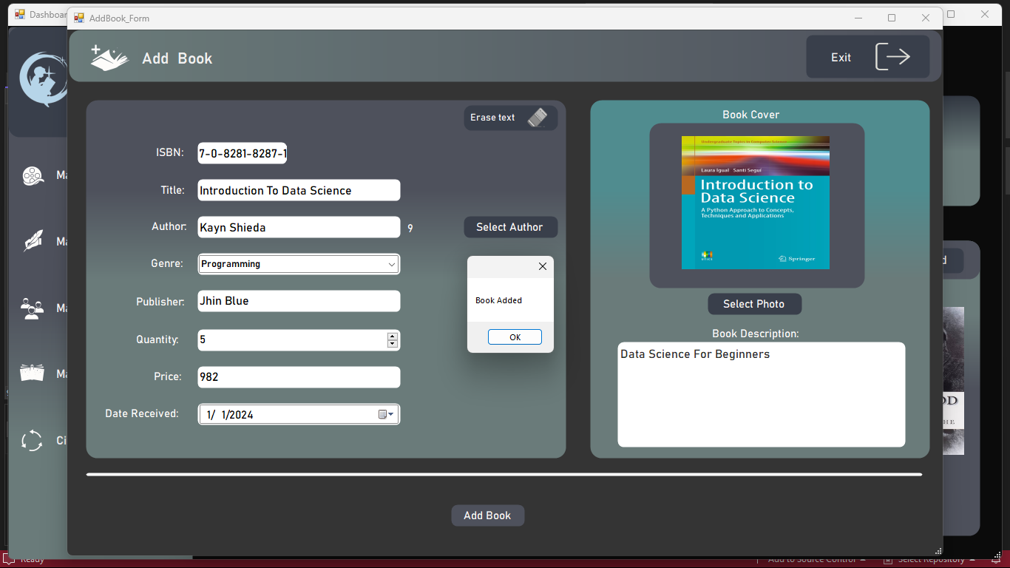**

**Function: Enables the addition of new books to the library catalog by providing a form to input book details.**

**AUTHOR LIST FORM  
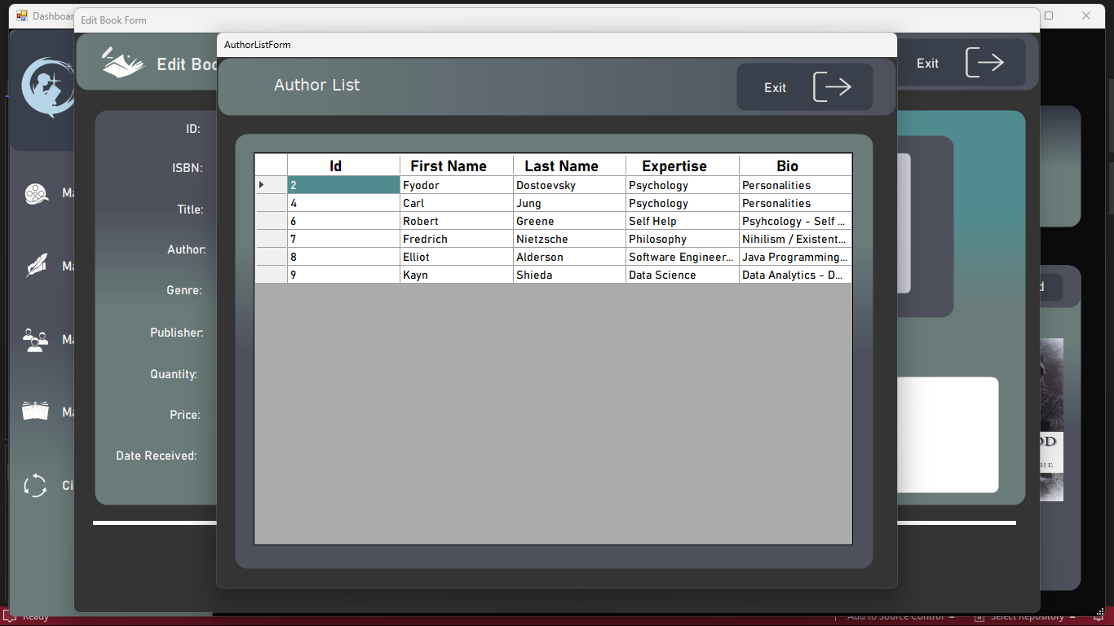**

**Function: Displays a list of authors in the library, allowing users to view and manage author information.**

**Ps: It will only appear if the user click adding a book and requires the author information to fill required informations.**

**EDIT BOOK FORM  
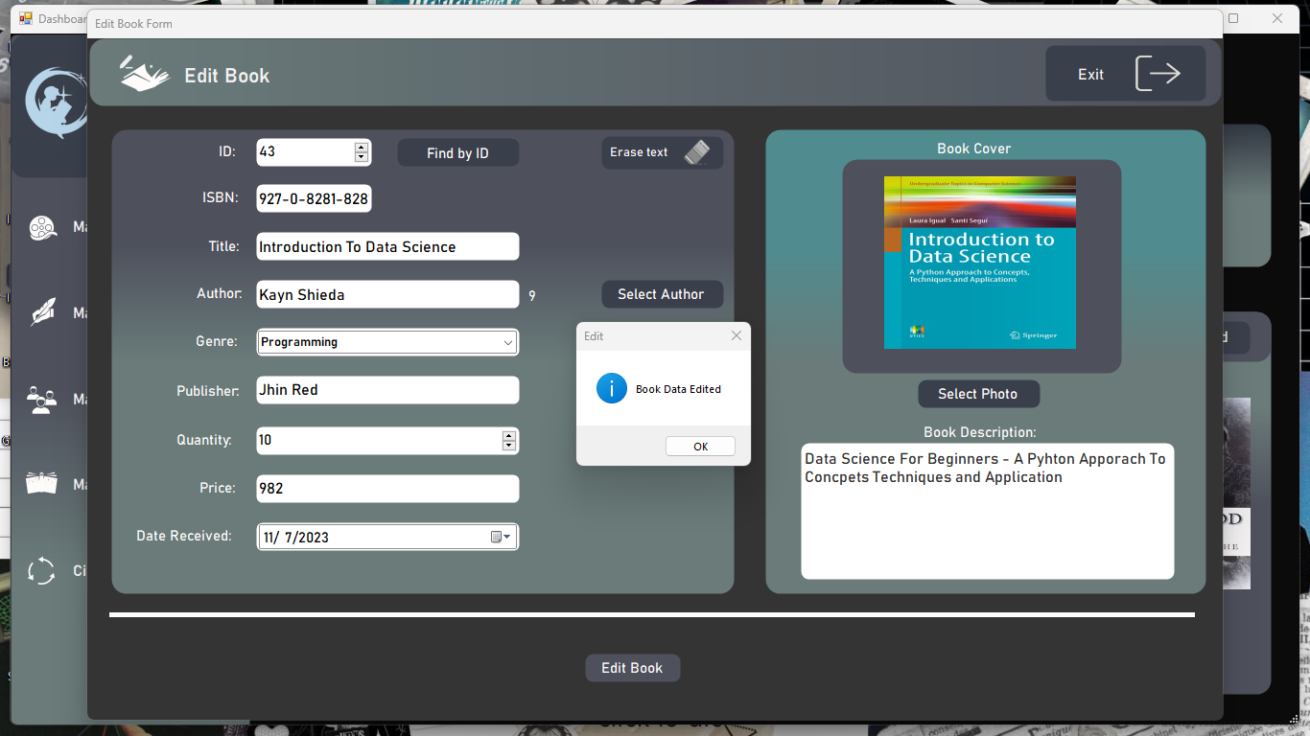**

**Function: Provides a form for editing existing book details, such as title, author, genre, etc.**

**BOOK LIST FORM**

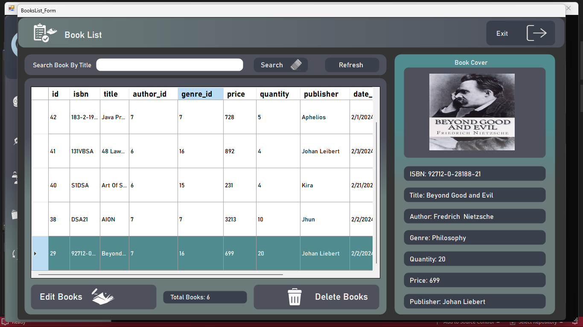

**Function: Displays a list of all books in the library catalog, providing an overview of book details.**

**DELETE BOOK FORM**

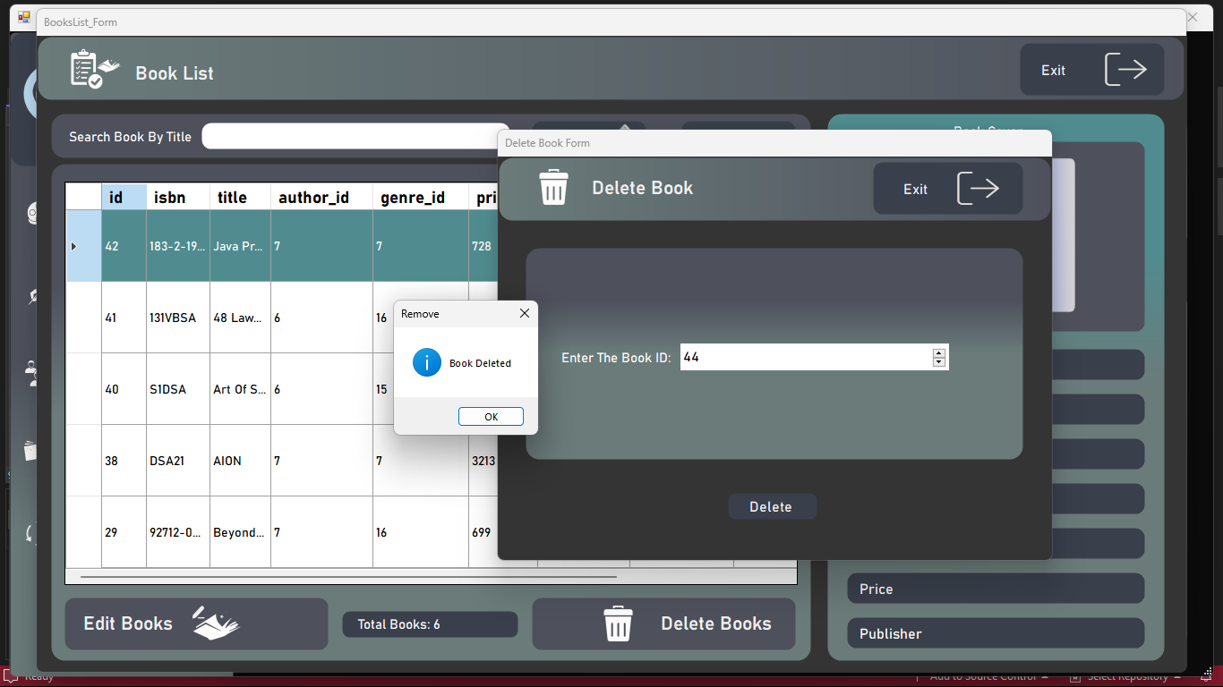

**Function: Allows administrators to remove books from the library catalog by providing a form or interface for book deletion.**

**CIRCULATION BUTTON – CIRCULATION PORTAL  
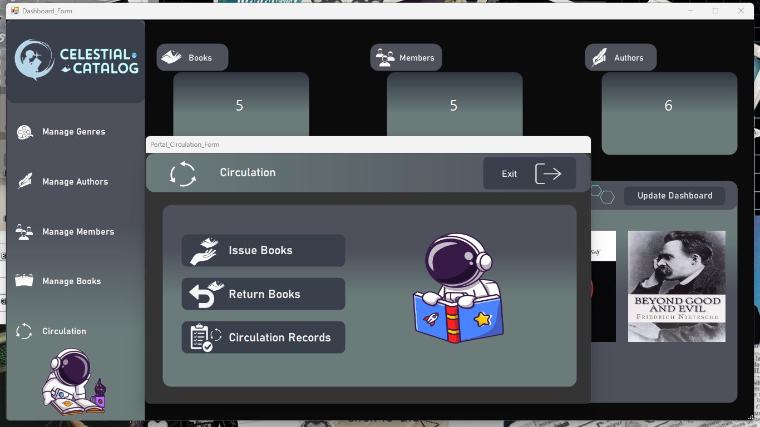**

**Function: Acts as a button or link to open a portal or form for managing book circulation activities, such as issuing and returning books.ve books from the library catalog by providing a form or interface for book deletion.**

**ISSUE BOOK**

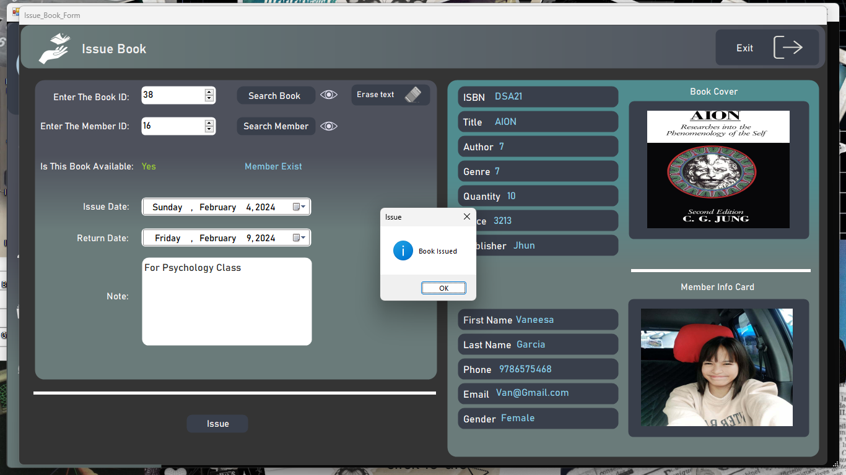

**Function: Provides a form or functionality for issuing or borrowing books to library members.**

**RETURN BOOK FORM**

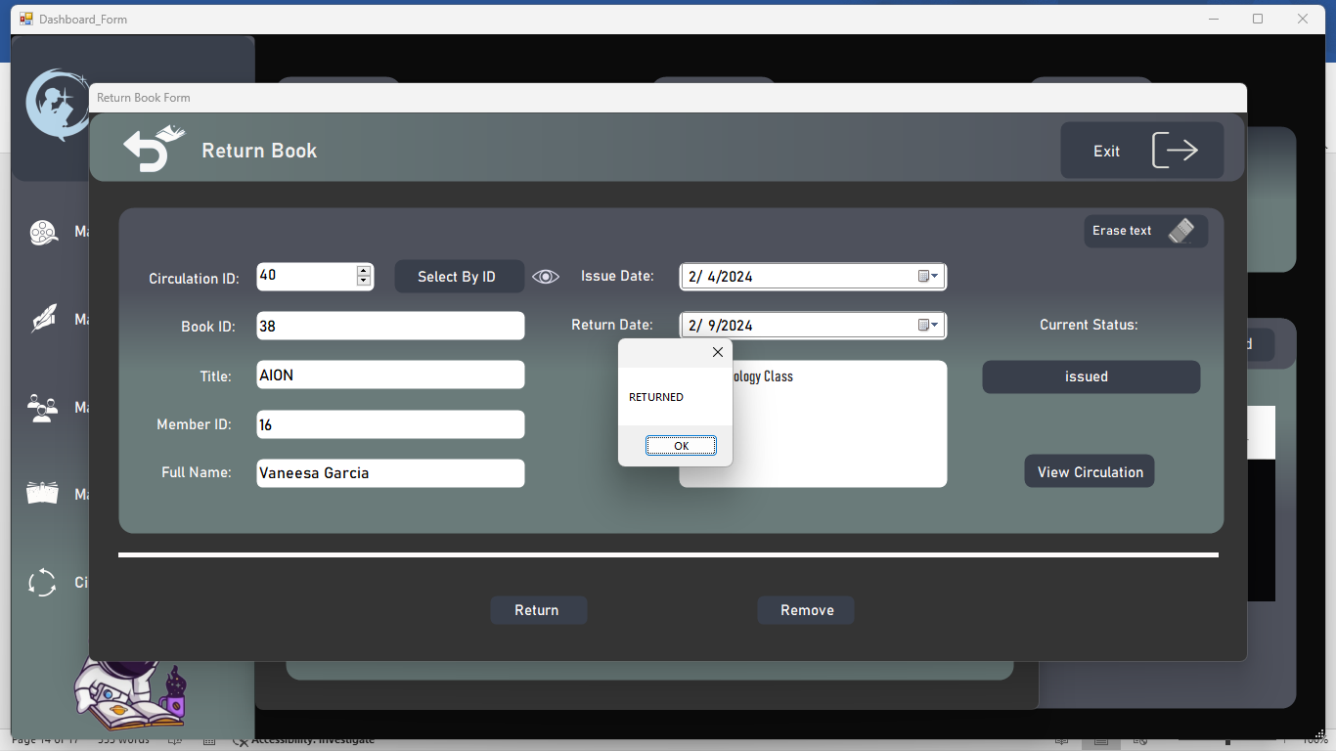

**Function: Provides a form or functionality for returning borrowed books to library members.**

**CIRCULATION RECORDS**

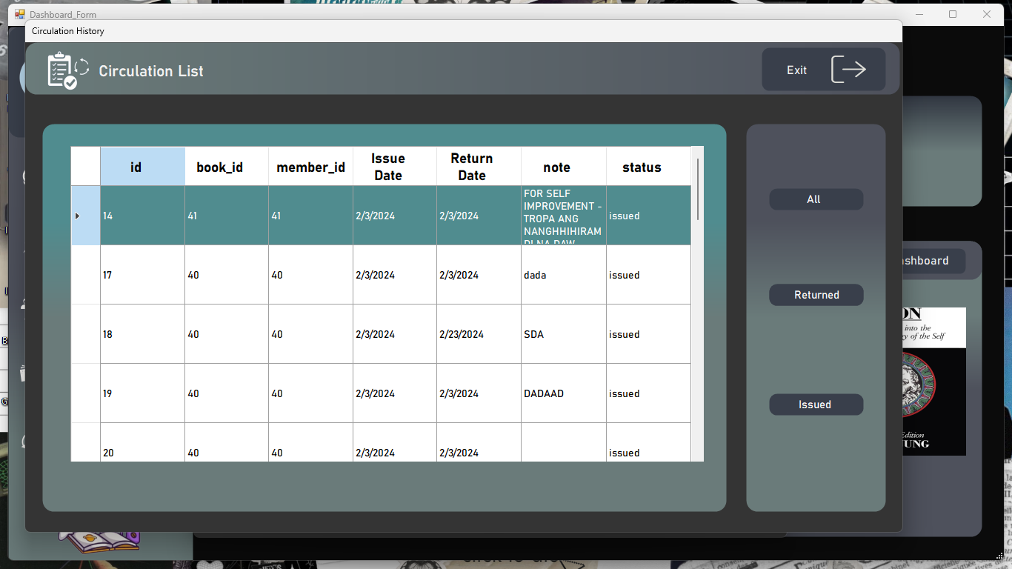  
**Function: Displays a record of book circulation activities, including details such as who borrowed a book, when it was borrowed, and when it was returned.**