Dynamics of diseases spreading on multiplex networks

Yang Haoxin, University of Michigan - Shanghai Jiaotong University Joint Institute
Instructor: Wang Lin, School of Electronic Information and Electrical Engineering

ABSTRACT
Diseases spreading has been a hot topic among mathematicians, physicists and hygienists for a long time and it has received increasing concern as it contributes to other studies nowadays. Here we investigate in the percentages of people under different states against time in order to study the influence of degree distribution, interaction between diseases, initial percentage, infection & recovery rate, overlap rate and individual traits. Most models of diseases spreading only consider one disease on a single network. Our model takes coexisting diseases on multiplex networks into consideration. Most similar models deal with different diseases separately and ignore their mutual influence. Our model concentrates on the simultaneous spreading process and mutual effect of diseases. This model can also be applied to information spreading study.
Key words: multiplex network, diseases spreading, mutual influence, epidemics

- INTRODUCTION
Understanding the dynamics of diseases spreading contributes to the control of epidemics. It is a paradigm to study the spread process by viewing the population as individuals connected by networks [1-3]. Modeling the spread of diseases can apply the networks of physical contacts between individuals [1, 4-6], which attract more interest than biological networks of pathogens interaction recently [7-9].
Usually, the networks are multiple and the diseases spread on two-layered networks with same nodes through different routes. There are many examples for diseases spreading on two biological networks (animals and human beings) such as SARS epidemic in 2003, H1N1 influenza pandemic in 2009 and H7N9 avian influenza in 2013. Furthermore, two-layered networks may be different social networks [10-17].
Though many studies on two-layered networks focus on one disease only, it is likely that two or more diseases coexist. For example, type-I of adenoviruses could exist for 15 months at one side of a village in south-east Asia and type-II existed in a village at the other side. These two pathogens coexist in the center of the village [18-20]. It is important to consider coexisting diseases.
The diseases will interact with each other on the same node (individual) and the results vary. The diseases may affect each other or have single-side influence. One can either suppresses the immune system and contributes to the other’s infection, or provides partial immunity against the other [21-24]. There are various cases for concern.
Different variables will lead to the change of infection process, including degree distribution, interaction between diseases, initial percentage, infection & recovery rate, overlap rate and individual traits. All the variables must be taken into consideration in order to find the best way to control epidemics.
In this paper, we improve the simple model of single disease spreading on a single network into a model of two diseases spreading on two-layered networks simultaneously with interaction. The diseases are of common SIR-type. We change different variables which will influence the process of infection and record the percentages of individuals under different state against time. We study this model in order to find a good way to control epidemics.
- METHODS
In order to investigate in the spread process of diseases on multiplex networks, we build models for both the networks and spreading process. We apply Monte Carlo simulations and use the computer programs to simulate the generation of networks as well as the infection among individuals. We change variables in the program and record data in different circumstances. After plotting the percentage of individuals under different states against time and compare the figures, we get conclusions.
The networks are consist of two layers, which stand for two ways of infection. Each layer is consisted of nodes and lines. Each node represents an individual and each line represents a contact between two individuals. In order to generate the networks, we first create N nodes where N represents the total number of individuals. For each node, it will have an ID to show its identity, a char to show its state, a degree to show its activity, a number to show how many lines can still be connected to it and a coefficient to show its trait (weak or strong). The initial states of all nodes are randomized according to the initial percentage of infected people. The degree of each node is randomized but the whole distribution of degrees will satisfy certainty distribution such as average distribution, normal distribution and Poisson distribution. The coefficient is determined by randomizing a state according to the whole percentage of weak people. If the node is determined to have the weak trait, the coefficient will be smaller than 1. Otherwise, for common people, they will have a coefficient of 1. Then we create lines between nodes according to the degree of nodes. We will randomly connect two nodes which both have rest degree for connection until no more lines can be created. Each line will record the nodes it connects. All the lines and the number of lines form a layer with mesh topology and the layer will also have three percentages to record the susceptible, the infected and the recovered. With the same method, we can create the second layer with different ways of connection. This shows that epidemics spread through different routes. The two layers and all the nodes form the networks.
If we want to create networks with two layers having certain overlap rate, we will first create a layer, then choose M lines in layer I and connect in the same way in layer II, where M equals overlap rate times the number of total lines. Next, we will connect the rest lines in layer II and make sure each line is different from those in layer I. There is a little flaw in this progress. If people have few average degrees, after connecting M lines in layer II, there may be no way to connect the rest lines without creating an equal line. In this situation, the program judge the number of trials. If there are too many trials, the program will automatically stop and report an endless loop.
After the generation of the networks, we simulate the spread process step by step and each step represents a short period of time. For each step, as the period is short, we regard the sequence of contacts and recoveries insignificant. People will contact according to the lines first. All the lines in the two layers will be randomly traversed and each time a line is traversed, it represents the two nodes of the line will form a touch. For a disease, if one person has the state of infected and the other one has the state of susceptible, there will be a judgement according to the infection rate of the disease as well as the states of the other disease. If the judgement returns success, the susceptible one will be infected. After traversing all lines in both two layers, each node will have a judgement according to the recovery rate and randomly recover. After each step, the percentage of nodes under different states will be calculated and recorded. By repeating the step for many times, we simulate the infection and recovery of the diseases in a long time.
When investigating in the influence of different variables, we will use the variable-control method. We will first set a control group and then change variables one by one. For each variable, we will give a list of numbers and record the data as well as plot them for each different number. By comparing the figures, we can get intuitionistic conclusions and find the best way to control epidemics.
- RESULTS
- Control group
We use reasonable data for the control group. We set the number of people as 5000, the average degree of nodes as 6, the overlap rate as 0.3, the initial percentage of individuals infected by disease 1 as 0.01, the initial percentage of individuals infected by disease 1 as 0.01, the basic infection rate of disease 1 as 0.02, the basic infection rate of disease 2 as 0.02, the basic recovery rate of disease 1 as 0.01, the basic recovery rate of disease 2 as 0.01, the coefficient for disease 1’s influence on disease 2 when disease 1 has the state of susceptible, infected or recovered as 1, the coefficient for disease 2’s influence on disease 1 when disease 2 has the state of susceptible, infected or recovered as 1, the percentage of weak or sensitive individuals as 0, the coefficient for weak individuals as 0.5. The degrees for individuals are normally distributed. After simulation, we get the following curves (Figure 1):
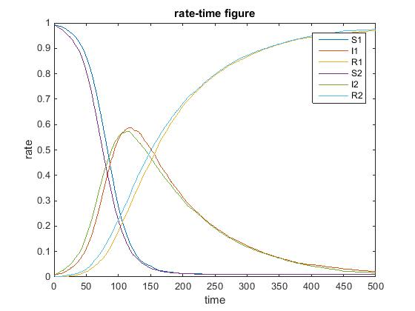
Figure 1 Dynamical process for the control group.
As we use symmetry data for disease 1 and disease 2, the counterparts for disease 1 and disease 2 are similar, the curves conform well. The infected percentage will rise rapidly at first, reach a peak and drop more and more slowly afterwards. The peak percentage is 0.6516. The susceptible percentage will drop rapidly at first and slowly after the infected percentage reaches the peak. At last, when there are no infected people, the percentages for both susceptible people and recovered people will become stable and remain unchanged.
- Degree distribution
In order to investigate in the influence of degree distribution, we change two variables one by one. First is the distribution method and there are three kinds of degree distribution: average distribution, normal distribution and Poisson distribution. Second is the average degree of all people, we decrease by 1 for a trial and increase by 1 for another trial. After plotting all the figures, we get Figure 2 and Figure 3.
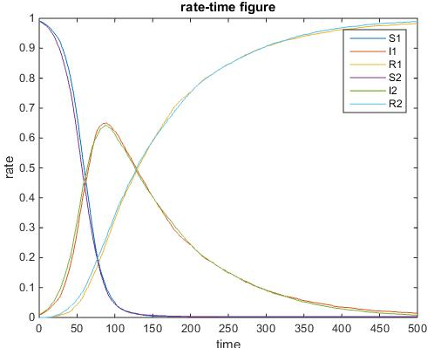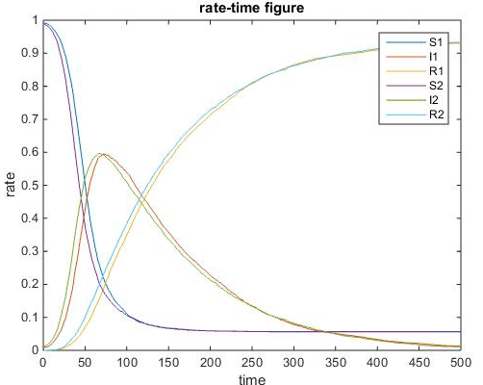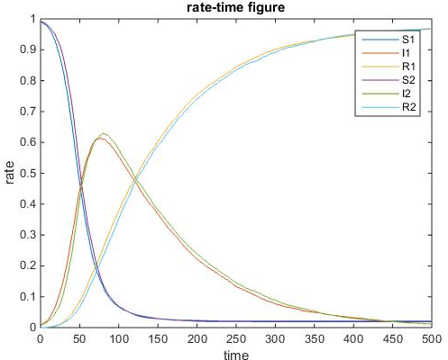
(a) (b) (c)
Figure 2. Dynamical processes under different degree distribution pattern.
(a) Control group (normal distribution) (b) Average distribution (c) Poisson distribution.

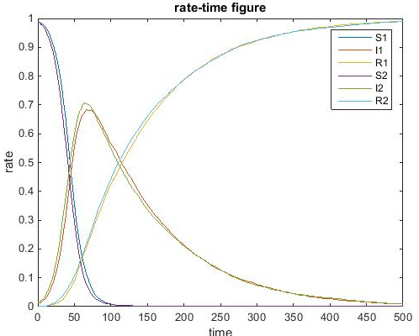
(a) (b) (c)
Figure 3. Dynamical processes under different average degree.
(a) degree = 5 (b) degree = 6 (control group) (c) degree = 7.
In reality, the degree distribution follows Poisson distribution as this is a model of numbers of touch. Under the circumstance of average distribution, the diseases spread fastest and the peak percentages for the infected people are lowest. However, the variances among three figures are very small, and we can use any distribution for study.
From Figure 3, we can see that when the average degrees increase, the epidemic will spread much faster and the peak percentages for the infected people are much higher. This is because when people pretend to touch more, it is more likely for susceptible people to contact with infected people in each period of time. Thus, the diseases will spread very fast and reach peak early without waiting for infected people to recover and have high peak percentages for infected people.
- Interaction between two diseases
In order to investigate in the interaction between the two diseases, we change the coefficients of interaction influence and get Figure 4 and Figure 5. Figure 4 shows unilateral influence and Figure 5 shows reciprocal influence.
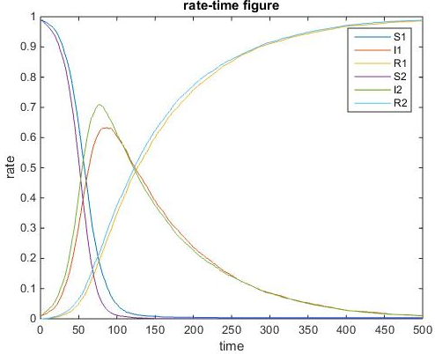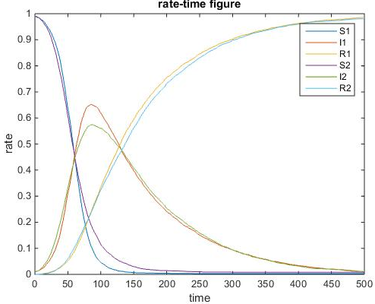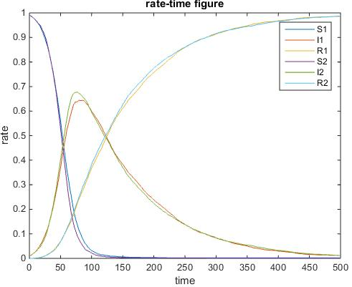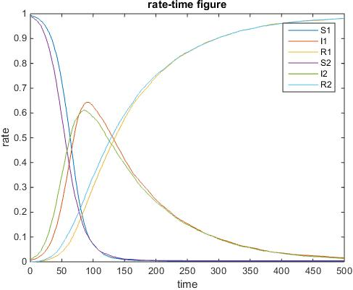
(a) (b) (c) (d)
Figure 4. Dynamical processes with disease 1 influencing the spreading of disease 2 and disease 2 having no impact on the spreading of disease 1.
(a) q_{S} = 1, q_{I} = q_{R} = 1.2 (b) q_{S} = 1, q_{I} = q_{R} = 0.8 (c) q_{S} = 1, q_{I} = 1.2, q_{R} = 0.8 (d) q_{S} = 1, q_{I} = 0.8, q_{R} = 1.2. In all four cases, disease 1 is not influenced by disease 2, and so: pS = pI = pR = 1 and the curves of disease 1 in these four graphs are almost identical to the curves of disease 1 in the control group.

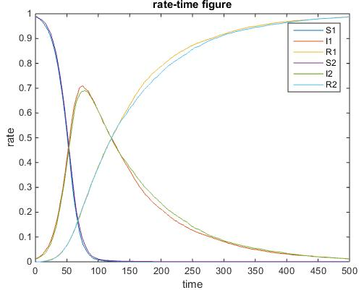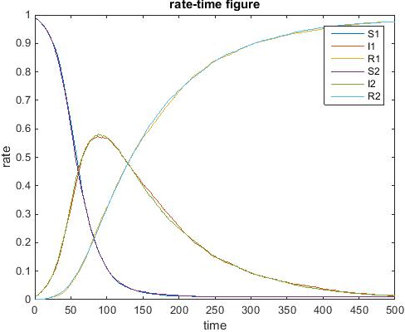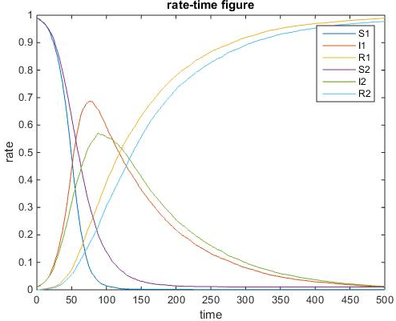
(a) (b) (c) (d)
Figure 5. Dynamical processes with reciprocal impact on each other.
(a) p_{S} = p_{I} = p_{R} = q_{S} = q_{I} = q_{R} = 1 (control group) (b) p_{S} = q_{S} = 1, p_{I} = p_{R} = q_{I} = q_{R} = 1.2 (reciprocal enhancement) (c) p_{S} = q_{S} = 1, p_{I} = p_{R} = q_{I} = q_{R} = 0.8 (reciprocal impairment) (d) p_{S} = q_{S} = 1, p_{I} = p_{R} = 1.2, q_{I} = q_{R} = 0.8 (enhancement and impairment).
What we are really interested in our model is the interaction between two diseases, which is innovation compared to common single-disease model. There is a great chance that two diseases coexist on the multiplex networks. The diseases may enhance and facilitate each other or lead to impairment. The impairment may provide significant ways to develop vaccines or provide ways to prevent one of the diseases from spreading in large scale. From Figure 4, we can get the process of disease spreading under the state that disease 1 will affect disease 2 while disease 2 will not influence disease 1. Subfigure (a) shows that disease 1 facilitates disease 2 and people who have disease 1 are more vulnerable to disease 2. Also, disease 1 prevents disease 2 from recover. In this situation, the percentage of infected people will increase rapidly and maintain a high peak percentage for a longer time. The peak percentage is 0.7096 which is much higher than 0.6516 in the control group, Subfigure (b) shows that disease 1 impairs disease 2. People who get disease 1 get immune to disease 2. They are more difficult to be infected and easier to recover from disease 2. In this situation, the percentage of infected people will increase slowly and soon comes back to the low value after reaching the peak. The peak is 0.5752 which is much lower than 0.6516 in the control group. Subfigure (c) shows that disease 1 will make people be more vulnerable to disease 2 but easier to recover from it. The percentage of infected people will rise rapidly and drop quickly. The peak is 0.6778, which is higher than the control group but lower than subfigure (a). Subfigure (d) shows that disease 2 will make people resist disease 2 but once they get disease 2, they will be more difficult to recover from it. The percentage of infected people will rise slowly and drop slowly. The peak is 0.6132, lower than the control group but higher than subfigure (b). The results conform to the reality and verify our model. The results are reasonable.
Figure 5 shows that the mutual effect between the diseases. Subfigure (b) shows that disease 1 facilitates disease 2 and vice versa. The mutual enhancement is much more powerful than that in the unilateral-influence situation. The peak comes to 0.7096 more quickly. Subfigure (c) shows that disease 1 impairs disease 2 and vice versa. The mutual impairment is much more significant than that of unilateral-influence situation. The peak coms to 0.5738, much lower. Subfigure (d) shows that disease 1 impairs disease 2 and disease 2 enhances disease 1. Than disease 1 will reach a lower peak than unilateral-enhancement situation which is still higher than the control group. The disease 2 will reach a higher peak than unilateral-impairment situation which is still lower than the control group. All the subfigures in Figure 5 are reasonable and verify our model.
For sections D, E, F, G, H, we take the most useful situation, reciprocally-impaired situation with parameters p_{S} = q_{S} = 1, p_{I} = p_{R} = q_{I} = q_{R} = 0.8 into consideration.
- Initially infected individuals
In Figure 6 (a) (b) (c), we slowly increase the initial percentage of infect individuals. In Figure 6 (d) (e), we set unequal initial percentage to investigate in the mutual impairment influence.
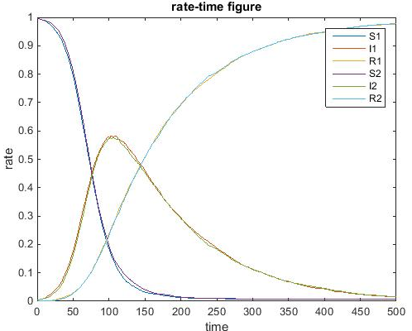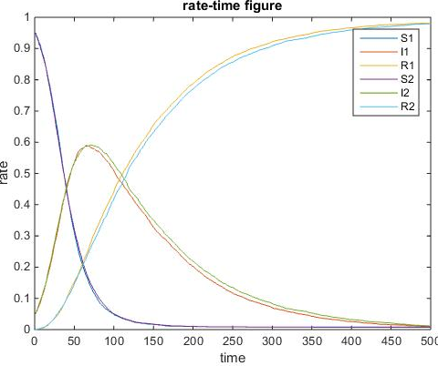
(a) (b) (c)
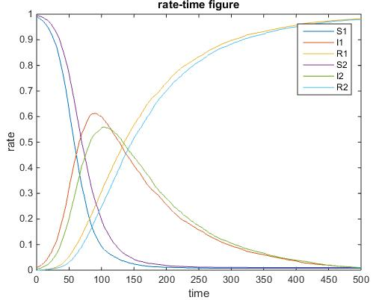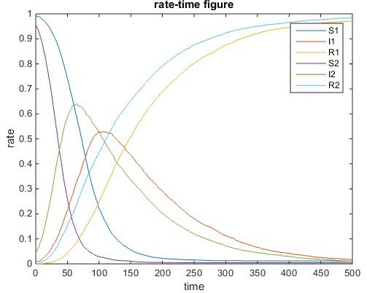
(d) (e)
Figure 6. Dynamical processes with different initially infected individuals.
(a) ε₁ = ε₂ = 0.005 (b) ε₁ = ε₂ = 0.01 (control group 1) (c) ε₁ = ε₂ = 0.05 (d) ε₁ = 0.01, ε₂ = 0.005 (e) ε₁ = 0.01, ε₂ = 0.05.
From subgraphs (a) to subgraphs (c), the initial infected percentage rises and then the infected percentage rises more and more quickly. The peak is higher and higher as well. This shows that the initial percentage is significant for an epidemic to spread quickly. Comparing subfigure (d) and subfigure (e). The initial percentage of disease 2 increases. As disease 2 will impair disease 1, the peak of disease 1 in (e) is 0.5298, which is lower than that in (d). The peak of disease 1 in (d) is 0.6128. This result shows that providing people with vaccines are useful.
- Infection & recovery rate
We change the infection rates of two diseases and get the following graphs:
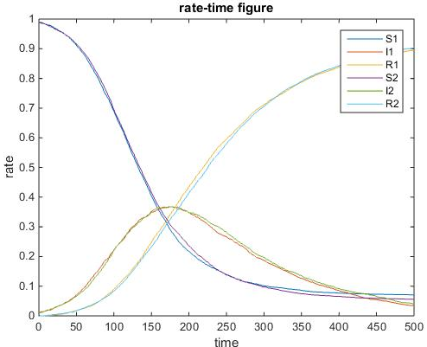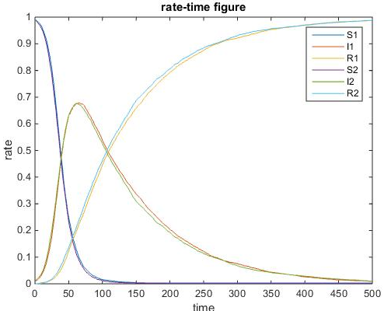
(a) (b) (c)
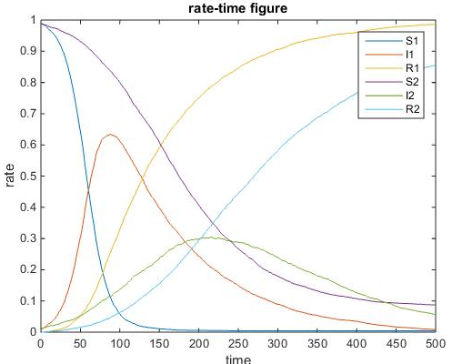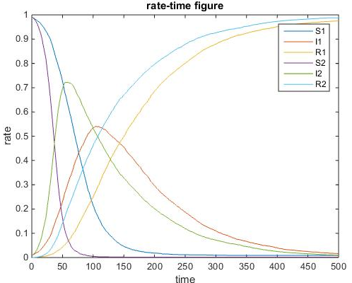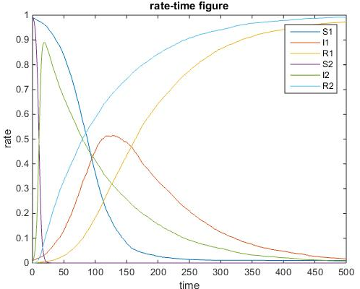
(d) (e) (f)
Figure 7. Dynamical processes with different infection. (a) β₁ = β₂ = 0.01 (b) β₁ = β₂ = 0.02 (control group 1) (c) β₁ = β₂ = 0.03 (d) β₁ = 0.02, β₂ = 0.01 (e) β₁ = 0.02, β₂ = 0.03 (f) β₁ = 0.02, β₂ = 0.1.
From subfigure (a) to subfigure (c), we investigate in symmetry infection rate and the curves coincide perfectly. As the infection rates rise, the peak percentages of infected people will come earlier and reach higher value. The figures show this point. From subfigures (d) to subfigures (f), we investigate in asymmetry infection rate. As disease 2 will impair disease 1, when 2 has higher percent, the peak percentage of disease 1 will come later and reach lower value. For disease 2 whose infection rate rises, the infected percentage of disease 2 will surely rise more quickly and reach higher peak.
We change the recovery rates of two diseases and get the following graphs:
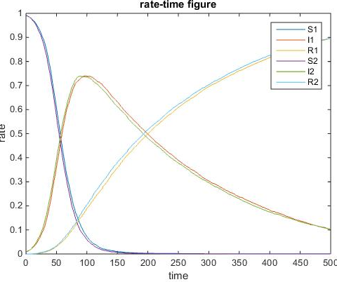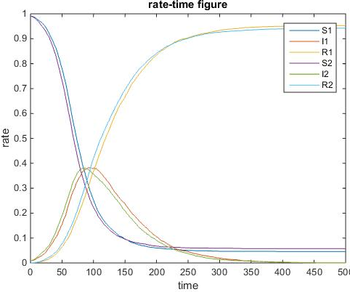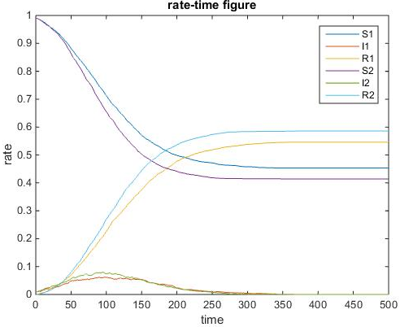
(a) (b) (c) (d)
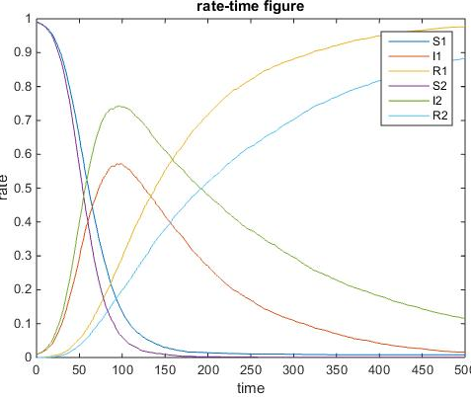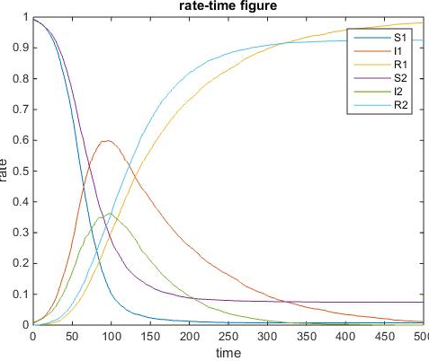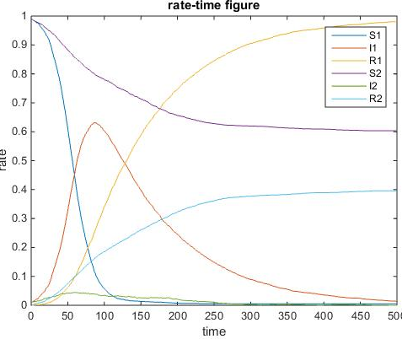
(e) (f) (g)
Figure 8. Dynamical processes with different recovery rate. (a) μ₁ =μ₂ = 0.005 (b) μ₁ =μ₂ = 0.01 (control group 1) (c) μ₁ =μ₂ = 0.02 (d) μ₁ =μ₂ = 0.05 (e) μ₁ = 0.01, μ₂ = 0.005 (f) μ₁ = 0.01, μ₂ = 0.02 (g) μ₁ = 0.01, μ₂ = 0.05.
From subfigure (a) to (c), we investigate in symmetry recovery rate and the curves coincide perfectly. As the recovery rates rise, the peak percentages of infected people will come later and reach lower value. The figures show this point. From subfigures (d) to subfigures (f), we investigate in asymmetry infection rate. As disease 2 will impair disease 1, when disease 2 has lower percentage, the peak percentage of disease 1 will come earlier and reach higher value. For disease 2 whose recovery rate rises, the infected percentage of disease 2 will surely rise more slowly and reach lower peak.
- Overlap rate
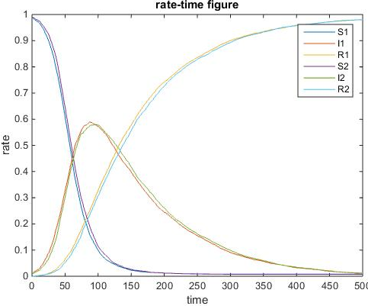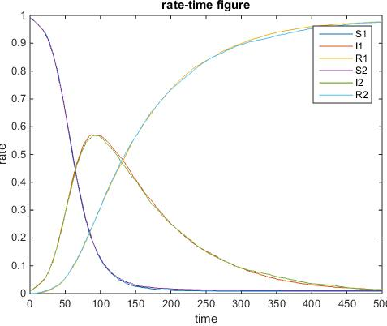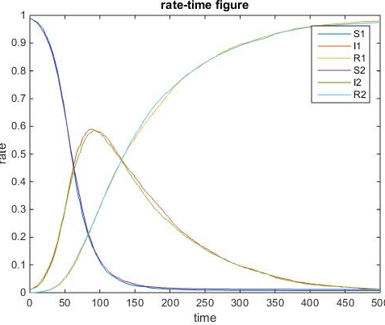
(a) (b) (c) (d)
Figure 9. Dynamical processes with different degree overlap between the two networks. (a) γ = 0 (b) γ = 0.3 (control group 1) (c) γ = 0.5 (d) γ = 1.
We are interested in the relationship between the disease spreading speed and the overlap rate (the percentage of contacts overlapped). From subgraph (a) to subgraph (d), the overlap rate increases and the peak percentage of infected people drops slightly. This means that when the two diseases are similar and share more contacts, they are more likely to appear on a node at the same time and interact. As the diseases are supposed to impair each other, the infected people will be less than the control group at the same period.
- Weak group
We pay special attention to the teenagers and the elder who are more vulnerable to diseases. They are more likely to be infected and more difficult to recover. We set the coefficient as 0.5, which means they have much higher chance to be infected and only half chance to recover from the infected states. We change the percentage of weak groups and get the following graphs.
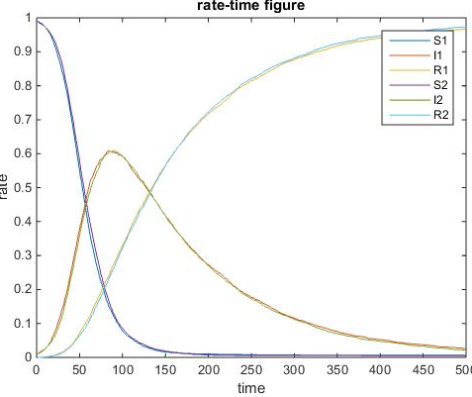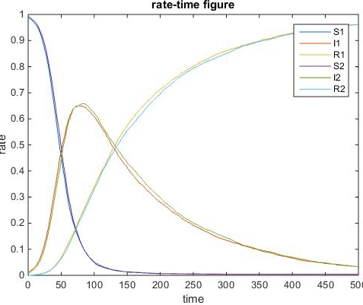
(a) (b) (c)
Figure 10. Dynamical processes with different percentage of weak/sensitive individuals. (a) η = 0 (control group 1) (b) η = 0.1 (c) η = 0.25.
From subfigure (a) to subfigure (c), as the percentage of weak group increases, the peak of percentage comes earlier and reaches higher value. This shows that if we do not pay special attention to the weaker group, the epidemics will spread much more quickly and affect more people.
- ANALYSIS
After comparing the figures with changes of the same variable, we can find the influence of each variable and some ways to control epidemics and improve the health states of the whole society accordingly.
From section B, we know that the larger average degree for contacts, the more likely the disease will spread very fast and reach a higher peak percentage of infected people. This is because when contacts are more, susceptible people are more likely to contact with infected people and more likely to be infected. In this situation, the spread will become so fast that most people will get infected quickly without having the time to recover. Thus, the peak percentage of the infected people will be very high. This is dangerous. Our model can provide methods to control epidemics. When severe epidemics explode, government and hospitals should separate the infected people and suggest that people should not gather together and had better stay in home. When contacts diminishes, the disease will spread very slow and can be controlled.
From section C, we know that some diseases may provide partial immunity against other diseases and decrease the chance of being infected by them. This can help develop vaccine or deal with fatal diseases. As known to most people, small pox is a fatal disease which is likely to lead to death. Cowpox is a mild disease which will have little influence on a person’s life. In order to help a person get immune to the fatal small pox, doctors may make him be infected by cowpox and diminish the chance for him to be infected by small pox and get into danger.
From section D, we know that the larger the initial infection percentages are, the faster the diseases will spread and reach higher peak percentages. This shows that ministry of health should provide ways to monitor new diseases and respond to new epidemics quickly. The earlier we begin to separate infected people and take actions, the slower the epidemic will spread and we can easily control the epidemic.
From section E, we know that the larger the infection rates are, the faster the diseases will spread and reach higher peak percentages. The lower the recovery rates are, the faster the diseases will spread and reach higher peak percentages. This is intuitive and shows that hospital should provide useful medicine for severe epidemics. If the epidemic can easily infect the susceptible people, government should allocate medicine to prevent dangerous situation from taking place.
From section F, we know that when the overlap rate is big, the two diseases will interact more. This shows that similar diseases will interact more and the ministry of health should keep an eye on similar diseases, preventing them from varying quickly and forming mutual facilitation. This also explains for the emergency of complication. The sick should pay attention to the diseases similar to what they have.
From section G, we know that weak people are vulnerable and easily infected. They will influence the whole health condition of the society. Government and ministry of health should pay more attention to the teenagers and the elder. If we do not pay special attention to such groups, they will become sources of diseases and lead to health problems.
- CONCLUSION
In this paper, we study the dynamics of diseases spreading on multiplex networks. We create advanced model for spread of disease and study the process of spreading. We investigate in the influence of different variables and find how to control epidemics and improve the health states of the whole society.
Compared with common models focusing on the spread of a single disease on a single network, our model deal with multiplex networks and pay special attention to the interaction between diseases. This is innovative and scientific.
Nowadays, we are in an information society, it is important to study the spread of information and its influence. Our model can be applied to study the information spreading and many other similar issues.
- ACKNOWLEDGEMENT
Wang Lin, School of Electronic Information and Electrical Engineering
Xu Shuangdie, School of Electronic Information and Electrical Engineering

- REFERENCES
[1] M. E. J. Newman, Phys. Rev. E 66, 016128 (2002).
[2] M. J. Keeling and K. T. D. Eames, J. R. Soc., Interface 2, 295 (2005).
[3] R. M. May, Trends Ecol. Evol. 21, 394 (2006).
[4] D. Mollison, Journal of the Royal Statistical Society Series B (Methodological) 39, 283 (1977).
[5] L. Sattenspiel and C.P. Simon, Math. Biosci. 90, 341 (1988).
[6] R. Pastor-Satorras and A. Vespignani, Phys. Rev. Lett. 86, 3200 (2001).
[7] S. Funk, E. Gilad, C. Watkins, and V. A. A. Jansen, Proc. Natl. Acad. Sci. U.S.A. 106, 6872 (2009).
[8] S. Funk, E. Gilad, and V.A.A. Jansen, J. Theor. Biol. 264, 501 (2010).
[9] K. T. D. Eames, J. R. Soc., Interface 6, 811 (2009).
[10] C. Granell, S. Gomez, and A. Arenas, Phys. Rev. Lett. 111, 128701 (2013).
[11] G. Su, Z. Ruan, S. Guan, and Z. Liu, Europhys. Lett. 103, 48004 (2013).
[12] Z. Ruan, M. Tang, and Z. Liu, Phys. Rev. E 86, 036117 (2012).
[13] S. Funk, E. Gilad, C. Watkins, and V. A. A. Jansen, Proc. Natl. Acad. Sci. 106, 6872 (2009).
[14] F. Bagnoli, P. Lio, and L. Sguanci, Phys. Rev. E 76, 61904 (2007).
[15] Q. Wu, X. Fu, M. Small, and X. Xu, Chaos 22, 013101 (2012).
[16] H. Zhang, J. Zhang, C. Zhou, M. Small, and B. Wang, New J. Phys. 12, 023015 (2010).
[17] A. Perisic and C. T. Bauch, PLoS Comput. Biol. 5, e1000280 (2009).
[18] Y. Zhao, M. Zheng, and Z. Liu, Chaos 24, 043129 (2014).
[19] K. Dietz, J. Math. Biol. 8, 291 (1979).
[20] F. B. Bang, Int. J. Epidemiol. 4, 337 (1975)
[21] L. Elveback, J. P. Fox, and A. Varma, Am. J. Trop. Med. Hyg. 80, 356 (1964).
[22] I. W. Saunders, J. Math. Biol. 11, 311 (1981).
[23] L. J. Abu-Raddad, P. Patnaik, and J. G. Kublin, Science 314, 1603 (2006).
[24] D. A. Vasco, H. J. Wearing, and P. Rohani, J. Theor. Biol. 245, 9 (2007).

