Software Engineering 2

**Cover Sheet**

# Project Title:

……...employment dashboard......................................................................

# Project Description:

……....you can find and search for the available jobs you want...............................

.........................................................................................................................

# Main functions:

…….....login and search for jobs if you are applicant................................................

............add and delete applicants as admin and same for jobs................................

……............................................................................................................................

1

|  |  |  |  |
| --- | --- | --- | --- |
| # | Student ID | Student Name (In Arabic) | Grade(20) |
| 1 | **202000318** | **رحيم احمد موسى** |  |
| 2 | **202001058** | **يحيى طارق محمد جمعه** |  |
| 3 | **202000**243 | **حازم احمد سعد** |  |
| 4 | **202000206** | **بكر ابو حسيبه زكى** |  |
| 5 | **202000**181 | **ايمن شوقي محمد** |  |
| 6 | **202000253** | **حامد سامى حميده** |  |

|  |  |  |
| --- | --- | --- |
| Requirement | points |  |
| Backend project with RESTful APIs | 6 |  |
| DB architecture (schema and data) | 2 |  |
| SOLID principles | 3 |  |
| Clean Code | 2 |  |
| UML diagrams | 5 |  |
| OCL constraints | 2 |  |
| Total | 20 |  |

## Table Of Contents : page

## **Activity Diagram 4**

## **Communication Diagram 20**

## **Sequence Diagram 29**

## **State Diagram 43**

## **Use-case Diagram 44**

## **Class Diagram 47**

## **OCL Diagram 48**

## **DB architecture 51**

## Activity Diagram

## 1.1 create job.

## get jobs.

## get/delete/update job.

## delete/update Request.

## send Request

## respond To Request

## get Request

## 

## get Requests

## delete/update/get User

## get Applicant

## 

## gets Applicant

## add User

## login Admin

## 

## login User

## 

## create Qualification

## 

## get Qualifications

## get/update/delete Qualification

## get skills

## create skill

## get/update/delete Skill

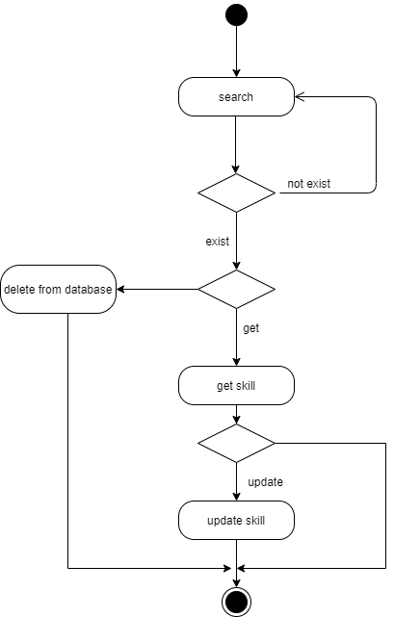

## 2. Communication Diagram

2.1 create job

2.2 delete job

2.3 get job

2.4 get jobs

2.5 update job

2.6 login admin

2.7 login user

2.8 create qualification

2.9 delete qualification

2.10 get qualification

2.11 get qualifications

2.12 update qualification

2.13 delete Request

2.14 get Request

2.15 get Requests

2.16 Respond To Request

2.17 send Request

2.18 create Skill

2.19 delete Skill

2.20 get Skill

2.21 get Skills

2.22 Add New User

2.23 Delete User

2.34 Get Applicant

2.35 Get Applicants

2.36 Update User

3 Sequence Diagram

3.1 Create Job

3.2 Delete Job

3.3 Get Job

3.4 Get Jobs

3.5 Update Job

3.6 Admin Login

3.7 User Login

3.8 Create Request

3.9 Delete Request

3.10 Get Request

3.11 Get Requests

3.12 Respond To Request

3.13 Add New User

3.14 Delete User

3.15 Get Applicant

3.16 Get Applicants

3.17 Update User

3.18 Create Qualification

3.19 Delete Qualification

3.20 Get Qualification

3.21 Get Qualifications

3.22 Update Qualification

3.23 Create Skill

3.24 Delete Skill

3.25 Get Skill

3.26 Get Skills

3.27 Update Skill

4 State Diagram

4.1 Login



4.2 Request

5 Use-Case Diagram

Detailed Use-Case Description

|  |  |
| --- | --- |
| **User case name** | **createJob** |
| **ID** | **NW1** |
| **Goal** | **Admin can create job with their company name , position , description and offer** |
| **Actor** | **Admin** |
| **Pre-condition** | **Admin logged in** |
| **Post-condition** | **Job created successfully** |
| **Main scenario** | **steps** |
| 1. **Enter the company name.** 2. **Enter the position.** 3. **Enter the description.** 4. **Enter the offer.** |
| **Alternative scenario** | **steps** |
| 1. **Invalid information** 2. **The candidate number is max.** |

|  |  |
| --- | --- |
| **User case name** | **deleteJob** |
| **ID** | **NW2** |
| **Goal** | **Admin can delete job** |
| **Actor** | **Admin** |
| **Pre-condition** | **Admin logged in and the job is existed** |
| **Post-condition** | **Job deleted successfully** |
| **Main scenario** | **steps** |
| **Enter the job id.** |
| **Alternative scenario** | **steps** |
| **There is no job with this id** |

|  |  |
| --- | --- |
| **User case name** | **getJob** |
| **ID** | **NW3** |
| **Goal** | **Admin can get specific job with its id** |
| **Actor** | **Admin** |
| **Pre-condition** | **Admin logged in** |
| **Post-condition** | **Get job successfully** |
| **Main scenario** | **steps** |
| **Enter the job id** |
| **Alternative scenario** | **steps** |
| **The job is not existed** |

6 Class Diagram

7 OCL

7.1 Login User

7.2 Logout Admin

7.3 Request Admin

7.4 Skill User

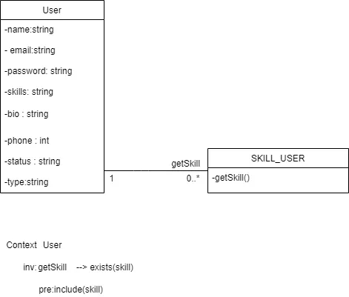

8 Database Architecture

