**第01章 电与磁（1题）**

1. Before and after work for DC electromagnet and AC electromagnet, please analyze the changes of reluctance and magnetomotive force and flux. Respectively explain the results if DC electromagnet and AC electromagnet cannot close due to mechanical stuck.

**第02章 变压器（1题）**

1.Please describe the function of the single phase transformer.

1. What should be paid attention to when using the voltage transformer?
2. What should be paid attention to when using the currenttransformer?

**第03章 直流电机（1题）**

1. Please describe the conditions for a self-excited DC generator to build up the voltage.

**第04章 异步电动机（1题）**

What determines the direction of the *rotating filed* of the three-phase asynchronous motor，and how to change it ?

**第05章 船舶同步电机（4题）**

1.（1）what is armature reaction of synchronous generator？（2）which armature reaction is produced by inductive load for synchronous generator？（3）If no have AVR, what are the effects for output voltage with inductive load? How to adjust?

1. Under what working condition will the synchronous generator suffer armature reaction? How many different types of armature reaction will happen with the change of the characteristics of the load, and what are they?

3. Please draw the output curves of the synchronous generator under different load, and indicate each: *cosφ=*0.9(lagging)*, cosφ=*0.6(lagging)*, cosφ=*1*, cosφ=*0.9(leading)*, cosφ=*0.6(leading)

Solution:

4. Please draw the regulating curves of the synchronous generator under different load, and indicate each: *cosφ=*0.9(lagging)*, cosφ=*0.6(lagging)*, cosφ=*1*, cosφ=*0.9(leading)*, cosφ=*0.6(leading)

**第06章 控制电机**

**第07章 电力拖动基础（1题）**

1.（1）How many working conditions for 3-phase induction motor, describe the corresponding speed and the range of slip s ?

（2）What starting methods there have for 3-phase induction motor？

（3）What braking methods there have for 3-phase induction motor？

**第08章 电力拖动控制电路及系统（8题）**

1. Figure shown right is the control circuit of a 3-phase induction motor. Please try to analyze the followings:

(1) What is the function of the circuit ?

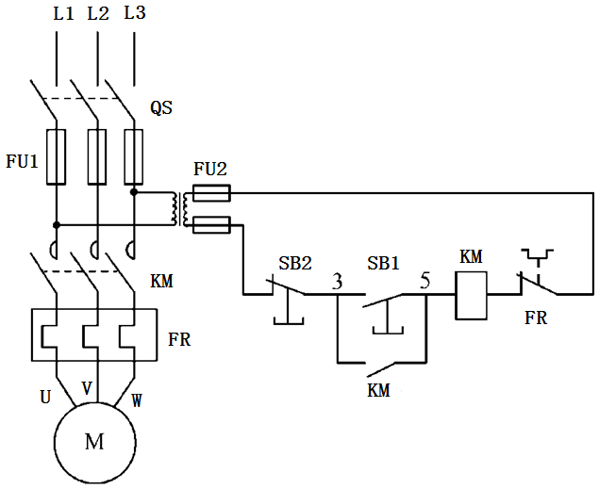 (2) What are KM, FR, FU1 and SB1 in the circuit ?

(3) Please discuss what protections have been set in the circuit and how these protections achieved respectively?

2. Please analyze the following control circuit, and answer the questions below:

(1) Please illustrate the function of this circuit in simple words.

(2) Please list the basic protections this circuit, and element used to realize these protections.

(3) Please illustrate the function of NC contacts ( KMF and KMR) in simple words.

(4) Please analyze what will happen if change the NO contact of KMF to NC contact.

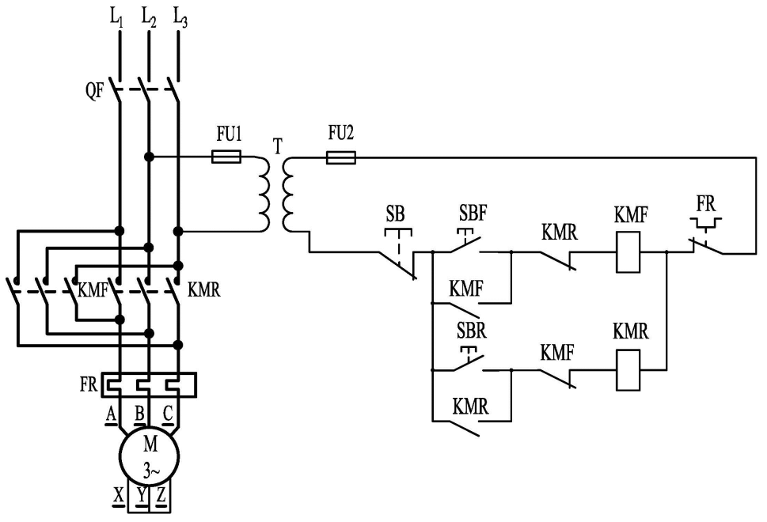 (5) What are the functions of KMF and KMR? How do they achieve the self-lock and mutual interlock in the circuit?

3. Please analyze the following control circuit, and answer the questions below:

(1) Please illustrate the function of this circuit in simple words.

(2) Please list the basic protections this circuit can realize, and elements used to realize these protections.

(3) Please illustrate the function of NO auxiliary contact 1KM.

(4) Please analyze the reason why we connect a 2KM in series with the coil of time relay KT.

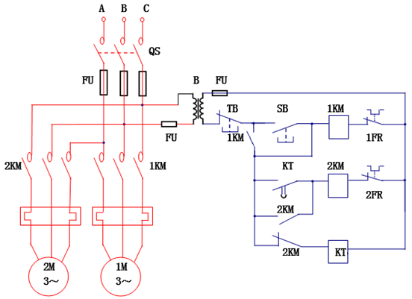

4. Please analyze the following control circuit, and answer the questions below:

(1) The function of this control circuit.

(2) Please discribe what protections have been set in the circuit and how these protections achieved respectively?

(3) Functions of contacts KT

(4) The function of time relay KT.

(5) What happen if exchange the position of contacts KT when switch on QS and press SB2.

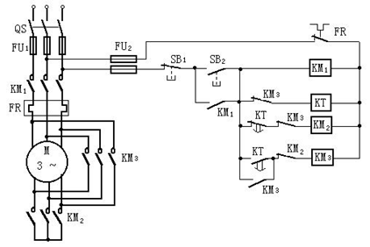

5. The figure on the right is the control circuit of a three-phase induction motor. Please try to analyze the followings:

(1) What is the function of the circuit?

(2) What are NC contact of KTand FR in the circuit respectively?

(3) What is the function of the NO contact 2KM in parallel with contact of KT ? What is the function of the NC contact 2KM in seried with coil of KT ?

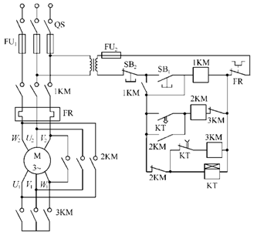 (4) What protections have been set in the circuit? Please list the corresponding equipment.

6. The control circuit of a 3-phase induction motor is shown below, the motor is used to drive the pump of a pressurized fresh water tank. Please analyze the control circuit, and answer the questions below:

(1) List the name and function of the following devices：FU4、FR、KM、SB1、SB2;

(2) when the actual water level in the pressurized water tank HL﹤H﹤HH, analyze the pressure relay’s contacts KP(H) and KP(L)’s status.

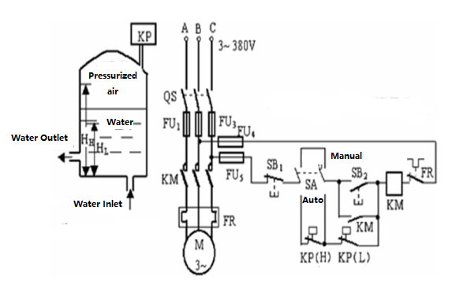(3) when the actual water level in the pressurized water tank HL﹤H﹤HH, the QS is switched on, SA is at “auto” position, please analyze the status of all the contacts in the control circuit and working status of motor M.

7. The control circuit of a 3-phase induction motor is shown below, the motor is used to drive the pump of a pressurized fresh water tank. Please analyze the control circuit, and answer the questions below:

(1) List the name and function of the following devices：FU5、FR、KM、SA、SB2;

(2) when the actual water level in the pressurized water tank H﹤HL , analyze the pressure relay’s contacts KP(H) and KP(L)’s status.

(3) when the actual water level in the pressurized water tank H﹤HL , the QS is switched on, SA is at “auto” position, please analyze the status of all the contacts in the control circuit and working status of motor M.

8. The control circuit of a 3-phase induction motor is shown below, the motor is used to drive the pump of a pressurized fresh water tank. Please analyze the control circuit, and answer the questions below:

(1) List the name and function of the following devices：FU1、FR、KM、SA、SB2;

(2) when the actual water level in the pressurized water tank H﹥HH , analyze the pressure relay’s contacts KP(H) and KP(L)’s status.

(3) when the actual water level in the pressurized water tank H﹥HH , the QS is switched on, SA is at “auto” position, please analyze the status of all the contacts in the control circuit and working status of motor M.

**第09章 船舶甲板机械电力拖动及其电气控制**

**第10章 船舶舵机的电力拖动与控制（1题）**

1.Please describe the following items simply:

(1) what are the steering mode of marine hydraulic steering gear ?

(2) what are the basic types of automatic steering ?

**第11章 舱室辅助机械的电气控制**

**第12章 船舶电力系统的组成（7题）**

1. List the marine power station’s special characteristics, compared with the land power station.

2. Please describe the constructions of the main switchboard and list the basic parameters of the marine power system.

3. Please describe the function of the main switchboard.

4. Schematic diagram of short-circuit(overload),loss of voltage and shunt tripping device are shown below, answer the questions below:

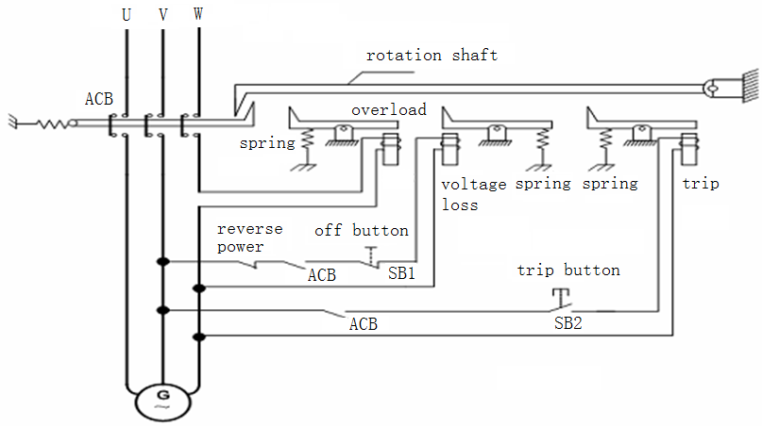(1)What are main protections for marine synchronous generator？

(2)Please describe the tripping units inside and main functions of every unit simply.

5. What are main protections for marine synchronous generator？which device to realize these protections respectively？

6. To be sure reliability of power supply, what link has there between main switchboard and emergency switchboard, please describe its functions of this link?

7. please decrible the requirements when shore power connection.

**第13章 船舶同步发电机的并联运行（4题）**

1. Please answer these below items:

(1) the requirements for parallel running.

(2) manual synchronizing methods.

(3) whether the smaller for frequency difference, the better. Please explain simply.

**2.** Please draw the phasor diagram and analyze what will happen if there have *f1=f2, δ1=δ2*, but *U1>U2* during synchronizing operation. (*U1*, *f1*, *δ1* are the basic parameters of the standby generator, *U2*, *f2*, *δ2* are the basic parameters of the network)

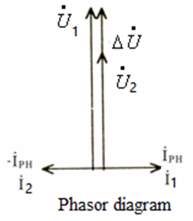

3. Please draw the phasor diagram and analyze that what will happen if there have *f1=f2, U1=U2*, but *δ2* leads *δ1* by an α angle during synchronizing operation. (*U1*, *f1*, *δ1* are the basic parameters of the network, *U2*, *f2*, *δ2* are the basic parameters of the standby generator )

4. List the steps when using synchroscope method to switch on a standby generator online and running in parallel with the generator which has already been online.

**第14章 船舶同步发电机电压及无功功率自动调整（6题）**

1. Describe the functions of the excitation automatic adjustment devices.

2. Please shortly describe the voltage-building conditions of the self-exiting synchronous generators.

3. For the uncontrollable phase compound exciting device of a marine synchronous generator:

(1) Please draw the single line principle diagram.

(2) Please list the components of the field current and functions of each component;

(3) Please draw the phasor diagram and analyze the device’s operating principle when load current increases but power factor remains the same.

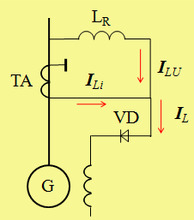

4. For the uncontrollable phase compound exciting device of a marine synchronous generator:

(1) Please draw the single line principle diagram.

(2) Please list the components of the field current and functions of each component;

(3) Please draw the phasor diagram and analyze the device’s operating principle when load current decreases but power factor remains the same.

5. For the uncontrollable phase compound exciting device of a marine synchronous generator:

(1) Please draw the single line principle diagram.

(2) Please list the components of the field current and functions of each component;

(3) Please draw the phasor diagram and analyze the device’s operating principle when power factor decreases but load current remains the same.

6. For the uncontrollable phase compound exciting device of a marine synchronous generator:

(1) Please draw the single line principle diagram.

(2) Please list the components of the field current and functions of each component;

(3) Please draw the phasor diagram and analyze the device’s operating principle when power factor increases but load current remains the same.

**第15章 船舶电力系统频率及有功功率自动调整（4题）**

1. Describe the function of the automatic frequency adjustment and load control device.

2. As show right, No.1 and No.2 generators are two identical generators with same capacity, and No.1 generator is running online with 70% PN ( point A), No.2 generator is the stand-by generator, the operating curves of the speed governors are shown in figure, please:

(1) List the procedures to switch on the No.2 generator and load sharing with the No.1 generator；

(2) Draw the position of the operating curves of each speed governor after load sharing and the final working point of each generator.

3. As show right, No.1 and No.2 generators are in parallel running, every generator shares the same active power ( point C ). Now, No.1 generator should be disconnected, please answer these below questions:

(1) List the procedures to disconnect No.1 generator

(2) Draw the position of the operating curves of each speed governor before pressing the pushbutton to disconnect ACB.

4. Please analyze these below items ( network load is fixed ):

(1) No.1 and No.2 generators are in parallel running, every generator shares the same active power , what are the results if increase oil throttle of No.1 prime mover individually?

(2) No.1 and No.2 generators are in parallel running, every generator shares the same active power , what are the results if decrease oil throttle of No.1 prime mover individually?

**船舶电气安全管理与维护**

1. Please describe the difference between protective grounding and working grounding?