**File introduction**

Point.py and Class.py implement the classes to store a polygon and the data processes function described in report.

CreatePolygon.py and CreatePolygonAl1.py implement the function to create a test polygon.

rectangleCover.py and rectangleCoverAl2.py implement the algorithms logic introduced in report. rectangleCover.py implement algorithm1 and another is algorithm2. The visualization functions also are implemented in rectangleCover.py.

ReadShapefile1.py implement the function about reading a shapefile and process the read data to create a test data set which mentioned in chapter5.

The code in test.py is about the experiment.

The algorithm in rectanlgCover.py is described in[1].

The algorithm in rectanlgCover1.py is described in[2].

1. Kumar V S A, Ramesh H. Covering rectilinear polygons with axis-parallel rectangles[C]// Acm Symposium on Theory of Computing. ACM, 1999.
2. András Hegedüs. Algorithms for covering polygons by rectangles[J]. Computer Aided Design, 1982, 14(5):257-260.

**Program manual**

The program do not be completed as a software, so the program has to be executed under development environment. Download python3.7 and any IDE, Pycharm is recommended.

Then use pip command to install the following packages.

matplotlib 3.2.0

Shapely 1.7.0

After all those steps, the program can be executed successfully. Run ReadShapefile1 can execute almost all functions in project. So in this time, how to execute Readshapefile1.py is main goal. The detail of other file will update later.

Open ReadShapefile1.py, the code under “if __name__ == '__main__':” is the key.

See following figure:

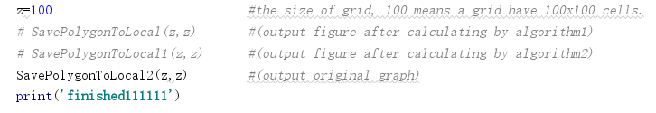

This three functions are main functions of the project. Executing them, the program will read a shapefile into program, process all shape polygons in the file and mashing them according to a given size. The ‘z’ variables in figure control the size of grid,or the size of grid can be input as parameters of the functions. Two parameters of three functions are the length and width of grid. What do the functions do are showing in figure. It has to mentioned that the directory of shapefile should be change in a function. As showing in following figure.

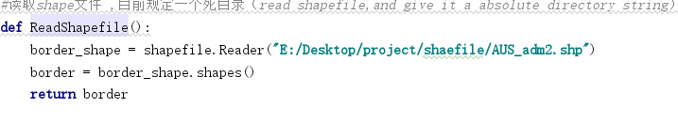

Change the directory according to the specific situation. The shapefile which download from web may have several file. The file have .shp as suffix is the one which should be read. The shapefile used in project can be found in “AUS_adm2.zip”.

There are some other points should be mentioned:

1. the directory in showing following can be find in methods “SavePolygonToLocal(z,z)” and “SavePolygonToLocal1(z,z)”. The function want to open two file which save the running time and unit number of a particular polygon. They also should be change depend on the situation.

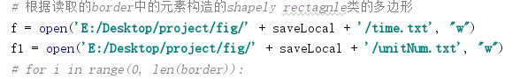

1. The following code will save the figure to localhost. The directory should be changed.If you want the figure to be printed out. You can cancel the “plt.savefig” and use “plt.show()”, it has be canceled in figure. It has to mentioned that print out the figure will use a lot of memory, the shapefile may have too much polygons to print out. It is recommended that save the figures to local.

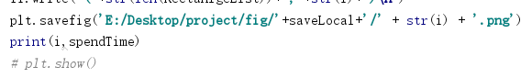

Any other problem, you can leave a message. I will answer it.