1. When step3 is finished, you will get a Wells.zip file. Unzip it to Wells subfolder. You will get the following files and folder.

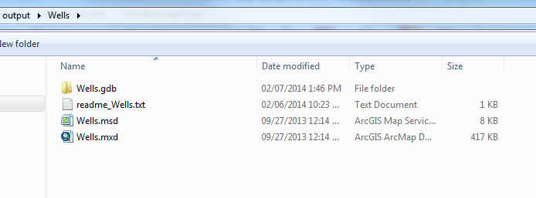

1. Start ArcMap and add the WellsBasic feature class to ArcMap.

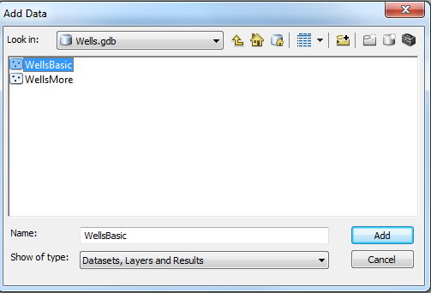

1. Open WellsBasic feature class’s attribute table and add a field named PATH. Field type is String and Length is 50.

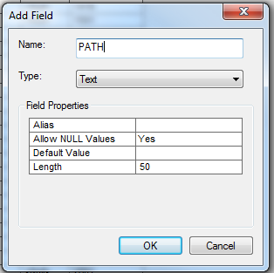

1. Now the WellsBasic feature class will look like

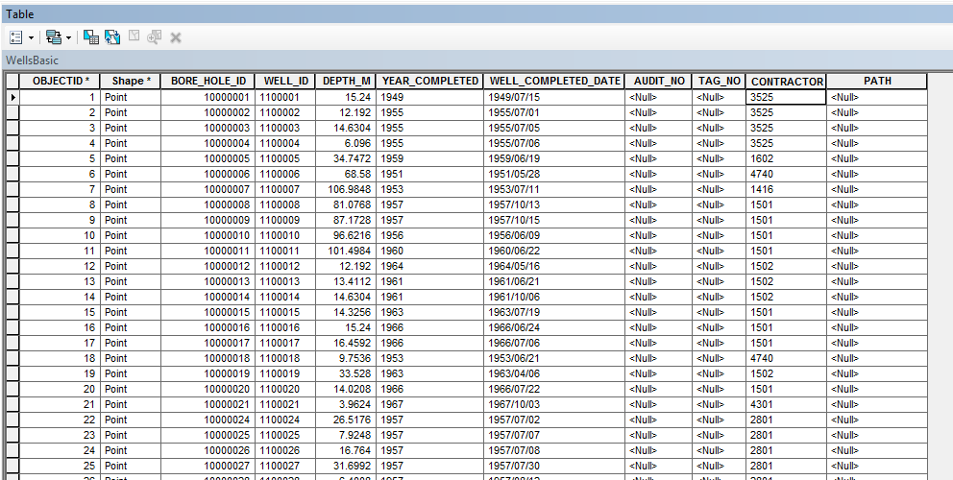

1. Add the WellPath table in PDFpath.mdb from Tim Cheng to ArcGIS.

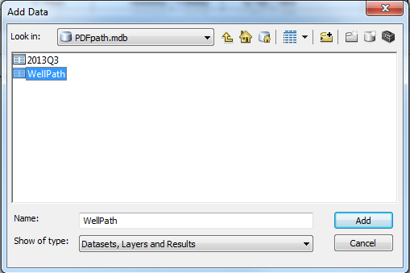

1. Start to Join the WellsBasic feature class with WellPath table.

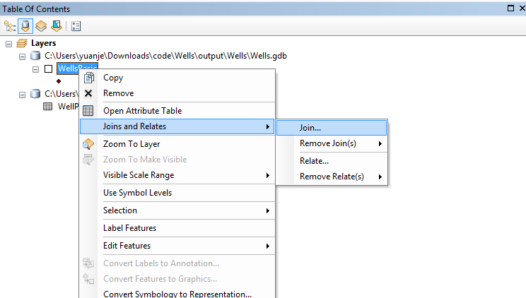

1. Use BoreHoleID as the field to Join them together.

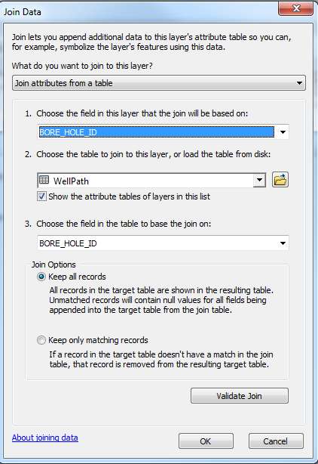

1. Open the attribute table of WellsBasic feature class again. You will see the joined attributes.

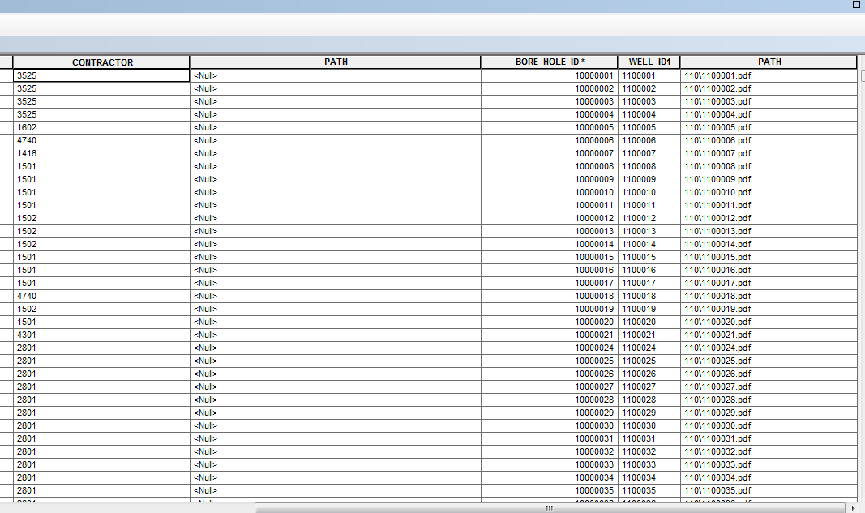

1. Right click on the PATH field on the left (the one with NULL value) rather than the PATH field with content and select Calculate field. Click Yes if confirmation is required.

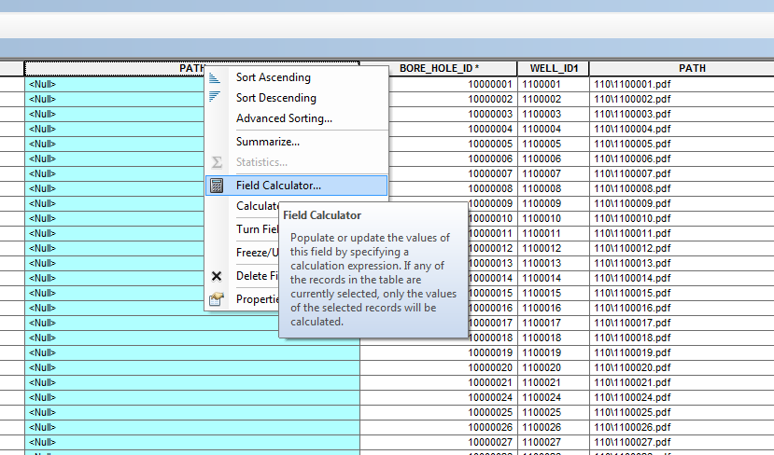

1. Use [WellPath.PATH] as the formula to calculate the field value of WellsBasic.PATH. Click OK when it is done.

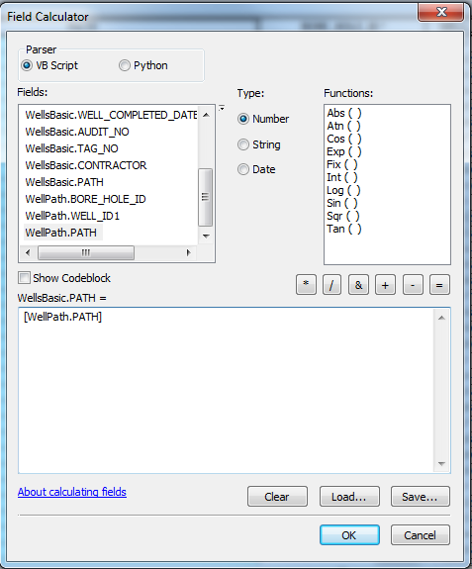

1. The calculation may take several minutes. When it is done, unjoin the WellPath table from WellsBasic table.
2. Go back the Wells folder and compress the following files and folder together and submit as the package to LRC.

