# R10922123 周昱豪

# Code:

基本上就是套kernel下去，然後跟原圖做convolution，而zero crossing就是如果現在的值 >= t，就去檢查鄰居是否有 <= -t，然後執行順序都是先做Laplace再做zero crossing，出來的結果存成圖片

## Laplacian

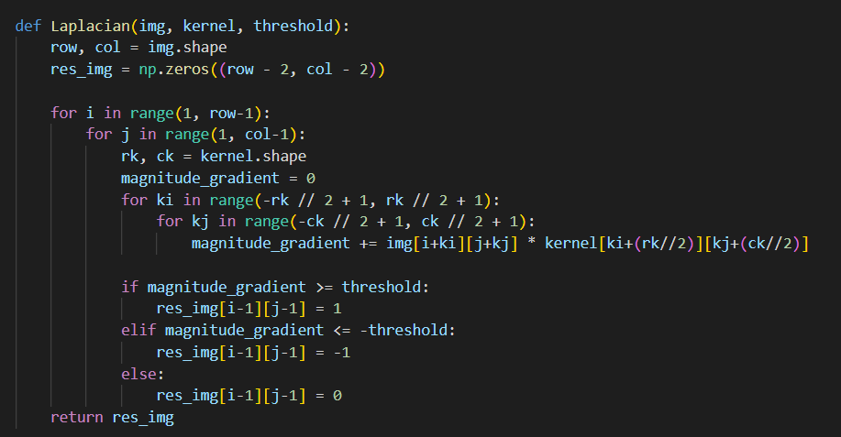

## Zero crossing

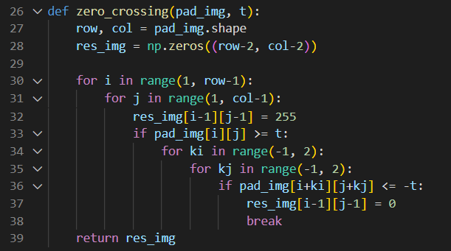

## Laplacian of Gaussian

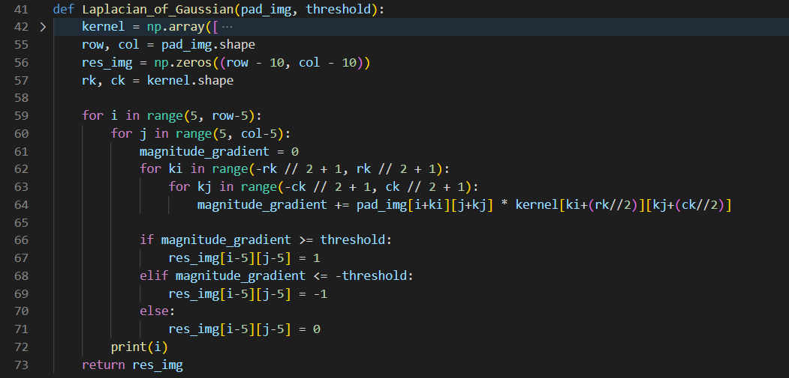

## Difference of Gaussian

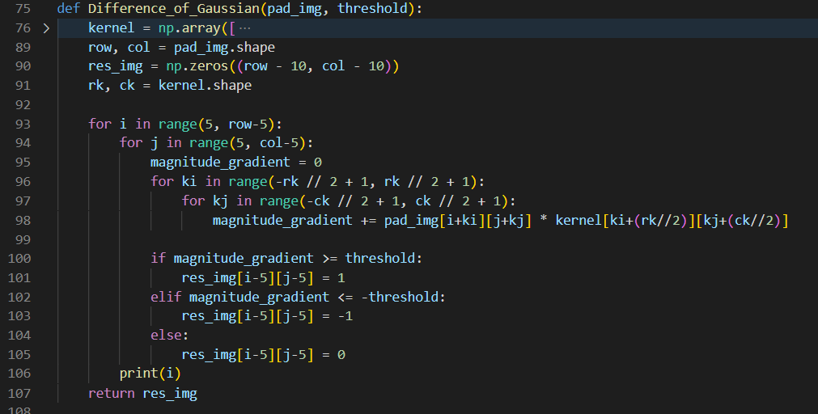

# Result:

|  |  |
| --- | --- |
| Laplace Mask1 (0, 1, 0, 1, -4, 1, 0, 1, 0): 15 | Laplace Mask2 (1, 1, 1, 1, -8, 1, 1, 1, 1) |
| Minimum variance Laplacian: 20 | Laplace of Gaussian: 3000 |
| Difference of Gaussian: 1 |  |