# 資工所碩一 R10922123 周昱豪

# Code:

I use the python cv2 library to read the image，so the parameter img is numpy array, so I can do some array operation.

## Part(a): Same as the HW2

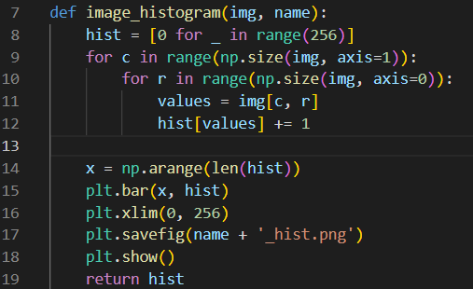

## Part(b): Simply divided by 3.



## Part(c):

1. Calculate CDF with each pixel.
2. 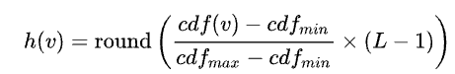, v is the original pixel value, and L is the number of grey levels used.

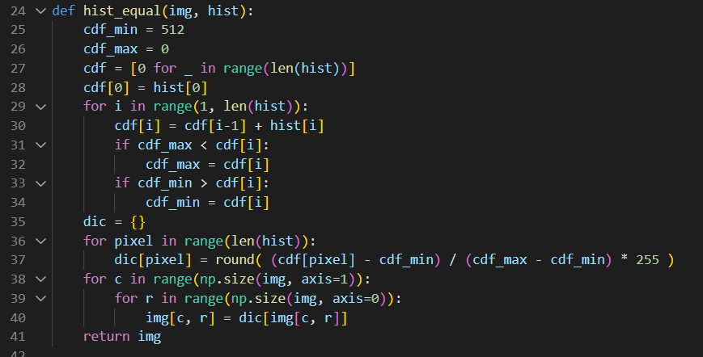

# Result

|  |  |
| --- | --- |
| Part(a) |  |
|  |  |
| Part(b) |  |
|  |  |
| Part(c) |  |
|  |  |