# R10922123 周昱豪

# Code:

做(a)~(g)前都有先將原圖做padding，以下分別為往外補一格與補兩格的code

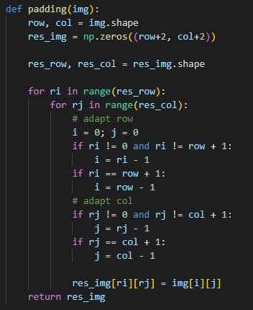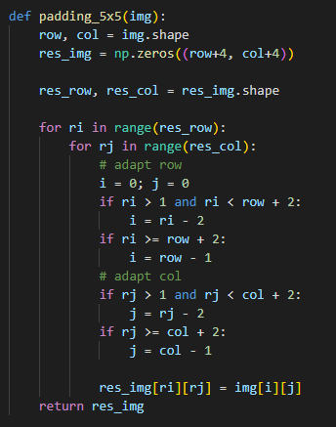

基本上(a) ~ (g)就是對padding後的圖，依照講義上給的方向取值計算gradient magnitude

Robert's Operator

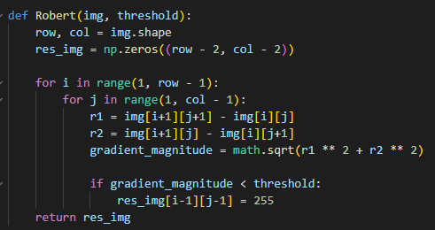

Prewitt's Edge Detector

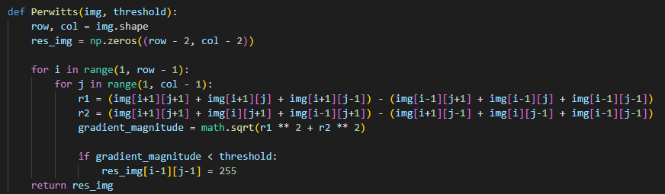

Sobel's Edge Detector

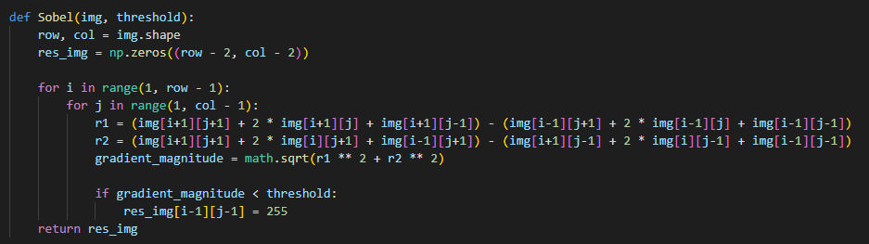

Frei and Chen's Gradient Operator

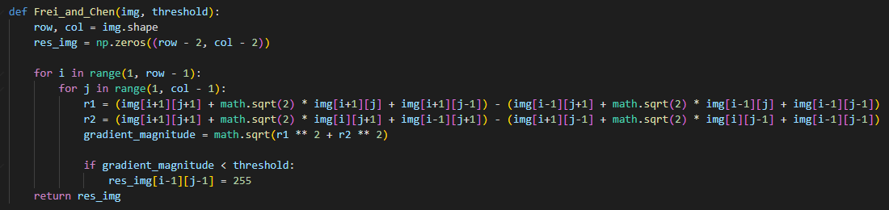

Kirsch's Compass Operator

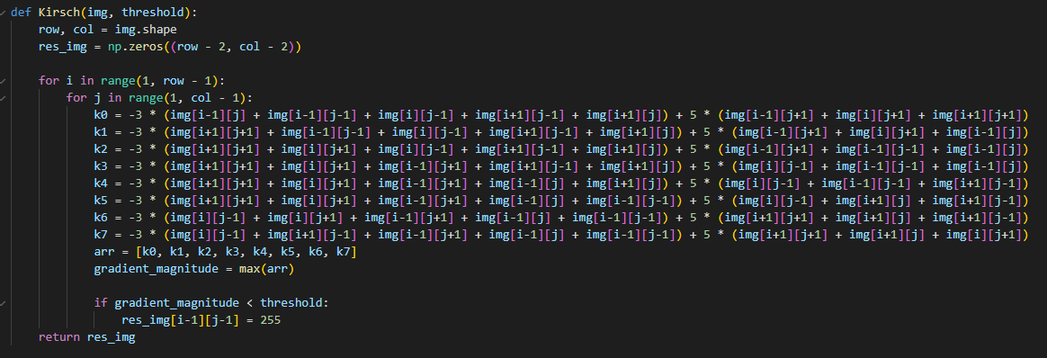

Robinson's Compass Operator

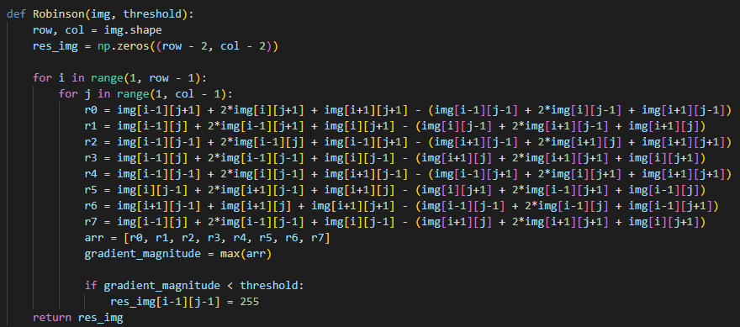

Nevatia-Babu 5x5 Operator

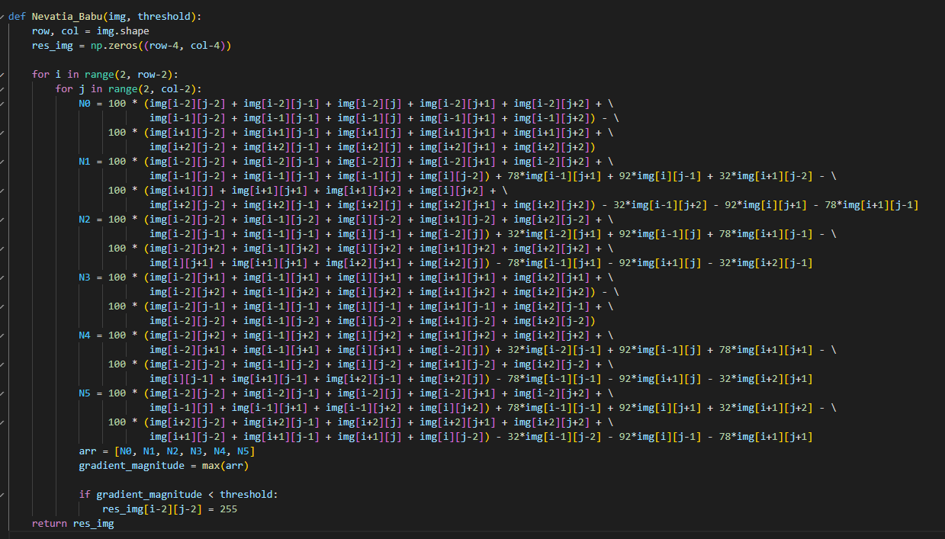

# Result

|  |  |
| --- | --- |
| Robert's Operator: 12 | |
| Prewitt's Edge Detector: 24 | Sobel's Edge Detector: 38 |
| Frei and Chen's Gradient Operator: 30 | Kirsch's Compass Operator: 135 |
| Robinson's Compass Operator: 43 | Nevatia-Babu 5x5 Operator: 12500 |